HOMEWORK-STUDY QUESTIONS

CONVENTIONAL FOUNDRY PROCESSES
- Draw a green sand mold and indicate sprue, gate, cavity, pouring basin, parting line, cope, drag, riser and core.
- Why are skin-dried molds required? How is the skin-dried surface formed?
- Under what circumstances are the dry-sand molds preferred?
- Why are the risers used in sand casting? Explain briefly.
- How is the "shrinkage cavity" eliminated in the casting?
- The following steel slideway will be produced by sand casting. Design your pattern(s) and locate the pattern(s) in the sand mold.
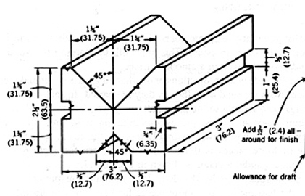
- How is the binding property of silica sand improved in sand casting? Explain briefly.
- What is the importance of the "sand fineness test" in deciding the characteristics of sand mold?
- The permeability test determines which characteristics of sand mold? Does the permeability test reflect the actual characteristics of sand mold during the casting process?
- Design the necessary dry-sand cores for the following part and show their location in the sand mold.
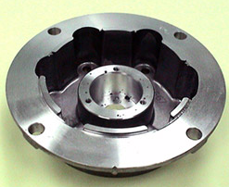

CONTEMPORARY CASTING PROCESSES
- Explain the circumstances for using permanent molds and sand molds.
- Compare the characteristics of two parts (the same size and geometrical properties) produced by sand casting and die casting.
- High pressure in pressing the metal into the cavity improves some casting properties in die casting. What are those properties?
- What typical metals are cast by hot- and cold-chambered die-casting methods?
- Briefly explain die life, casting size, and casting production rate for different melting-temperature metals used in die casting.
- What is the meaning of single-cavity and multi-cavity mold/die?
- In centrifugal testing, "superior physical properties" are obtained. Explain why it is so.
- What is gravity segregation in centrifugal casting?
- Give six examples (parts) produced by centrifugal casting.
- In precision (or investment) casting, explain the mold structure.
- What types of parts are produced by investment casting?
- How does the shell form in investment casting? Explain briefly.

HOT AND COLD WORKING OF METALS
- What are the advantages and disadvantages of hot working processes?
- List the names and draw the intermediate and final forms produced in steel rolling.
- Draw two figures showing the variations in grain structures in the hot and cold rolling process.
- Draw the progressive forging of material in a closed die schematically.
- What is the main difference between steam hammers and gravity drop hammers?
- How is the surface scale formed, cleaned (removed) in forging operations?
- Provide examples of shot peening of forged parts in industry.
- List the materials of parts commonly forged in industry.
- List the superiorities of parts forged compared to those produced by other techniques.
- Some industry-standard sample parts collect data on the number of blows and the blowing force.
- Compare the final properties/characteristics of parts forged by drop and press forging.
- Collect information about three forms produced by the extrusion process.
- List direct (forward) and indirect (reverse) extrusion advantages and disadvantages.
- Draw the indirect extrusion process and show the terminology of the parts.
- List the advantages of the cold working process over hot working.
- Search and find two sample forms produced by cold extrusion. Collect the necessary data for the forms.
- What are the materials of the dies of the wire drawing process?
- Collect information about a wire drawn (i.e., wire material, initial wire/rod diameter, number of stations, reduction of wire diameter at each station (or reduction in area, use of lubricant, etc.).

SHEET METAL WORKING
- List at least seven different types of sheet metal operations.
- Using simple sketches, show the difference between piercing and blanking operations.
- For an industrial die, obtain information on the die and angular clearances (provide a drawing or photo of the die if available).
- Two holes with a 25 mm diameter will be pierced through a 1.5 mm sheet of plain carbon steel at 28 kgf/mm². Calculate the required piercing force for the holes. Design your punch system step by step (provide the necessary dimensions) and calculate the forces for the new design.
- For the bracket blanks given in Figure 5.9 (b) in the class notes, calculate the percent use of strips for both locations of blanks (the strip width is 100mm, bracket dimensions are 60x90x12 mm, sheet thickness is 1.5mm).
- Collect information on the four parts produced by the deep-drawing process.
- A bullet cartridge's initial height and diameter drawn from a 0.25 mm brass sheet are 20 mm and 9 mm. Calculate the diameter of the brass blank to be used for the process.

POWDER METALLURGY (PM)
- PM technology is expensive. List the reasons for this. If so, why do we use this technology?
- Draw the PM process flowchart and label the intermediate products.
- Why is the "particle size distribution of a powder important? Explain.
- Obtain a particle size distribution chart for a powder.
- What is the definition of "compressibility" in PM for a powder?
- Collect apparent density, green strength density and sintered density information for two parts produced by PM in the industry.
- List the names of processes used for producing powders.
- Explain the atomization process.
- Give information (powder characteristics, atomization settings, gas used, gas pressure and nozzle system) about two powders produced by the atomization process.
- For the production of copper powder, explain the electrolytic deposition technique.
- How is the iron powder produced in the reduction method?
- List the production methods used for the production of iron powder.
- What are the typical lubricants added to the powder in the PM? Collect information about the volumetric amount of their additions.
- What is a green compact?
- Collect information on two PM parts made from iron powders. Obtain their compression force/pressure, compression ratio, density before and after sintering, sintering temperature, sintering medium, and porosity before and after sintering.
- Explain the solid-state sintering briefly.
- Explain briefly liquid state sintering. Give examples of PM parts sintered by liquid state sintering.
- Collect information about different PM parts (sintering temperature, sintering medium, duration, increase in density, etc.)
- List the finishing processes for PM parts.
- Briefly explain the production method for cemented carbide tools.
- Learn the mixture of powders and their amounts in the PM gears.
- Explain the structure of porous bearings shortly.
- Find some other applications (use) of PM parts in the industry. Do not give the applications mentioned in the class notes.

METAL CUTTING
- Draw an orthogonal cutting tool model and give the necessary terminology.
- Draw cutting and the related forces in orthogonal cutting.
- Mention factors affecting forces in cutting. Which factors are more effective in changing cutting forces?
- For an orthogonal turning operation power consumption of lathe when idle= 325 W, power consumption of lathe when cutting= 2580 W, spindle speed, N = 124 rpm; cutting speed, v = 24.5 m/min depth of cut, d = 3.8 mm; feed rate, f = 0.2 mm/rev
Find the torque at the spindle, cutting force, and material removal rate.
- For a turning tool, show the angles on sketches.
- What are the functions of tool angles?
- What are the geometries of inserts used in metal cutting?
- Select tool holders and inserts from manufacturers' catalogs for steel-turning operations.
- List the types of insert mounting techniques for tool holders. Schematically show these mounting techniques.
- List the types of HSS tools and their applications in the industry.
- List the types of carbide tools and their applications in the industry.
- Explain the structure and applications of ceramic tools.
- What are the types of chips formed? Under what cutting conditions and work materials are these types of chips formed?
- What are the functions of cutting fluids in metal cutting operations?
- List commonly used cutting fluids in the industry.
- List and explain the terms used to describe the machinability of a material.
- Which addition of materials improves the machinability of steel?
- How can the machinability of the two materials be compared? Which value is given in the machinability catalogs to show the material's machinability?
- What are the types of tool wear in cutting?
- On a simple sketch, show the flank and crater wear. What are the critical values indicating the end of tool life?
- Write down the extended Taylor's tool life equation. Describe the variables in the equation.
- A coated carbide cutting tool has a 60-minute tool life when cutting mild steel at 1.2 m/s. Suppose Taylor's tool-life exponent is 0.25. Find Taylor's tool-life constant and tool life if the cutting speed doubles.

NON-TRADITIONAL PROCESSES
- Why do we need non-traditional machining processes? Explain.
- Classify the non-traditional machining processes according to the "type of energy used".

AJM/AWJM

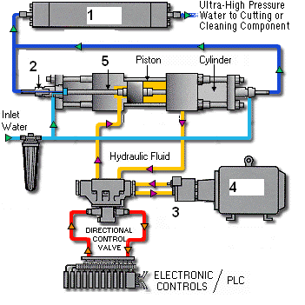
- Write down the names of the above-numbered items in a WJM system.
- What are the applications of WJM systems?
- What are the technical capabilities of the abrasive water jet cutting technique?

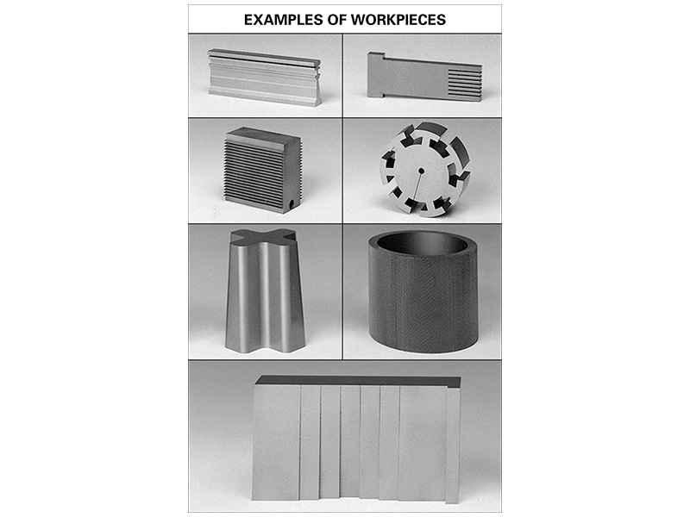

- The above-given part is 20 mm in diameter and 5 mm in depth (thickness). If the part was made of alumina, a non-conductive ceramic material, which technique(s) do you recommend? Only write the name(s) of the technique(s).
- Which technique(s) do you recommend to produce the parts shown below (the material is brass)?

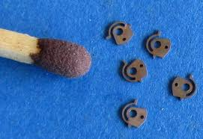

- If you attempt to build a WJM (water jet machining/cutting) machine tool for the first time in your manufacturing company, which machine tool unit will cause difficulties and need more know-how? Why? Discuss briefly.
- What is a coherent jet in WJM? How can we increase the coherent jet length?

EDM/WEDM
1) Why does the tool electrode wear less than the workpiece in the EDM process?
2) What are the applications of the EDM process in the industry?
3) What are the superiorities of the EDM technique to the other manufacturing processes we studied?
4) What are the functions of dielectric fluids in EDM?
5) What are the properties of suitable dielectric fluids in EDM?
6) What are the critical factors in tool design in EDM? How do these factors affect the cost of the process?
7) How is the electrode wear affected by EDM's machining depth and machining area? Explain briefly.

8) In which process(es) can you use the tools below to machine the workpiece?
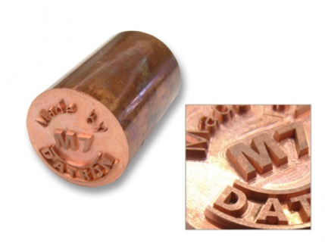

- List the processes required to produce the steel dies shown below (die dimensions are approximately 20 x 17 x 4 mm).

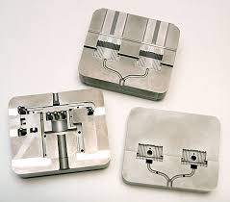

- The R-C (relaxation circuits) are the first power generators developed in the history of EDM (in 1945). However, they are still in use with pulse generators nowadays. For what type of machining applications is it recommended?
- What parameters are effective on wire-pushing (spark pushing) in wire EDM?
- One of the reasons for "less tool electrode wear than the workpiece" is the better heat ………(?)………. of the electrode (commonly Cu and alloys).
- If flushing does not apply, no successive independent pulses occur at different locations in the gap. The discharges occur continuously at the same spot (called "……(?)………." phenomena).
- In WEDM, machining accuracy is ……… mm (typical).
- The WEDM machine tools are more expensive than die-sinking EDM machine tools. Why?

LBM
1) What are the applications of the LBM process in the industry?
2) Draw a schematic figure showing the principles of the LBM process.
3) List five of the limitations of the LBM/LBC process.
4) What types of LBM resonators are available in the industry (like fiber lasers, …)?

COMMON QUESTIONS FOR WJM/AWJM, EDM/WEDM, LBM/LBC
- Name the suitable processes for the below-stated machining tasks (Note that some of the tasks may not be achieved with the above techniques):
a. glass material, opening 30x30x6 mm blind hole
b. removal of paint from tungsten workpiece surface
c. give cutting angles to carbide cutting tools (inserts)
d. Cu material (30 mm thick), cutting of a 20x30 mm elliptic through-hole
e. leather material, 1000 holes/min drilling
f. marble, opening 20x20x30 mm blind hole
g. removal of burr from a plastic workpiece
h. cutting of 150x150 mm blanks from 1030 steel sheet (15 mm thick)

ADDITIVE MANUFACTURING
1) Which additive manufacturing techniques can you use to produce "metallic" parts?
2) What are the technological problems of additive manufacturing techniques at today's level of technology?
3) Write down all you know about Selective Laser Sintering (SLS) / Direct Metal Laser Sintering (DMLS) techniques.

- Which process is shown above? What prototype materials could be used in the process?
- What are the other additive manufacturing techniques not mentioned in the lectures?

