Chapter 1
CONVENTIONAL FOUNDRY PROCESSES

Founding (dökümcülük) or casting is the process of forming objects by putting liquid or viscous material into a prepared mold (kalıp) or form.

A casting (döküm) is an object formed by allowing the material to solidify.

A foundry (dökümhane) is a collection of the necessary material and equipment to produce a casting.

A mold (kalıp) is a container with a cavity of the shape to be cast.

Although molds may be made of metal, plaster, ceramics, or other refractive substances, this chapter is concerned primarily with preparing sand molds.
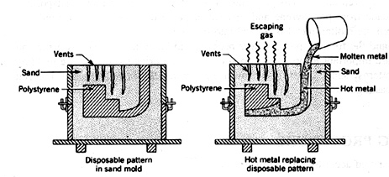

Figure 1.1 Sand mold.

TYPES OF SAND CASTINGS

There are two different methods by which sand castings can be produced. Classified according to the type of pattern used:

(1) Removable pattern (kalıcı model): In the method employing a removable pattern, sand is packed around the pattern, which is later withdrawn from the sand. The cavity produced is filled with molten metal to create the casting (Figure 1.2).

(2) Disposable (expandable) pattern (kalıcı olmayan model): Disposable patterns are made from polystyrene. The polystyrene pattern, including the gating and pouring system, is left in the mold Figure 1.1). Molten metal is poured rapidly into the sprue; the polystyrene vaporizes, and the metal fills the remaining cavity. Also, the "wax" type pattern is melted out before casting.

MOLDING PROCEDURE

Green-sand molds (kum kalıp). This is the most common method, which consists of forming the mold from damp molding sand.

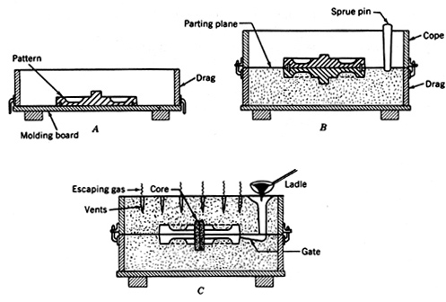

Figure 1.2 Procedure for making green-sand molds. (A, Pattern on molding board ready to ram up drag. B, drag rolled over and pattern assembled, ready to ram cope. C, mold complete with a dry-sand core in place)

Some information about the figure:
Riser—taşmalık, çıkıcı (to compensate shrinkage).
Sprue--dikey yolluk
Gate/runner--yatay yolluk ("runner" is the name of the gate used in large castings to distribute the metal to several gate passageways).
Cope--üst derece
Drag--alt derece
Pouring basin--dökme ağzı
Sprue pin--yolluk pimi
Parting plane--ayırma düzlemi
Molding board--döküm tablası
Core--maça

Molding Procedure for Removable (Permanent) Patterns

They are reused repeatedly. A simple procedure for molding a cast-iron gear blank is illustrated in Figure 1.2. The mold for this blank is made in a two-part flask. The top part is called the cope, and the lower part is the drag. The center is called a cheek if the flask is made in three parts.

1) The first step in making a mold is to place the pattern on a molding board that fits the flask being used. Next, the drag is placed on the board with the pins down, as shown in Figure 1.2A. Molding sand is then riddled into the pattern. The sand should be pressed around the pattern with the fingers, and the drag should be completely filled. For small molds, the sand is firmly packed in the drag by a hand rammer. Mechanical ramming is used for large molds and in high-production molding. The amount of ramming necessary can be determined only by experience. If the mold is not sufficiently rammed, it will not hold together when handled or when the molten iron strikes it. On the other hand, if it is rammed too hard, it will prevent steam and gas from escaping when the molten metal enters the mold.

2) After the ramming has been completed, the excess sand is leveled off with a straight bar called a strike rod. To ensure the escape of gases during pouring, small vent holes are drilled through the sand to within a fraction of an inch of the pattern.

3) The lower half of the mold is then turned over so that the cope may be placed in position and the mold finished. Before turning, a small amount of sand is sprinkled over the mold, and a bottom board is placed on top. This board should be moved back and forth several times to ensure an even bearing over the mold. The drag is then rolled over, and the molding board is removed, exposing the pattern. The sand surface is smoothed with a trowel and covered with a fine coating of dry parting sand. Parting sand is fine-grained, dry silica sand with no strength. It prevents the bonding of sand in the cope with that in the drag.

4) Next, the cope is placed on the drag, as shown in Figure 1.2.C, with the pins on either side holding it in the proper position. A tapered pin, known as a sprue pin, is placed approximately 25 mm to one side of the pattern to provide a location for the iron to enter the mold.

5) The sprue pin is first withdrawn. The cope half of the flask is then carefully lifted off and set aside. A draw spike is driven into it to loosen the pattern, and it is then rapped lightly in all directions. The pattern can then be withdrawn by lifting the draw spike.

6) Before the mold is closed, a small passage known as a gate must be cut between the cavity made by the pattern and the sprue opening. This passage is shallowest at the mold. To allow for metal shrinkage, a hollow is sometimes cut into the cope, which supplies hot metal as the casting cools; this opening is called a riser (taşmalık,çıkıcı) (Figure 1.3).

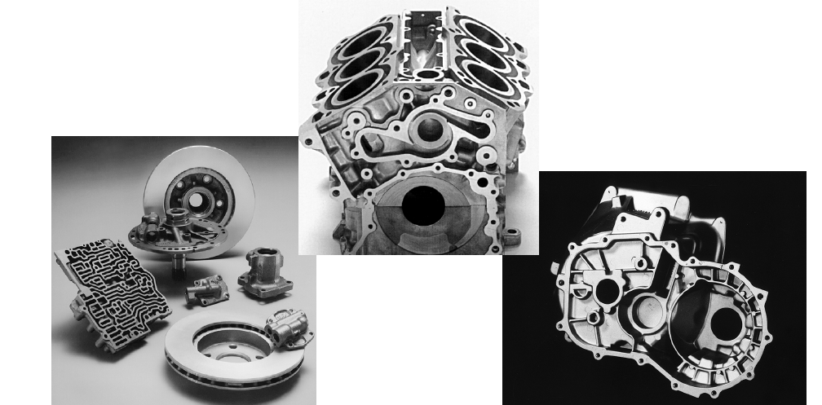
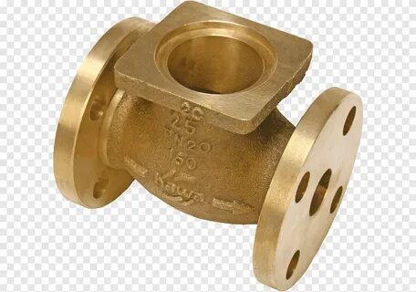
Some sand cast parts.

GATES, RISERS, AND SOLIDIFICATION CHARACTERISTICS

The passageway for bringing the molten metal to the mold cavity, which is known as the gating system (yolluk sistemi), is usually made up of a pouring basin (dökme ağzı), a downgate or vertical passage known as a sprue (dikey yolluk), and a gate (yatay yolluk) through which the metal flows from the sprue base to the mold cavity. A runner may be used in large castings, which takes the metal from the sprue base and distributes it to several gate passageways around the cavity.

The design of the gating system is important and involves several factors:

i) Metal should enter the cavity to provide directional solidification if possible. The solidification should progress first from the mold cavity to compensate for shrinkage.

ii) Risers (taşmalık/çıkıcı) and feeder heads (besleyici) are often provided in molds to feed molten metal into the main casting cavity to compensate for the shrinkage. They should be large in section to remain molten for as long as possible and be located near heavy sections that are subject to large shrinkage.

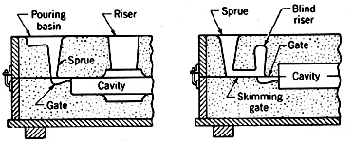

Figure 1.3a Methods used in introducing metal to the mold cavity.

iii) Volumetric shrinkage usually occurs when the metal solidifies, and a shrinkage cavity (void-çekme boşluğu) results if the solidification is not directed so that any voids caused by shrinkage take place in the gate, risers, or sprue. The shrinkage, and thus the shrinkage cavity, occurs where the metal remains molten the longest.

iv) Metal inserts called chills (soğutucu) are sometimes used to control solidification by carrying heat away from the solidifying metal at a more rapid rate. In contrast, exothermic chemical compounds may be packed next to a part of the casting to retain heat in that area.

……………………………………………………………….
PATTERNS

Pattern Allowances (Model Payları)

1) Shrinkage allowance (Çekme payı). When pure metals and most alloys cool, they shrink. To compensate for shrinkage, a shrink rule must be used when laying out the pattern measurements. A shrinkage rule for cast iron is 1.04%. The shrinkage for brass varies with its composition, but is usually close to 1.56%. For steel, it is 2.08%, and for aluminum and magnesium, it is 1.3%. When metal patterns are to be cast from original patterns, double shrinkage must be allowed.

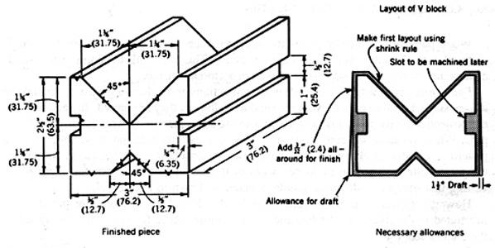
Figure 1.4 Pattern allowances for a cast-iron block.

2) Draft allowance (Koniklik payı). The tapering of the sides of the pattern, known as "draft", is done to provide a slight clearance for the pattern as it is lifted up. A draft is added to the exterior dimensions of a pattern and is typically 1.04-2.08%. Interior holes may require a draft of up to 6.25%.

3) Finish/machining allowance (İşleme payı). A finishing allowance should be given to the working areas of the workpiece. Additional metal must be provided so there will be some metal for the machine; hence, a finish allowance. The amount to be added to the pattern depends on the casting's size and shape. The finishing allowances are commonly close to the shrinkage allowance.

Materials for Removable Patterns

Most patterns are made of wood, which is inexpensive and can be worked easily. Many patterns used in production work are made of metal because they withstand hard use. Metals for patterns include aluminum, brass, white metal (Al+Zn alloy) (zamak) and cast iron. Aluminum is probably the best all-around metal because it is easy to work with, lightweight, and corrosion-resistant.

SAND

Types of Sand

1) Silica sand (SiO₂), found in many natural deposits, is well-suited for molding because it can withstand high temperatures without decomposition. This sand is low-cost, long-lasting, and available in a wide range of grain sizes and shapes.

Pure silica sand is unsuitable for molding since it lacks binding qualities. The binding qualities can be obtained by adding 8 to 15% clay (bentonite clay) and 5 to 8 % water.

2) Synthetic molding sands are composed of washed, sharp-grained silica, to which 3 to 5 % clay is added. Less gas is generated with synthetic sands, since less than 5% moisture is required to develop adequate strength.

Fine sand is desirable for small and intricate castings, as it allows all mold details to be brought out sharply. As the casting size increases, the sand particles should be coarser to allow the gases generated in the mold to escape. Sharp, irregular-shaped grains are usually preferred because they interlock and add strength to the mold.

CORES

Some core must be introduced into the mold when casting has a cavity or recess.

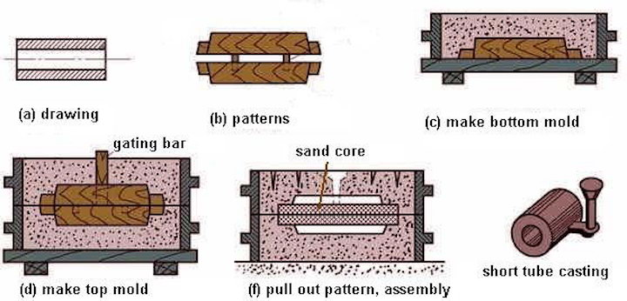

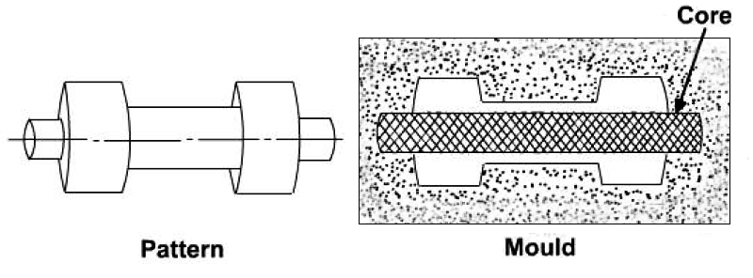

Types of Cores

Cores may be classified as green-sand cores (kum maça) and dry-sand cores (sert kum maça). Figure 1.7 shows various types of cores.
- Green-sand cores, as shown in Figure 1.7A, are those formed by the pattern and made from the same sand as the rest of the mold.
- Dry-sand cores are formed separately and inserted after the pattern is withdrawn but before the mold is closed. The box in which they are formed to the proper shape is called a core box (maça kutusu). In large cores, perforated pipes or wireframes are used.
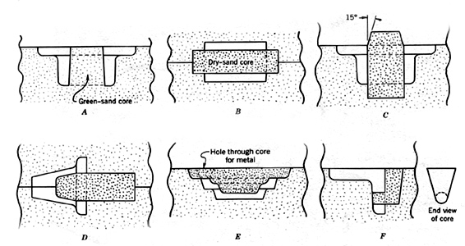
Figure 1.7 Typical cores. A, Solid pattern with a green-sand core. B, Dry-sand core supported on both ends. C, Vertical dry-sand core. D, Balanced dry-sand core. E, Hanging dry-sand core. F, Drop core.

Binders and Core Mixtures: Among the several types of binders used in making cores are oil binders. One of these, linseed oil, is frequently used in the manufacture of small cores. The oil forms a film around the sand grain, which hardens when oxidized by the action of heat. Such cores should be baked for 2 hours at a temperature between 180 °C and 220 °C. A common mixture uses 40 parts of river sand and 1 part linseed oil. In another group of binders, soluble substances such as wheat flour, dextrin, and gelatinized starch are found. The ratio of binder to sand in these mixtures is relatively high, at 1:8 or more. Several thermosetting plastics, including urea and phenol-formaldehyde, are used as core binders. A core must have sufficient strength to support itself. Porosity or permeability is also an important consideration in the making of cores. To ensure a smooth casting, the core must have a smooth surface.

**********kumdokumvideo.wmv************
*************** FORMING/casting (SME/Willey's video)

Chapter 2
CONTEMPORARY CASTING PROCESSES

The process used for making a casting depends on;

- the quantity to be produced,
- the size of the casting,
- the metal to be cast (the melting temperature of casting metal)
- the intricacy (complexity) of the part.

Most commercial metals can be cast in sand molds, and sizes vary from small to large. However, sand molds are used once and are destroyed after metal solidification. Permanent molds offer considerable cost savings for large production quantities when the casting size is not large. Permanent molds must be made of metals capable of withstanding high temperatures. Because of their high cost, they are recommended only when many castings are to be produced. Although permanent molds are impractical for large castings and alloys of high melting temperatures, they can be used advantageously for small and medium-sized castings.

DIE CASTING (Press döküm)

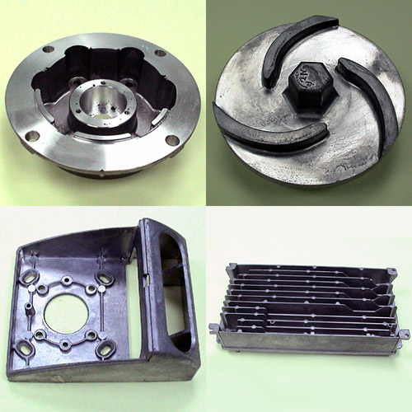

Some die-casting parts

In die casting, molten metal is forced by pressure into a metal mold known as a die under pressure from 100 to 125 atm. Two methods are employed: (1) hot chamber (sıcak hazneli) and (2) cold chamber (soğuk hazneli). The principal distinction between the two methods is determined by the location of the melting pot.

- In the hot-chamber method, a melting pot is included with the machine and the injection cylinder is immersed in the molten metal at all times (Figure 2.1). Low-melting alloys of zinc (Zn), tin (Sn), and lead (Pb) (melting temperature below 450ºC) are the most widely used materials cast in hot-chamber machines.

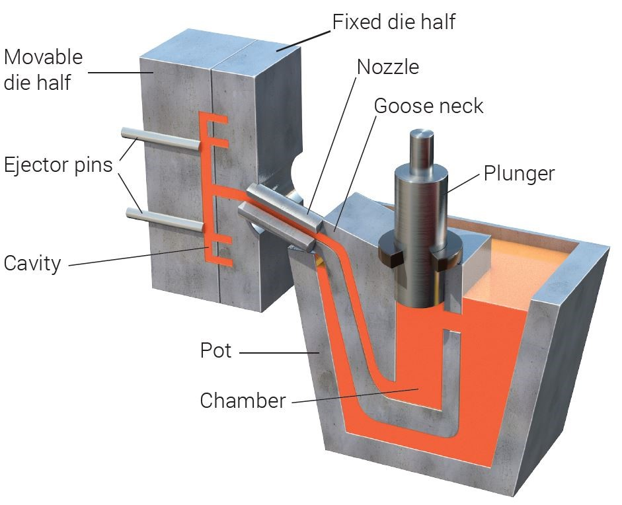
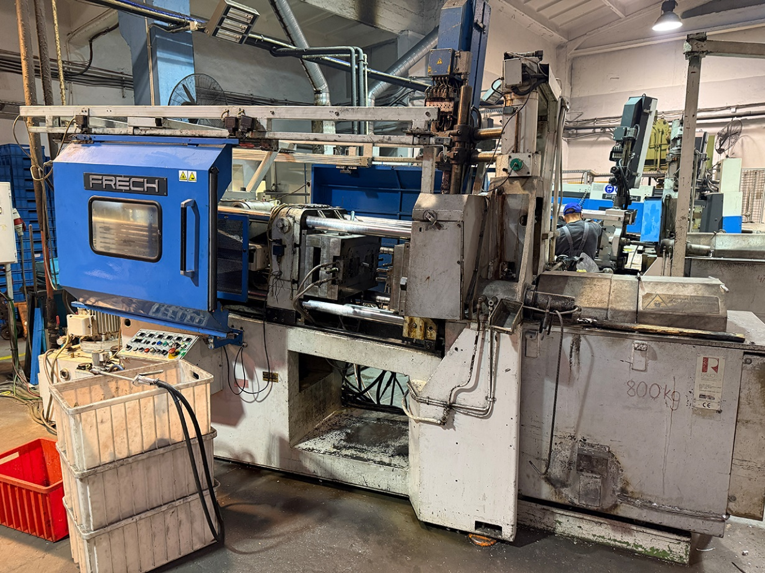

Frech DAW 125 hot chamber die casting machine

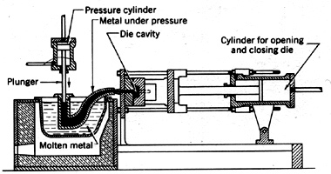
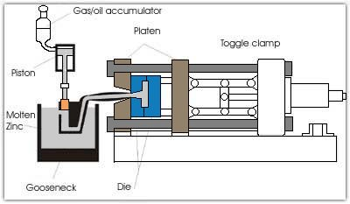

Figure 2.1 Plunger-activated hot-chamber die casting machine.
The operation sequence of hot chamber die casting:

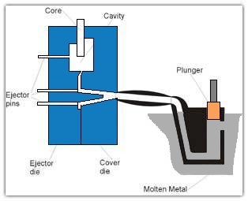
1. The die is closed and the plunger (dalıcı) rises, opening the port and allowing molten metal to fill the cylinder.

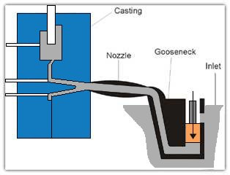
2. The plunger moves down and seals the port pushing the molten metal through the gooseneck (kaz boynu) and nozzle (meme) into the die cavity, where it is held under pressure until it solidifies.

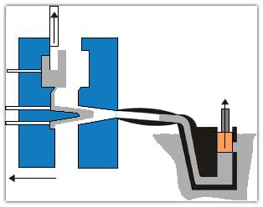
3. The die opens and the cores, if any, retract. The casting remains in only one die, the ejector side. The plunger returns, allowing residual molten metal to flow back through the nozzle and gooseneck.

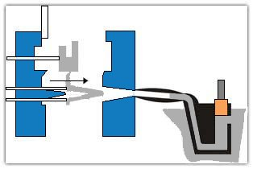
4. Ejector pins push the casting out of the ejector die. As the plunger uncovers the filling hole, molten metal flows through the inlet to refill the gooseneck, as in step (1).

Machines using the cold-chamber method have a separate melting furnace, and metal is introduced into the injection cylinder by hand or mechanical means (Figure 2.2). Die-casting of brass, aluminum (Al), and magnesium (Mg) requires higher pressures and higher melting temperatures (above 450 °C).

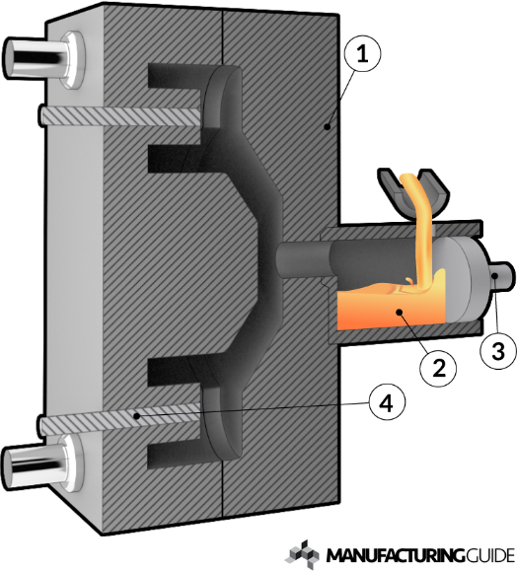

Figure 2.2 Plunger-activated cold-chamber die-casting.(1. Fixed die, 2. Molten metal, 3. Plunger)

Operating Sequence of the Cold-Chamber Die-casting Process:
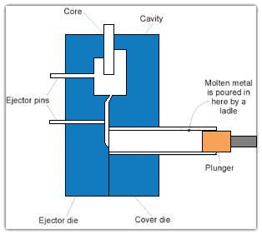
1. Die is closed and molten metal is ladled into the cold-chamber shot sleeve.

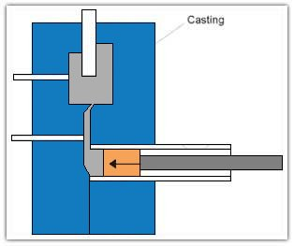
2. The plunger pushes the molten metal into the die cavity, which is held under pressure until solidification.
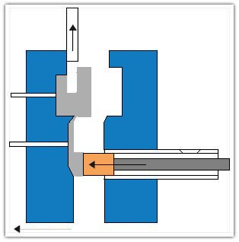
3. The die opens and the plunger advances to ensure that the casting remains in the ejector die. Cores, if any, retract.

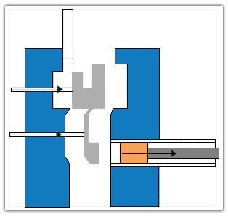
4. Ejector pins push the casting out of the ejector die, and the plunger returns to its original position.

The process is rapid because both the dies and cores are permanent. a) A smooth surface not only improves the appearance but also b) minimizes the work required to prepare the castings for plating or other finishing operations. The optimum production quantity ranges from 1000 to 200,000 pieces. The maximum weight of brass die casting (T_{m} is 910-1080 °C) is about 2 kg, but aluminum die castings (T_{m} is 650-750 °C) of over 45 kg are common. Small to medium-sized castings can be made at a cycle rate of 100 to 800 die fillings/hour. The size is so accurately controlled that little or no machining is necessary. The scrap loss is low because the sprue, runners, and gates can be remelted.

Dies
-The life of these molds depends on the metal cast (actually, its melting temperature) and may range from 10,000 fillings if brass castings are made to several million if zinc (T_{m} is 460 °C) is used.

-For large or complex castings, a single-cavity mold is used. If the quantity of castings to be produced is large and relatively small, a multiple-cavity die can be used.

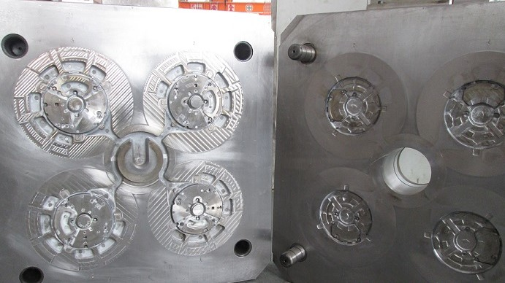
Multiple cavity die
-------------------------------------------------------------------------
CENTRIFUGAL CASTING (Savurma döküm)

Centrifugal casting is the process of rotating a mold while the metal solidifies to utilize "centrifugal force" to position the metal in the mold (Figure 2.3). Greater detail on the casting surface is obtained, and the dense metal structure exhibits superior physical properties. Castings of symmetrical shape lend themselves particularly to this method, although many other types of castings can be produced.

Centrifugal casting is often more economical than other methods. Cores in cylindrical shapes and risers or feed heads are both eliminated. There is no sprue, runner/gate connected to the part.

If a metal can be melted, it can be cast centrifugally; however, in a few alloys, the heavier elements tend to separate from the base metal. This separation is known as gravity segregation. The metal is forced against the mold walls by the centrifugal force of approximately. 70 g, which is a force 70 times that of the force of gravity in sand casting. Forces as high as 150 g have been used.

They are generally used for producing ductile iron pipe and soil pipe. These machines use metal molds cooled by a water jacket. A competitive production rate is obtainable. Although there are limitations on the size and shape of centrifugally cast parts, piston rings weighing 50-100 grams, and paper mill rolls weighing over 42 tons have been cast in this manner. Aluminum engine blocks utilize centrifugally cast iron liners.
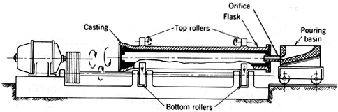

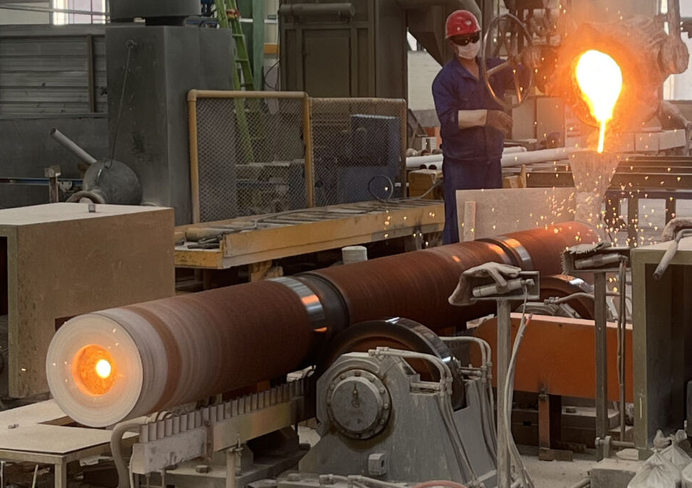

Figure 2.3 Centrifugal casting machine for casting steel or cast-iron pipe.

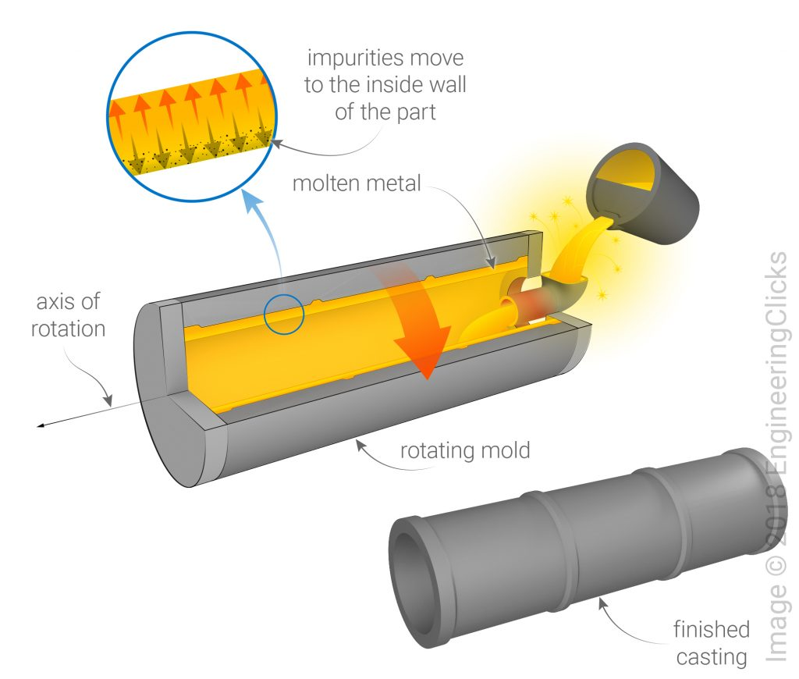

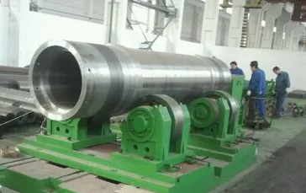
Steel Pipes

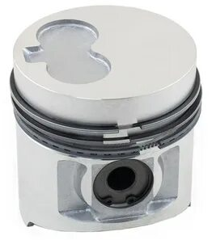
Piston Rings

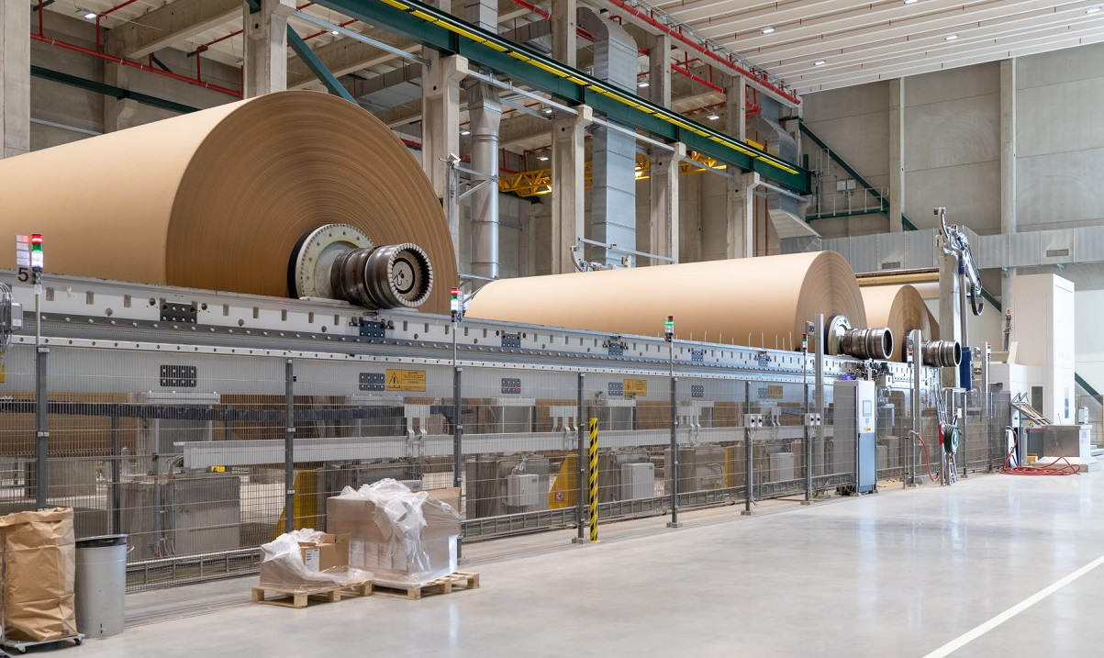

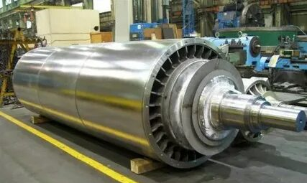
Paper roll mills

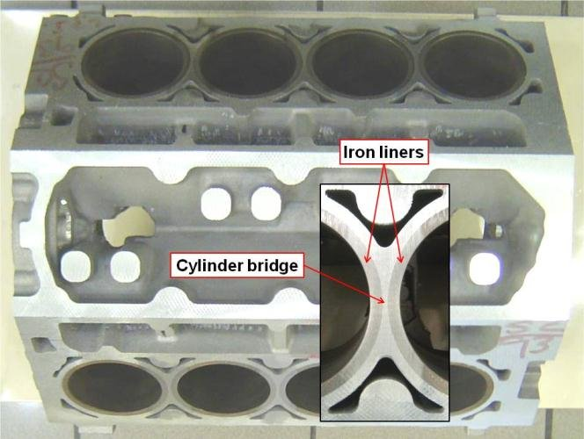

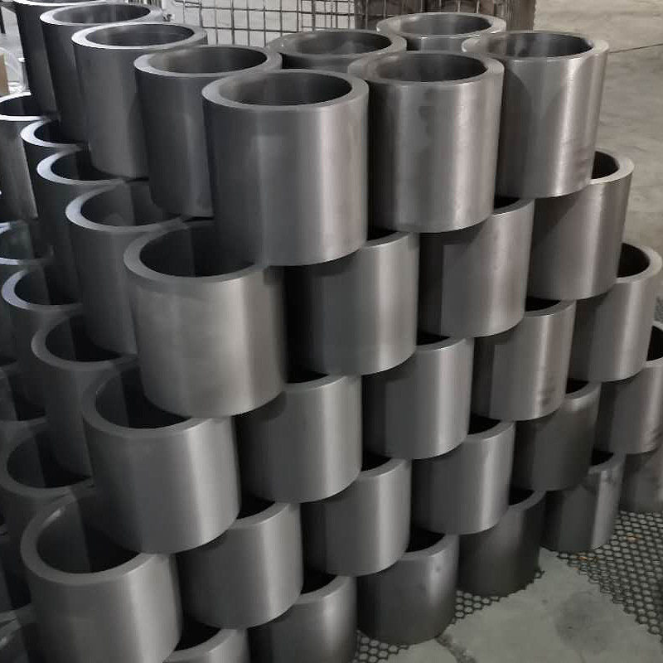
Cast iron liners of the Al engine blocks

Centrifugal cast parts

PRECISION OR INVESTMENT CASTING

Precision or investment casting (hassas döküm) employs techniques that enable very smooth, highly accurate castings from both ferrous and nonferrous alloys. No casting method other than die casting can produce intricate parts. The process is useful in casting unmachinable alloys and radioactive metals. Several processes are employed, but all incorporate sand, ceramic, plaster (alçı), or plastic shell made from an accurate pattern into which metal is poured.

Advantages of precision or investment casting:
1. Intricate forms at lower costs can be cast.
2. A very smooth surface is obtained with no parting line.
3. Dimensional accuracy is good.
4. Certain unmachinable parts can be cast into a preplanned shape.
5. It may replace die casting where short runs are involved.
Disadvantages:
The investment process is expensive and is usually limited to small castings.
Shell mold casting (Lost Wax Process): The lost wax process derives its name from the fact that the wax pattern used in the process is subsequently melted from the mold, leaving a cavity having all the details of the original pattern.

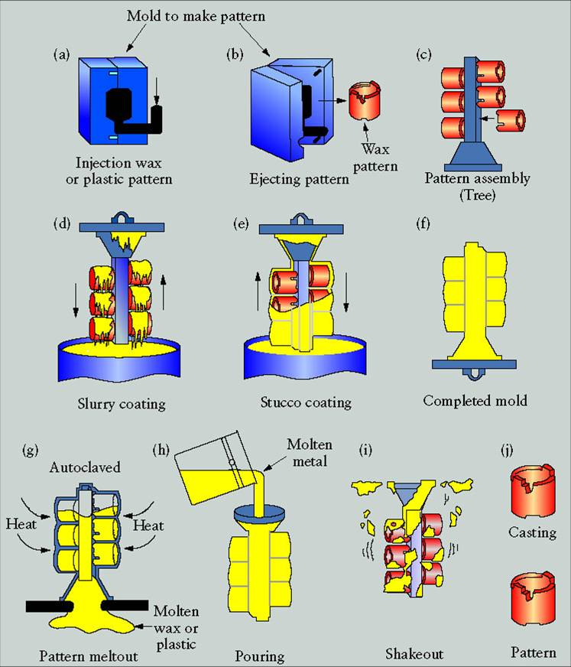

(a, b) WAX INJECTION: Wax replicas of the desired castings are produced by injection molding. These replicas are called patterns.
(c) ASSEMBLY: The patterns are attached to a central wax stick, called a sprue, to form a casting cluster or assembly.
(d, e, f) SHELL BUILDING: The shell is built by immersing the assembly in a liquid ceramic slurry (bulamaç) and then into a bed of extremely fine sand. Up to eight layers may be applied in this manner.
(g) DEWAX: Once the ceramic is dry, the wax is melted, creating a negative impression of the assembly within the shell.
(h) CONVENTIONAL CASTING: In the conventional process, the shell is filled with molten metal by gravity pouring. As the metal cools, the parts, gates, sprue, and pouring cup become one solid casting.
(i) KNOCKOUT: When the metal has cooled and solidified, the ceramic shell is broken off by vibration or water blasting.
CUT OFF: The parts are cut away from the central sprue using a high-speed friction saw.
(j) FINISHED CASTINGS: After minor finishing operations, the metal castings (identical to the original wax patterns) are ready for shipment to the customer.

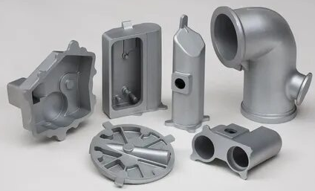

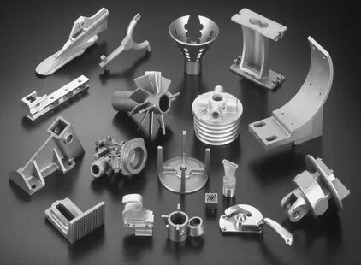
Some investment cast parts.

Present practice requires that;
- A replica of the part to be cast is made from steel or brass.
- A bismuth or lead alloy split mold (shell) is made from this replica.
- After the wax is poured into the mold and solidifies, the mold is opened, and the wax pattern is removed.
- Several patterns are usually assembled with necessary gates and risers by heating the contact surfaces (wax welding) with a hot wire. This cluster (salkım) is then molded by silica sand, plaster (alçı) or ceramic slurries (bulamaç).
- Once the mold has hardened, it is placed upside down and heated in an oven for several hours to melt out the wax and dry the mold.
- The casting can be produced by gravity, vacuum, pressure, or centrifugal casting.
- When the mold has cooled, the plaster is broken away. After gates and feeders are cut off, the castings are cleaned by grinding, sandblasting, or other finishing operations.

*************** FORMING/Casting-investment casting (S.M.E./Wiley’s video)*********
-------------------------------------------------------------------------------
CONTINUOUS CASTING

The process consists of continuously pouring molten metal into a mold that rapidly chills the metal to the point of solidification, then withdrawing it from the mold. Cross-sections can be RECTANGULAR for later rolling into a plate or sheet, SQUARE for long products, CIRCULAR for wire and seamless pipes, "DOG-BONE" shapes for "I" or "H" beams, and even thin strips, rods, and other products.

Brass Mold Continuous Process (for carbon steels and alloy steels) (Figure 6.20a)
A continuous-casting process for carbon and alloy steels uses brass or copper molds, with a thickness that permits a heat flow rate sufficient to prevent the mold from being damaged by the metal being cast. The brass or copper mold has high heat conductivity and is not easily wetted by molten steel. The mold cross sections provide a bloom size of up to 600 x 400 mm, a slab size of 200 x 50 mm, and 500 mm-diameter stocks. Metal is supplied to the mold by a nozzle located in a tundish or pouring box. The tundish (pota), in turn, is supplied from a conventional ladle.

Rapid mold cooling is essential to the success of this process and results in improved mold life, reduced segregation, a finer grain structure, and better surface finish. Below the molding are the withdrawal, speed-controlling rolls through which the casting passes to the cutting area. Typically, the solidified metal descends at 25 mm/s. The castings are cut to length by an oxyacetylene torch. The castings are rolled, forged, or extruded into blooms, billets, or slabs.

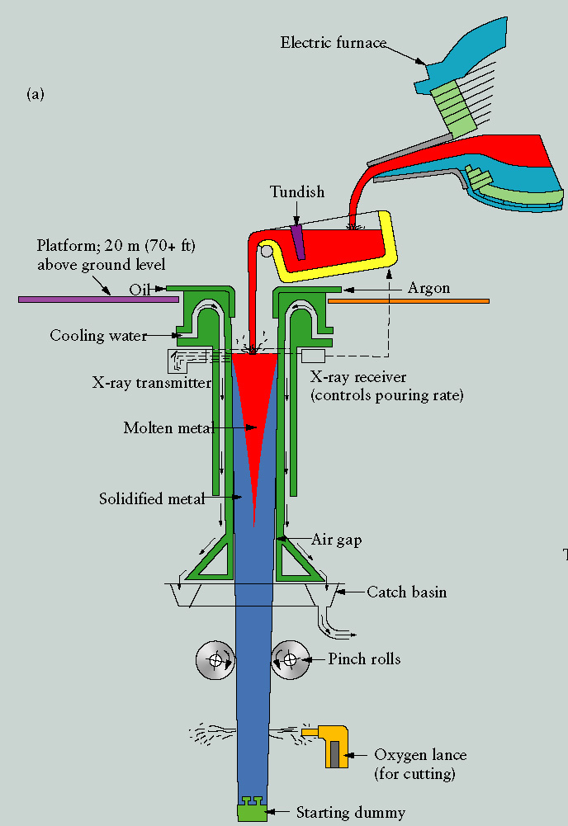
(a)
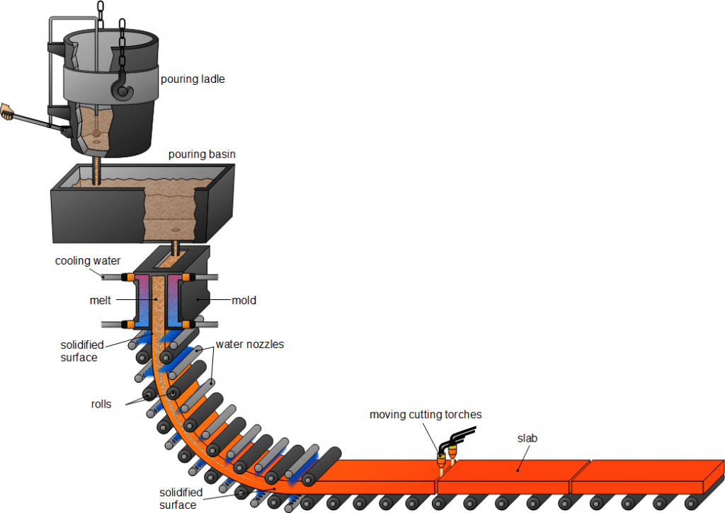
(b)
Figure 6.20 Process for continuous-cast shapes. (a) The continuous-casting process for steel. (b) Continuous slab casting.

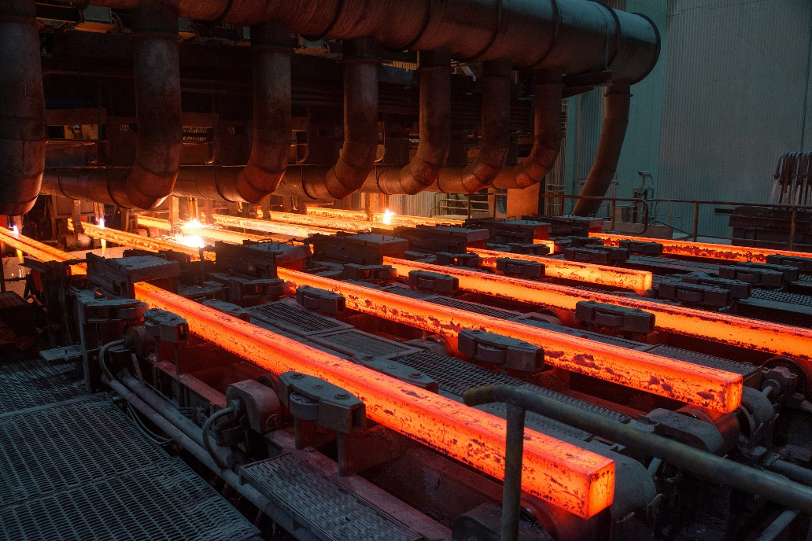
Square forms

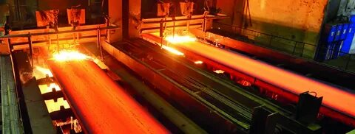
Rectangular forms

To start the process, a rod of the same shape as the one to be cast (called a "starting dummy" (Fig. 6.20a)) is placed between the drawing rolls and inserted into the die. As the molten metal enters the die, it melts the rod's end surface, forming a perfect joint. The drawing rolls then start the casting cycle, and the molten metal is continuously solidified as it is chilled and withdrawn from the die. When the casting leaves the furnace, it ultimately reaches the sawing floor, which is cut to the desired length while still in motion.

Metals processed by casting (%weight)

Chapter 3
HOT AND COLD WORKING OF METALS

HOT WORKING

Hot working is the plastic deformation of metals above their recrystallization temperature. It is important to note that the recrystallization temperature varies with different materials, and hot working does not necessarily imply a high absolute temperature. The recrystallization temperature can be formulated empirically as;

Recrystallization temperatures = 0.3T_{m} – 0.5T_{m}
Here, T_{m} is the melting temperature of the material in Kelvin [K].

Some recrystallization temperatures of common metals are listed here:

Recrystallization
Metal Temperature

Aluminum 150 (T_{m}=660 °C)
Copper 200 (T_{m}=1084 °C)
Iron 450 (T_{m}=1580 °C)
Lead Below room temperature (T_{m}=328 °C)
Magnesium 150 (T_{m}=650 °C)
Nickel 590 (T_{m}=1453 °C)
Zinc At room temperature (T_{m}=420 °C)
Steel Starts around 500° to 700°C (although most hot work on steel is at temperatures considerably above this range (i.e., 1100°C)). (for carbon steels T_{m}=1370-1550 °C)

In hot working, the advantages are
  - Less energy is required to change the shape of steel in the plastic state than to do so in the cold state.
  - It increases the ability of metals to flow without cracking.

Disadvantages;
- Due to the metal's high temperature, rapid oxidation or scaling (kabuk, tufal) occurs, resulting in a poor surface finish.
- As a result of scaling, close tolerances cannot be maintained.

ROLLING (haddeleme)

Rolling of steel: Steel that is not remelted and cast into molds is converted to useful products in two steps:

1. The ingot (ingot) is rolled into intermediate shapes: blooms (blum, kütük), billets (billet, çubuk), and slabs (yassı kütük).

2. These blooms, billets, and slabs are further rolled into plates, sheets, bar stock, structural shapes, or foils.

The ingot remains in the molds until solidification is complete, and the molds are then removed. While it is still hot, the ingots are placed in gas-fired furnaces called soaking pits, where they remain until they attain a working temperature of about 1200°C. The ingots are taken to the rolling mill, where they are first rolled into intermediate shapes as blooms, billets, or slabs because of the large variety of finished shapes.
-A bloom has a square cross-section with a minimum size of 150 by 150 mm. About 30 passes are required to reduce a large ingot into a bloom.
-A billet is smaller than a bloom and may have any square section from 40 mm up to the bloom size.
-Slabs may be rolled from either an ingot or a bloom. They have a rectangular cross-sectional area with a minimum width of 250 mm and a minimum thickness of 40 mm. The width is three or more times the thickness, up to 380 mm. Plates (generally 5 mm or thicker and 1.0 or 1.25 m in width and 2.5 m in length), sheets (less than 4 mm thick), and thin strips are rolled from slabs.
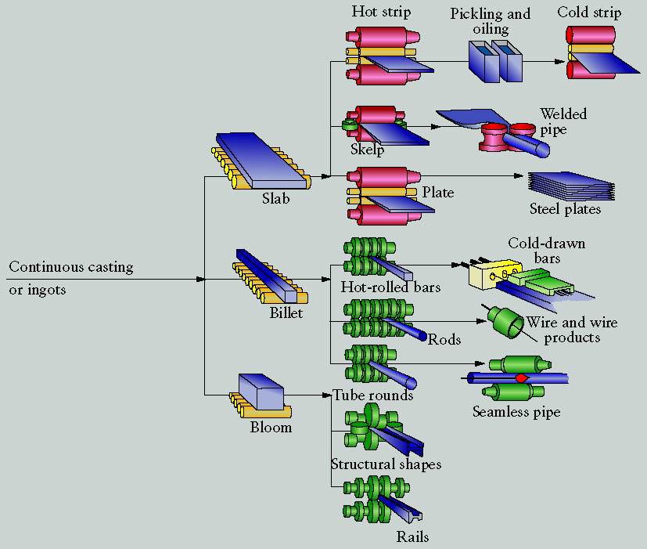

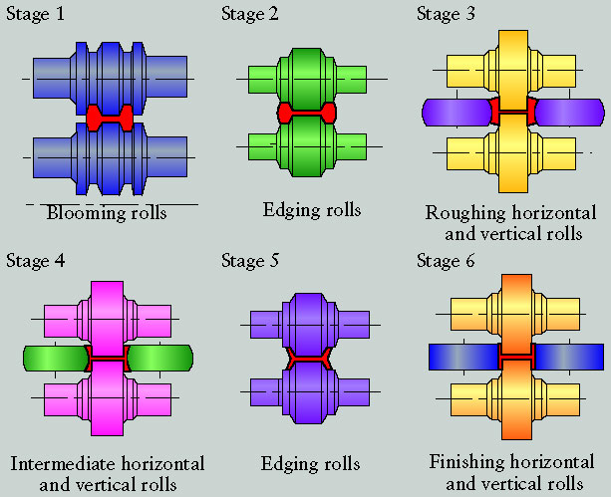
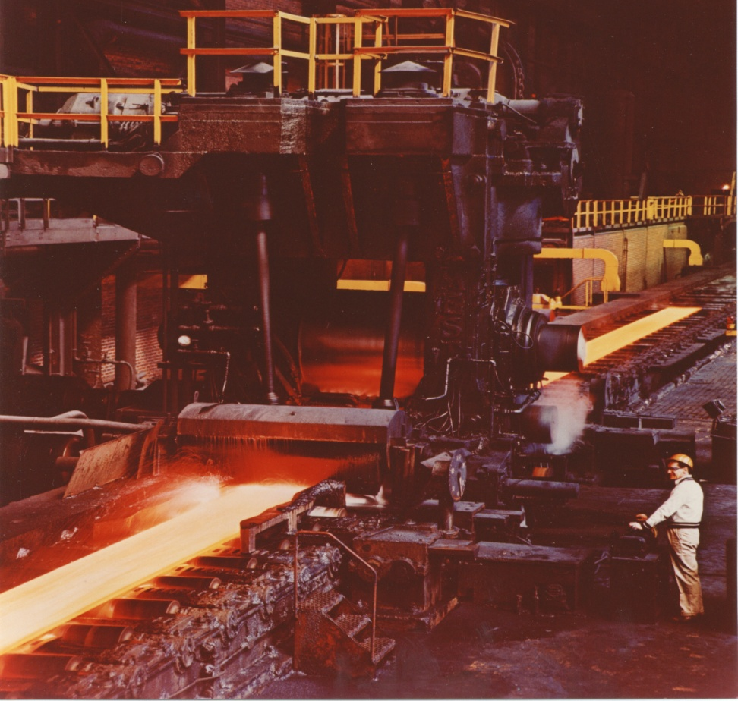
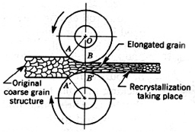

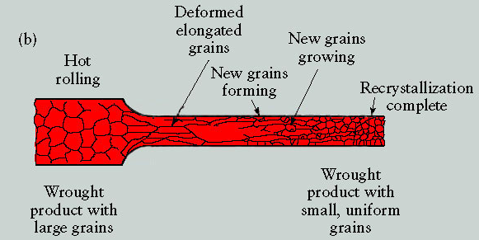

Figure 4.1 Effect of hot rolling on grain structure.

One effect of a hot-working rolling operation is the grain refinement brought about by recrystallization (Figure 4.1). The coarse structure is broken up and elongated by the rolling action. Due to the high temperature, recrystallization begins immediately, and small grains begin to form. These grains grow rapidly until recrystallization is complete.

In materials science, recrystallization is a process by which deformed grains are replaced by a new set of defect-free grains that nucleate and grow until the original grains have been entirely consumed. Recrystallization is usually accompanied by a reduction in the strength and hardness of a material and a simultaneous increase in the ductility. Imperfections of the material (gas pores can be closed, composition differences can be reduced) are greatly eliminated.

In the rolling process, stock enters the rolls with a speed less than the peripheral roll speed. The metal emerges from the rolls traveling at a higher speed than it enters. The reduction ratio (indirgeme/haddeleme oranı) of rolling can be defined as;

Reduction ratio = [(T-t)/T].100

Here, T is the initial and t is the final thickness of the material.
The quantity of metal entering and leaving a roll is the same, but the area and velocity change. Thus,

Q₁= Q₂ = A₁V₁ = A₂V₂

where
Q₁ = quantity of metal going into the roll
Q₂ = quantity of metal leaving the roll
A₁ = area of an element in front of the roll
A₂ = area of an element after roll
V₁ = velocity in the element before the roll
V₂ = velocity in element after roll

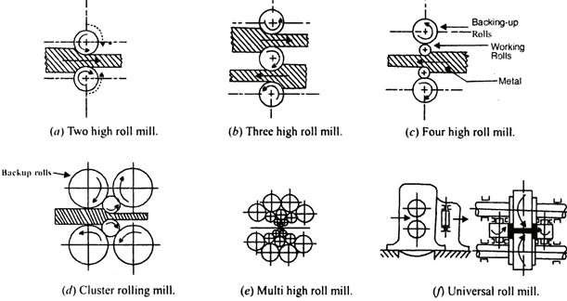

Figure 4.2 Roll arrangements used in rolling mills. (a) Two-high mill, continuous reversing, (b) Three-high mill for back-and-forth rolling. (c) Four-high mill with backing-up rolls for wide sheets. (d) Cluster mill (grup hadde) using four backing-up rolls.

Most primary rolling is done in either a two-high reversing mill or a three-high continuous rolling mill. In the two-high reversing mill (Figure 4.2a), the piece passes through the rolls, which are then stopped and reversed, and the operation is repeated. At frequent intervals, the metal is turned 90° on its side to keep the section uniform and to refine the metal throughout.

***************VİDEO*************
SSAB_TheHotRollingStripMill_in_Borlange.wmv
rollingmill.mpeg
---------------------------------------------------------------------------------
FORGING (Dövme)

Hammer or Smith Forging
It involves hammering the heated metal with hand tools or flat dies in a steam hammer. Hand forging is the oldest form of forging. The nature of the process means accuracy is not achieved, nor can complicated shapes be produced.

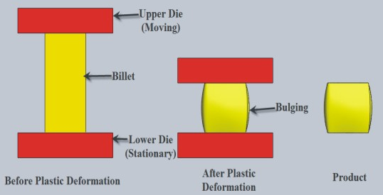
Hammer forging (open-die forging)

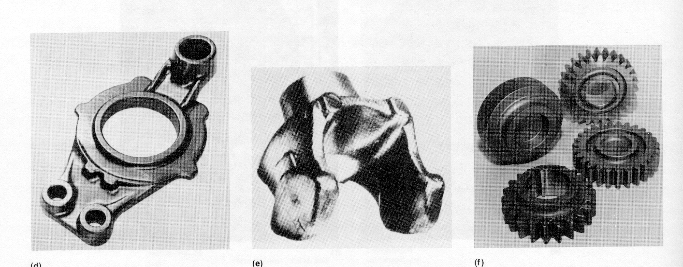

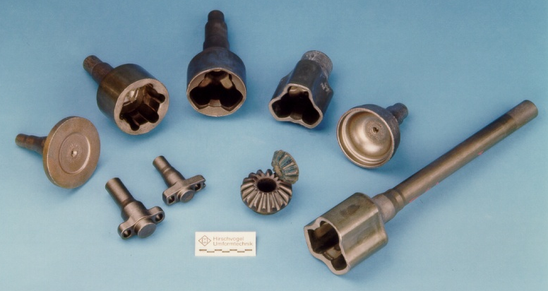
Warm forged parts

Forged railroad engine connecting part

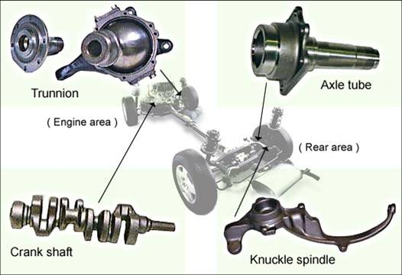
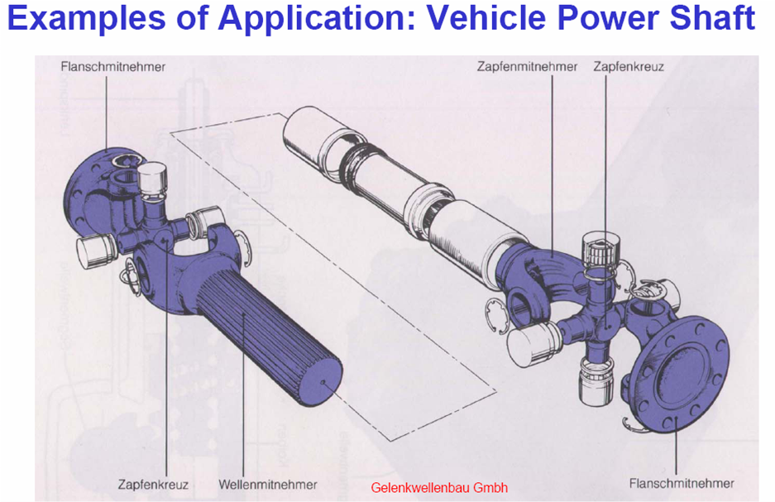
Some drop forged automobile parts

Drop Forging (energy-restricted machines) (Şahmerdanda dövme, serbest dövme)
Drop forging differs from hammer forging in that closed-impression (closed die) rather than open-face or flat dies (open dies) are used. The dies are matched and separately attached to the movable ram and the fixed anvil (Figure 4.3). Forging is produced by impact or pressure, which compels the hot, pliable metal to conform to the shape of the dies, as shown in Figure 4.4.

The two principal types of drop-forging hammers are the steam hammer (buharlı şahmerdanı) and the gravity drop (düşmeli şahmerdan) or board hammer. In the steam hammer, the ram and hammer are lifted by steam, and the force of the blow is controlled by throttling the steam (Figure 4.3). These hammers operate at over 300 blows/min. The capacity of steam hammers ranges from 2-200 kN (i.e., up to 20 t force). In the gravity-type hammer, the impact pressure is developed by the force of the falling ram as it strikes the lower fixed die. It utilizes air or steam to lift the ram.

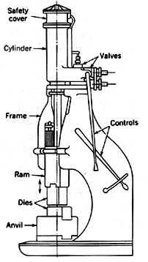
Figure 4.3 Open-frame steam hammer.

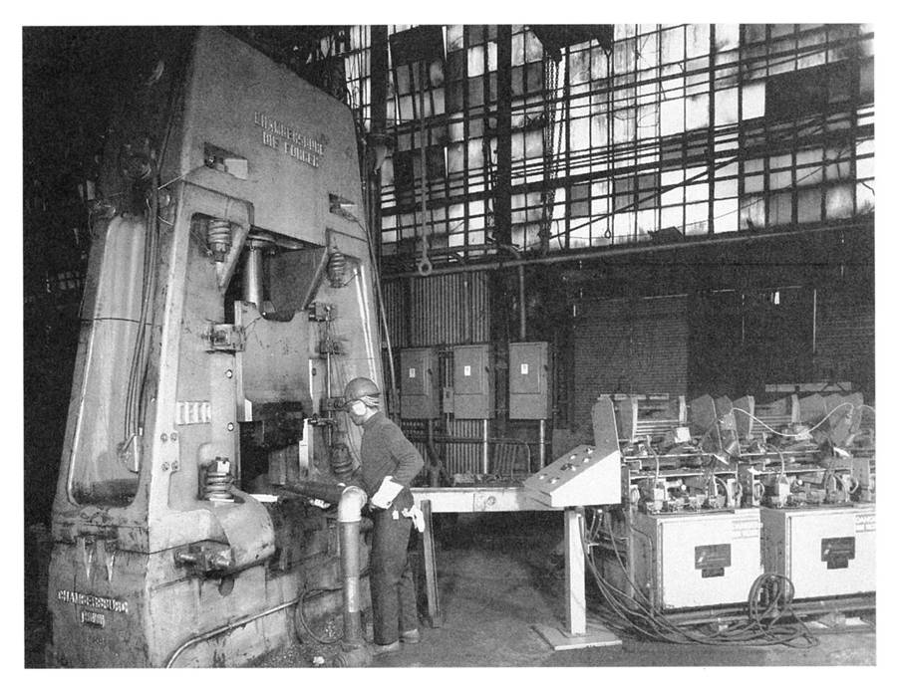
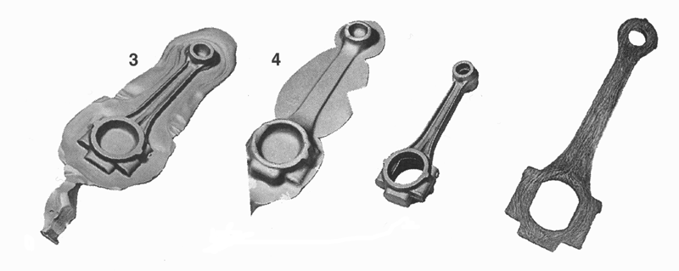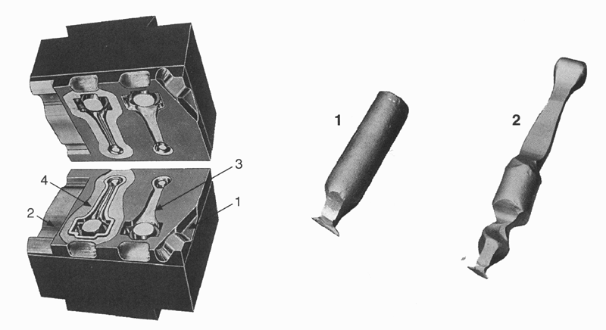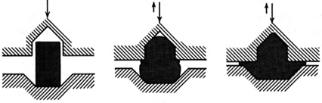

Figure 4.4 Drop forging with closed impression die (or "closed die).

Upon completion, all forgings are covered with scale (kabuk, tufal) and must be cleaned. This can be done by pickling in acid (asitle temizleme), shot peening (bilyalı dövme), or tumbling (değirmen), depending on the size and composition of the forgings.

Advantages of the forging operation include

-a fine crystalline structure of the metal (lower strength and hardness, higher ductility),
-closing of any voids,
-reduced machining time,
-improved physical properties

Disadvantages include

-scale inclusions,
-high cost of dies, which prohibits short-run jobs.

Closed impression die forgings have better material utilization than open (flat) dies, better physical properties, closer tolerances, higher production rates, and less operator skill requirement. Forging is adaptable to carbon and alloy steels, wrought iron, copper, aluminum, and magnesium alloys.

The number of blows required varies according to the size and shape of the part, the forging qualities of the metal, and the tolerances required.

The forging temperature for steel is 1100°-1250°C.

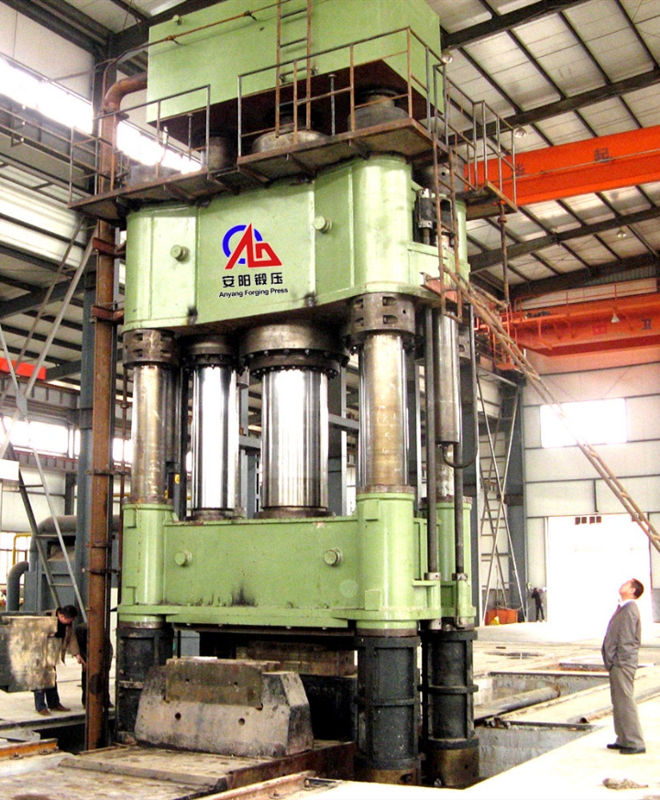
      - (b)
Pres forging machines. a) a huge one, b) 5000 t force capacity

Press Forging (stroke-restricted machines) (presle dövme)

Press forging employs a slow squeezing action in deforming the plastic metal, in contrast to the rapid impact blows of a hammer. These presses are vertical type and may be either mechanically or hydraulically operated. The mechanical presses, which operate faster, can exert 500 to 10,000 t force.

For small press forgings, closed-impression dies are used, and only one ram stroke is normally required to perform the forging operation.

In the forging press, a greater proportion of the total energy input is transmitted to the metal than in a drop hammer press. The machine and foundation absorb much of the impact of the drop hammer.

Most press forgings are symmetrical in shape with smooth surfaces, providing a closer tolerance than a drop hammer. However, drop forging can forge many parts of irregular and complicated shapes more economically. Forging presses are often used for sizing operations on parts made by other processes.

*************** FORMING/forging (S.M.E./Wiley’s video)*********

Upset Forging (yığma, şişirme)

Upset forging entails gripping a bar of uniform section between dies and applying pressure to the heated end, causing it to be upset or formed into shape (Figure 4.5).

The length of the stock to be upset cannot be more than two or three times the diameter, or else the material will bend rather than bulge out to fill the die cavity.

Machines of this type are an outgrowth of smaller machines designed for cold-heading nails and small bolts.

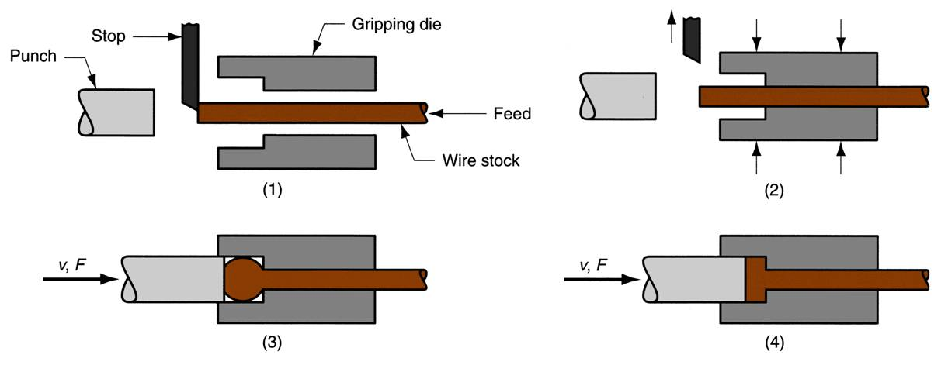

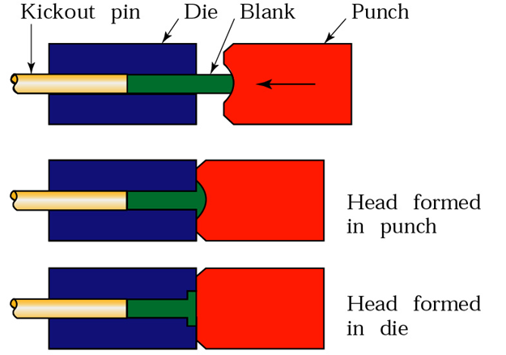
0
Figure 4.5 Upset forging.

EXTRUSION (ekstrüzyon)

Metals that can be hot-worked can be extruded into uniform cross-sectional shapes with pressure. Some metals, notably lead, tin, and aluminum, may be extruded cold, whereas others require the application of heat to render them plastic or semisolid before extrusion. In brief, they consist of forcing metal through specially formed dies (kalıp, matris). Rods, tubes, molding trim, structural shapes, brass cartridges (fişek), and lead-covered cables are typical products of metal extrusion.

Almost unlimited lengths of a continuous cross-section can be produced, and because of low die costs, production runs of 150 m may justify its use.

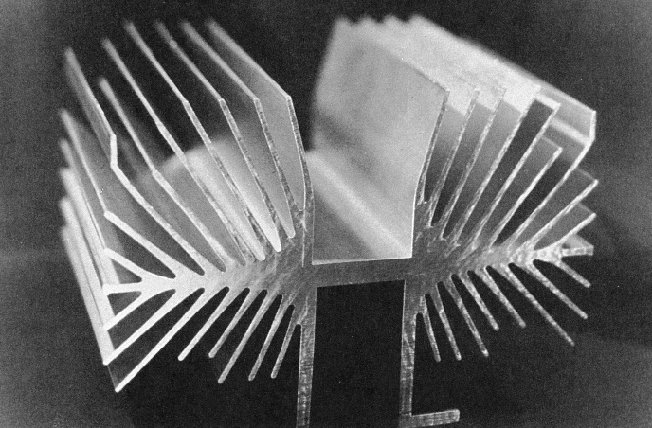

A complex extruded cross-section for a heat sink

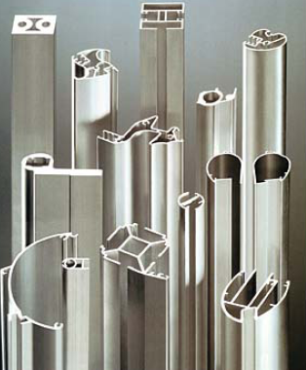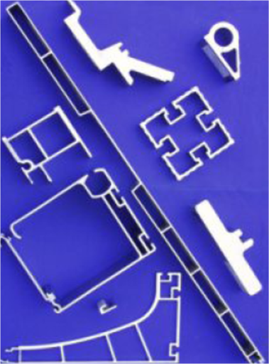

Direct extrusion (direk ekstrüzyon): Direct extrusion is illustrated diagrammatically in Figure 4.6.a. A heated round billet is placed into the die chamber and the ram. The metal is extruded through the die opening until only a small amount remains.

Indirect extrusion (indirek ekstrüzyon): Indirect extrusion (Figure 4.6.b) is similar to direct extrusion except that the extruded part is forced through the ram stem. Less force is required by this method because there is no frictional force between the billet and the container wall. The weakening and complexity of the ram when it is made hollow and the difficulty of providing good support for the extruded part, constitute the limitations of this process.
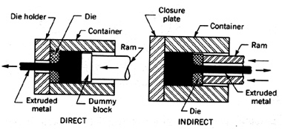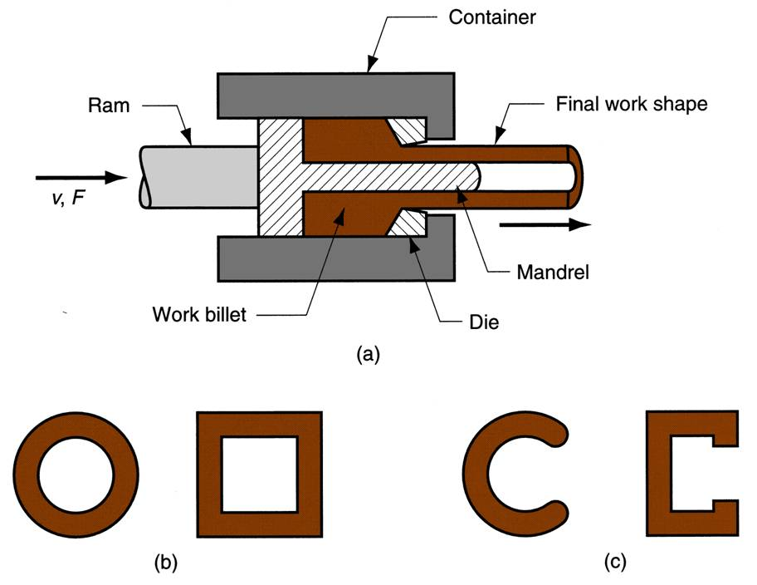
Figure 4.6a Diagram illustrating direct extrusion

Direct extruded gear part

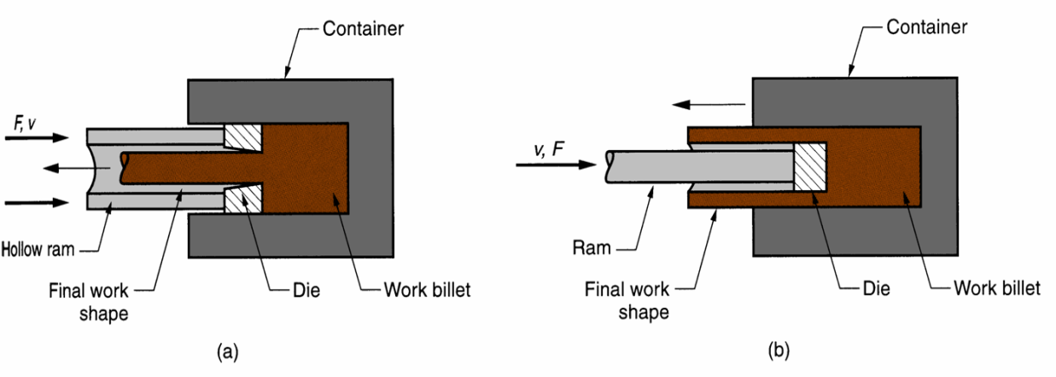
Figure 4.6b Diagram illustrating indirect extrusion

----(video)---
-------------------------------------------------------------
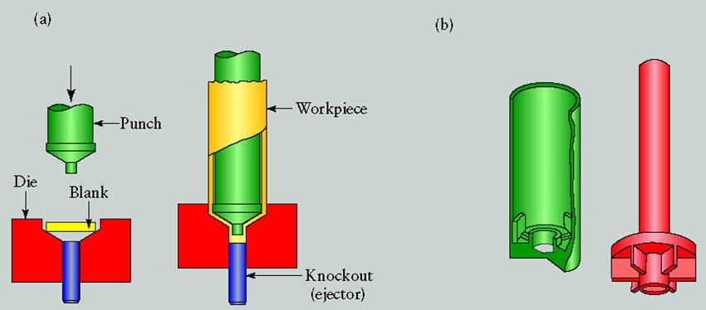

Figure 4.7 Production of a toothpaste tube by impact extrusion

Impact Extrusion (sıvama ekstrüzyon): In impact extrusion, a punch is directed to a slug (or blank) (taslak) with such a force that the metal from the slug is pushed up and around it (Figure 4.7). Most impact extrusion operations, such as collapsible tubes (shaving cream, toothpaste, paint pigment tubes), are cold-working.
COLD WORKING

ADVANTAGES AND LIMITATIONS

Advantages
-Surface oxidation does not result,
-the surface finish is improved (smooth surface),
-strength and hardness of the metal are increased with a corresponding loss in ductility,
-close dimensional tolerance can be maintained.

Disadvantages
-Higher pressure and heavier equipment are needed for cold-working than for hot-working operations,
-brittleness results if the metal is overworked, and an annealing operation becomes necessary.

WIRE DRAWING (tel çekme)

A wire is made by cold-drawing hot-rolled wire or rod through one or more dies to decrease its size and increase its physical properties (higher hardness and better surface quality) (Figure 4.7).
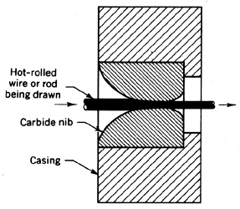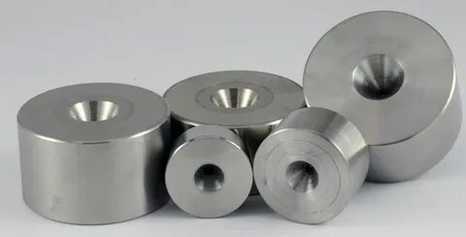

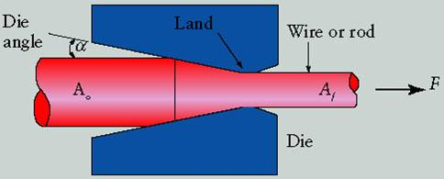
Figure 4.7 Section through a die used for drawing wires (casing-yuva)

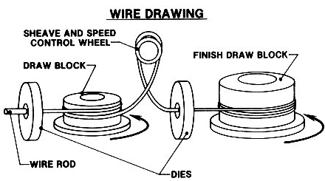
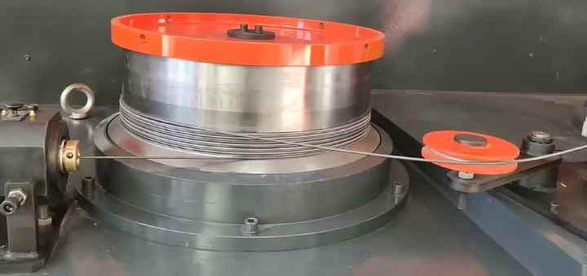
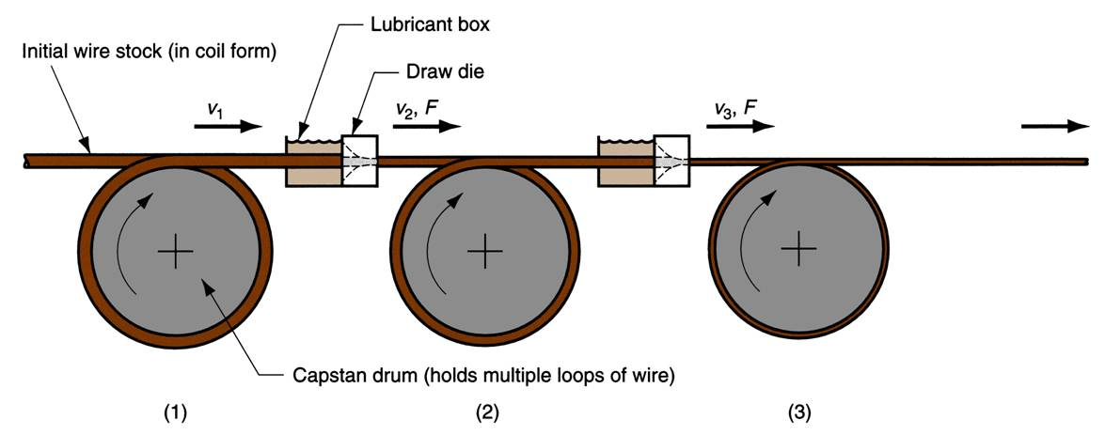
Figure 4.8 Wire Drawing machine and a drawing reel

The end is grasped by tongs (maşa, çene) on a drawbench and pulled through to such length as may be wound around a drawing block or reel. The number of dies in the series will depend on the kind and final diameter of the metal or alloy being processed and may vary from 4 to 12 successive drafts (Figure 4.8).

The dies are usually made of tungsten carbide, although diamond dies can be used to draw small diameters.

----(video)---

Chapter 4
SHEET METAL WORKING
(Saç metal şekillendirme veya presle şekillendirme)

INTRODUCTION

Sheet metal working is generally performed in a press and is commonly termed as presswork (presle şekillendirme). It involves operations such as shearing (kesme), piercing-blanking (delme-boşaltma) (figure 5.1), bending (bükme), drawing (çekme), etc.
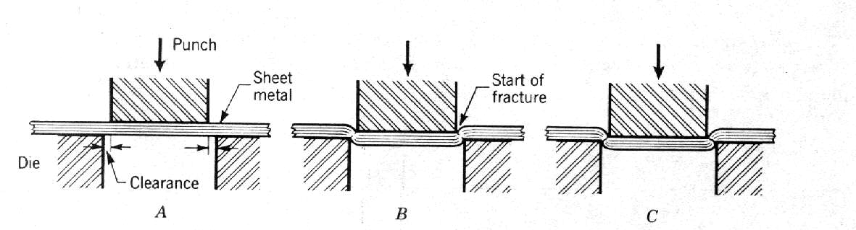
(The operation is called piercing (or punching) if the blank/slug (taslak) is "scrap")

Figure 5.1 Piercing and blanking process

PIERCING AND BLANKING (Delme ve Boşaltma)

A commonly used piercing-blanking die set is shown in Figure 5.2. The cutting of metal between die components is a shearing (kesme) process in which the metal is stressed in shear between two cutting edges to the point of fracture (kopma), or beyond its ultimate strength. The pressure applied by the punch on the metal tends to deform it into the die opening. When the elastic limit is exceeded by further loading, a portion of the metal will be forced into the die opening in the form of an embossed pad on the lower face of the material and a corresponding depression on the upper face (Figure 5.3). As the load increases, the punch will penetrate the metal to a certain depth. This penetration occurs before fracturing starts and reduces the cross-sectional area of the metal through which the cut is being made.
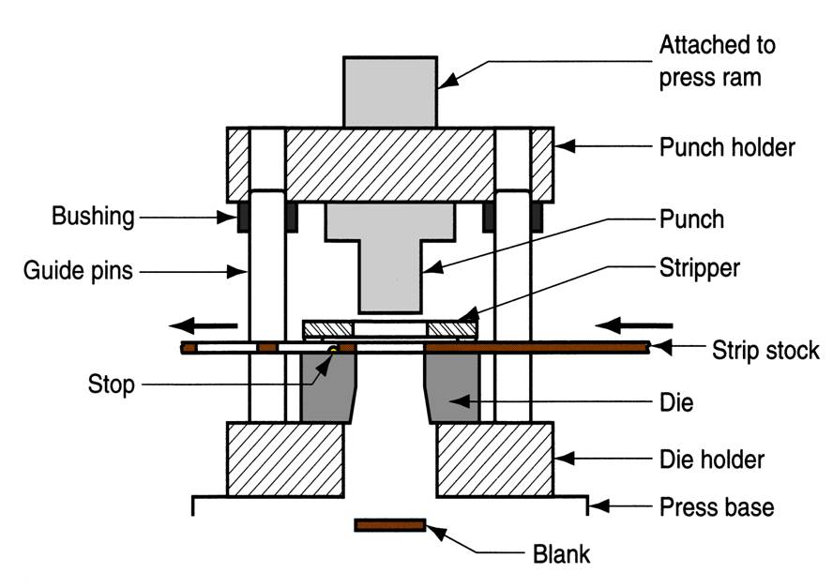
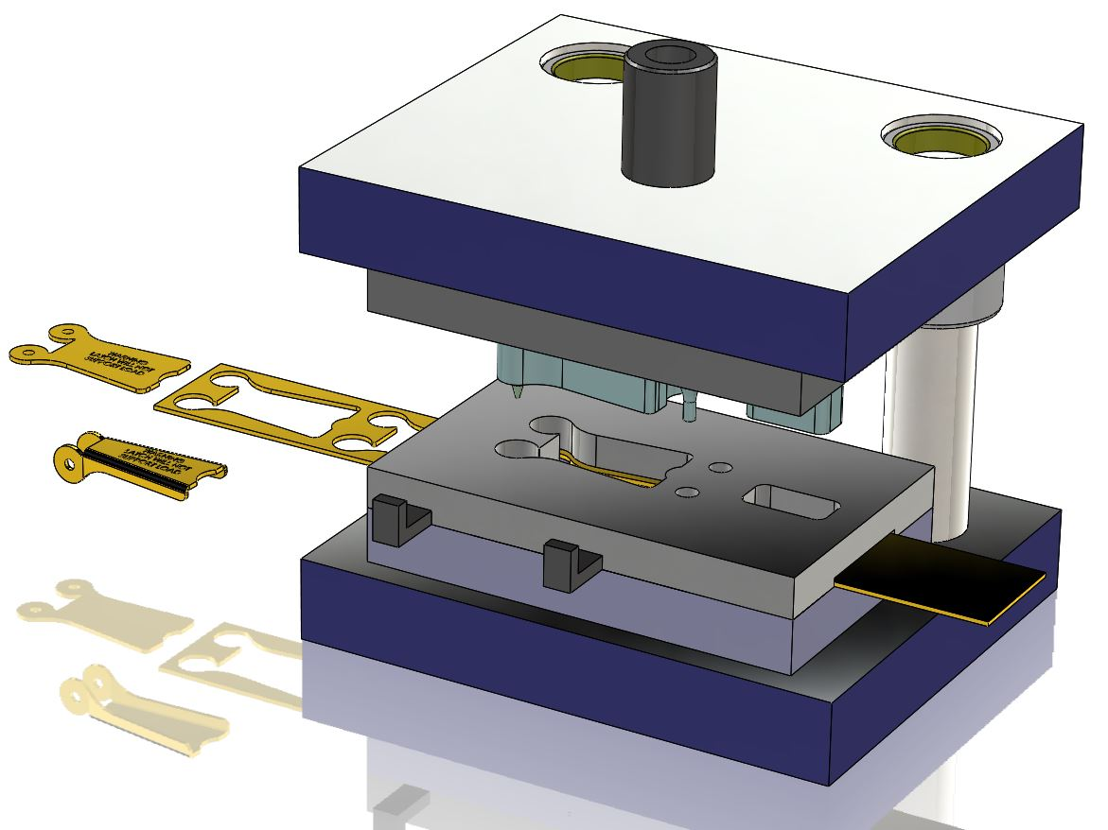
Figure 5.2 Common components of a simple piercing-blanking die.

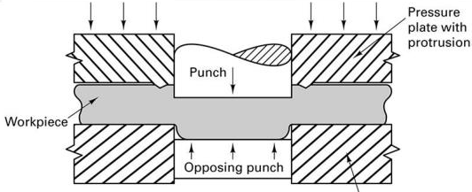
Figure 5.3 Embossing of the sheet metal

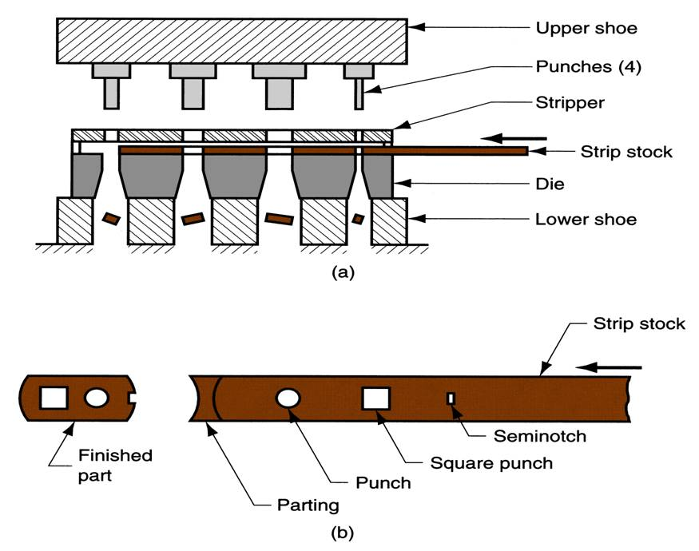

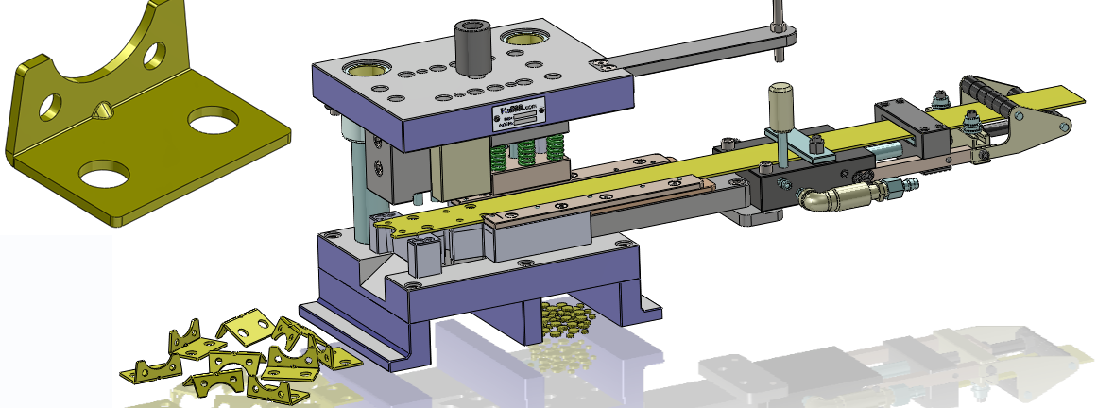

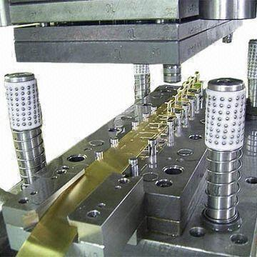

Progressive die set and strip development

CLEARANCES (Boşluklar)

Clearance is the space between the mating members of a die set. Proper clearance is necessary for an optimal cut-edge finish and depends on the working material's type, thickness, and hardness. In an ideal cutting operation, the punch penetrates the material to a depth equal to about 1/3 of its thickness before a fracture occurs (Figure 5.4d) and forces an equal portion of the material into the die opening. Common die clearance ("c" in Figure 5.4a) is 2-5% of the material thickness.

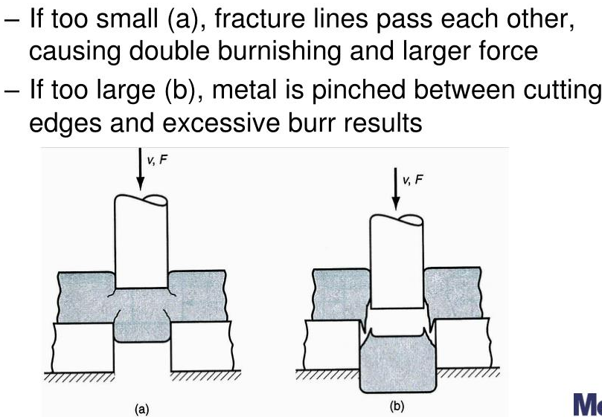

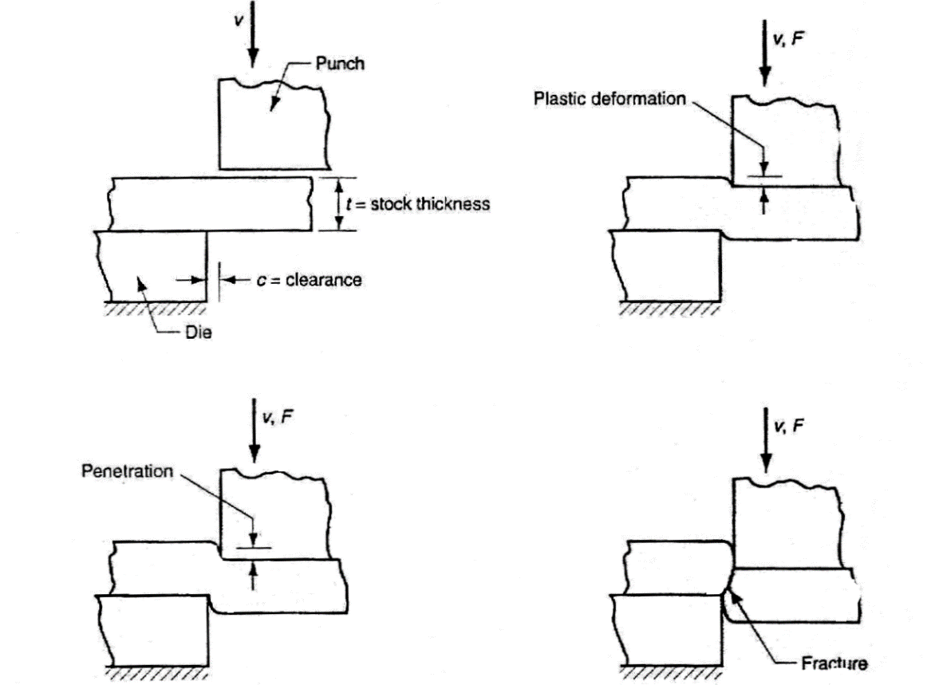
Figure 5.4 Punch and die clearance

Angular clearance is a gradient applied to the hole in the die (Figure 5.5) to ensure that cut material can be easily removed. Angular clearance is usually ground from 1/4º to 1 1/2º per side.

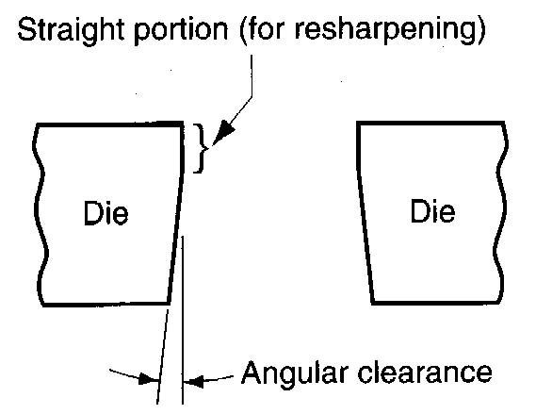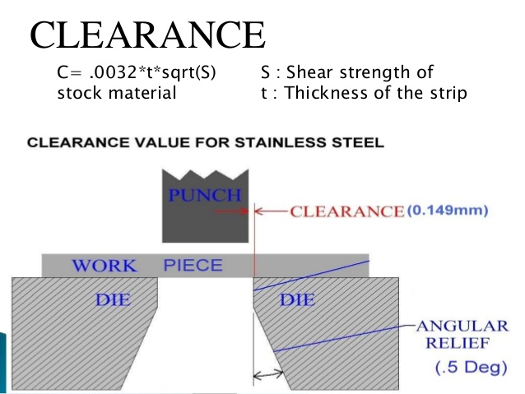

Figure 5.5 Angular clearance in a die

CUTTING FORCE

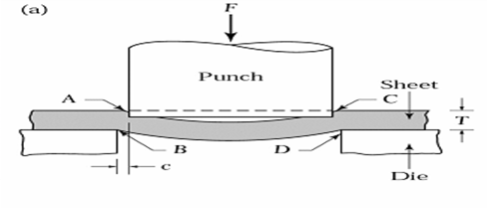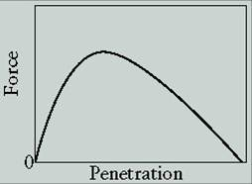
A typical punch-penetration curve in shearing. The area under the curve is the work done in shearing. The shape of the curve depends on process parameters and material properties.

The cutting force "F" required to cut (shear) work material is,

F = π.D.T.S (for round holes)
F = L.T.S (for other contours)
and
S~0.7 UTS (typically for steels)

where S = shear strength of the material, kg_{f}/mm²
D = hole diameter, mm
L = shear length, mm
T = material thickness, mm

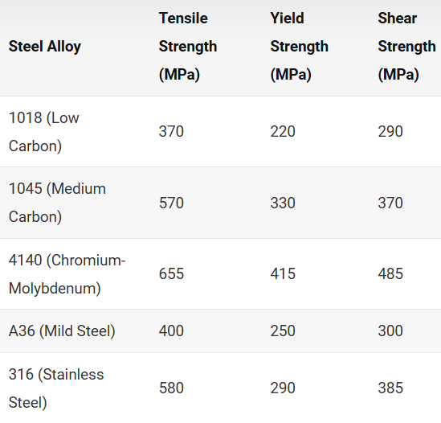

Example
To produce a hole of 20 x 20 mm in a material 2 mm in thickness with 40 kg_{f}/mm² shear strength, the force (F) required is,

F=40 kg_{f}/mm² x (2x20+2x20) x 2 mm= 40 kg_{f}/mm² x 160mm² = 6400 kg_{f} = 64 kN

REDUCING CUTTING FORCES

Since cutting operations are characterized by very high forces exerted over very short periods, reducing the force and spreading it over a longer portion of the ram stroke is sometimes desirable. Two methods are frequently used to reduce cutting forces and smooth out heavy loads:

1) Step the punch lengths (Figure 5.6): The load may thus be reduced by approximately 50%.
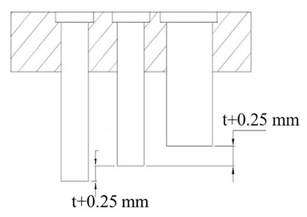
Figure 5.6 Reducing cutting force by stepping the punch (step of t+0.25 mm)

2) Grind the face of the punch or die at a small shear angle with the horizontal (Figure 5.7): This reduces the area in shear at any time and may reduce cutting force by 50%. The angle chosen should provide a change in punch length of about 1.5 times the material thickness. Using a "double angle" is usually preferable to maintain symmetry and prevent the setup of lateral force components.

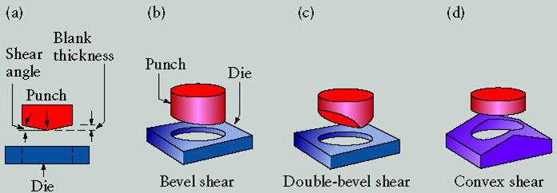
Figure 5.7 Reducing cutting force by giving angle with horizontal.

*************** FORMING/sheet metal shearing and bending (S.M.E./Wiley's video)*********
*************** FORMING/sheet metal stamping die and processing (S.M.E./Wiley's video)*********
BENDING (bükme)

- V-bending: Performed with a V-shaped die (Figure 5.10a)
-For low production volume
-Performed on a press brake
-V-dies are simple and inexpensive

- Edge bending (Figure 5.10b)
-For high production volume
-Pressure pad required
-Dies are more complicated and costly
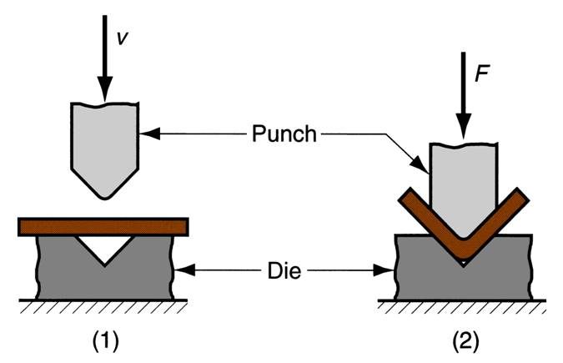
Figure 5.10a V-bending

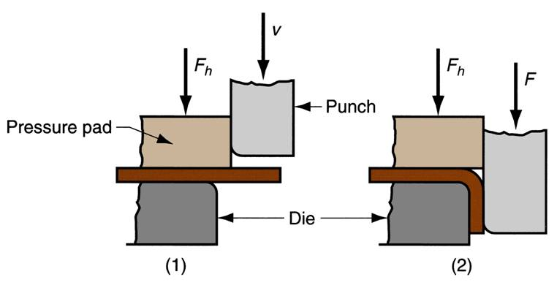
Figure 5.10b Edge bending (performed with a wiping die)

DEEP DRAWING (derin çekme)

Deep drawing is the metalworking process that shapes flat sheets into cup-shaped articles such as tubes, shell cases, automobile fenders (tampon), etc. (Figure 5.10). In deep drawing, the depth of the item created is equal to or greater than its radius. Generally, a hold down or pressure pad (or blank holder) (baskı plakası, pot plakası, taslak tutucu) is required to press the blank against the die to prevent wrinkling. An optional pressure pad from the bottom may also be used (Figure 5.11).

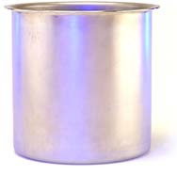

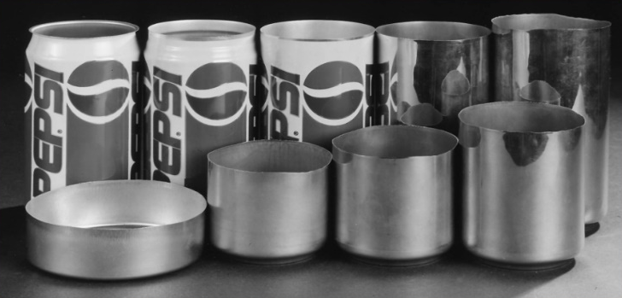

Figure 5.10 Some deep-drawn parts

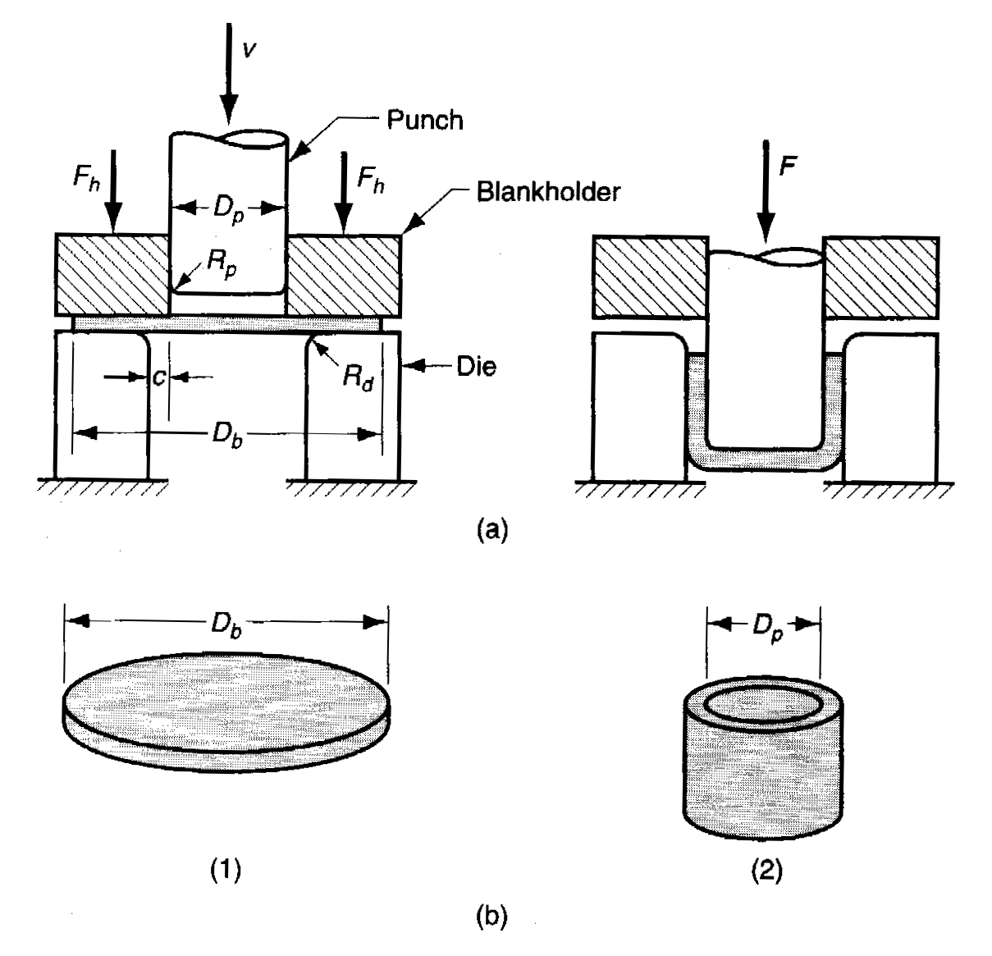
Figure 5.11 Deep drawing of a cylindrical cup

Some of the practical considerations which affect drawability:
R_{d} ≈ 10t
R_{p} should be big enough to prevent tearing.
Clearance between punch and die = 20 to 40 % greater than t.
Hold-down pressure = 2% of σ_{o} (average flow stress) of the blank material (die walls lubricated).

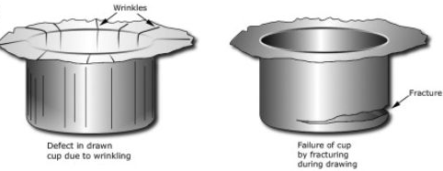

Defects in the drawn parts

The diameter of blank D:

The diameter of blank D required to draw a given cup with diameter d and height of h may be obtained approximately by equating surface areas.
Deep drawing force (F)

F=π.d.t (UTS) ((D/d)-0.7)

F = drawing force, N (kg_{f})
UTS = Tensile strength of the blank, MPa (kg_{f} /mm²)
D = Blank diameter, mm
d = Punch diameter, mm
t = Initial blank thickness, mm

----------------------------------------------------------------------------------------

Chapter 5
POWDER METALLURGY (PM)
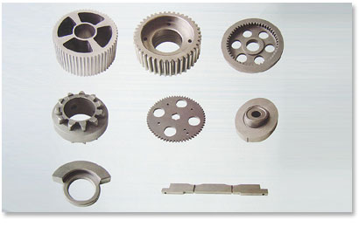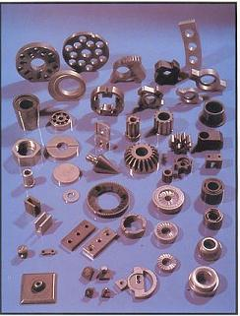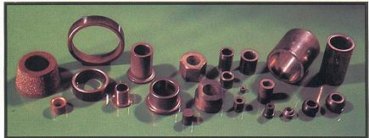

Some Powder Metallurgy Parts

Powder metallurgy is the art of producing products from metallic powders by pressure. Heat (sintering), which is usually used in the process, must be kept below the powder's melting point.

Metal in powder form costs more than in solid form, and the process most adaptable to mass production requires expensive dies and machines. This higher cost is often justified by the unusual properties obtained.

FLOW OF PM PROCESS (Figure 6.1)

Elemental
Powders
(mixing)
Blending
(Lubricants)
Prealloyed
Powders
pure
metal
powders
Compaction
Sintering
Finishing
Lubricant
Burn - off

Figure 6.1 Flowchart for fabricating metal powder parts.

CHARACTERISTICS OF METAL POWDERS

1) The shape of a powder particle depends mainly on how it is produced. It may be spherical (küresel), ragged, dendritic (dentiritik, salkım), flat/flake (pulsu), sponge, angular (köşeli), etc. A powder with good green strength can only be produced from irregularly shaped particles that will interlock on compacting.

2) Fineness refers to the particle size and is determined by passing the powder through standard sieves or by microscopic measurement. Standard sieves ranging from 100 to 325 mesh (45-150 μm) are used. Particle size distribution refers to the amount of each standard particle size in the powder. It influences flowability, apparent density, and compressibility.

3) Flowability is the characteristic of a powder that permits it to flow to the mold cavity. It can be described as the rate of flow through a fixed orifice. Very fine particles of 1 to 10 μm are like a liquid when pressed.

4) Compressibility is the ratio of the volume of the initial powder to the volume of the compressed piece. It varies considerably and is affected by particle size distribution and shape. The green strength of a compact depends on its compressibility. Most fine powders compress two-thirds (2/3) of their original filling depth.

5) Apparent density is the weight of loose powders occupying a certain volume, expressed as gr/cm³.

6) Sintering ability is the bonding of particles by applying heat. A broad temperature range is preferred. Mechanical properties are controlled by particle size, compaction pressure, sintering and heat treatment.

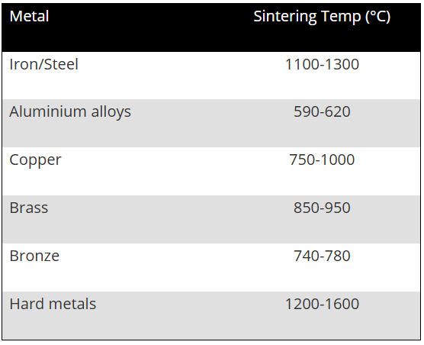

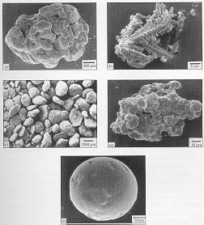
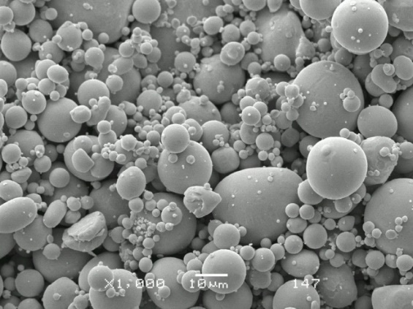
Types of Powders. (a) Sponge iron produced by direct reduction, (b) copper powder produced by electrolytic deposition, (c) Aluminum powders produced by the rotary kiln, (d) iron powder produced by water atomization, (e) nickel-based powder produced by gas atomization, (f) spherical tin powder produced by gas atomization.
METHODS OF PRODUCING POWDERS

a) Machining produces coarse particles and is used principally for producing magnesium powders.

b) Milling and grinding processes, utilizing various types of crushers, rotary mills (döner değirmen/öğütücü), stamping mills, and grinders (öğütücü), break down the metals by crushing and impact. Brittle materials may be reduced to irregular shapes of almost any fineness by this method. The process is also used in the manufacturing of ductile materials, where flake particles (pulsu) are obtained. Oil is used in the process to keep them from sticking together.

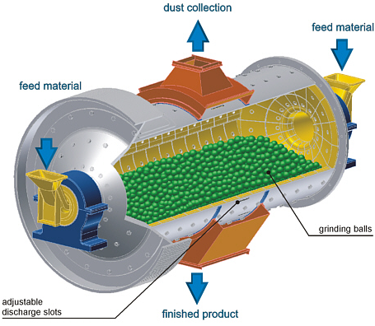
Rotary mill (öğütme değirmeni) to produce powder

- Atomization (metal spraying (Figure 6.2)). More than 60% of all powders are produced by atomization. Alloy steel powders can only be produced by this technique. Iron powders with high carbon content have been produced by this process. Atomization is also an excellent means of producing powders from many low-temperature metals such as lead, aluminum, zinc, and tin.

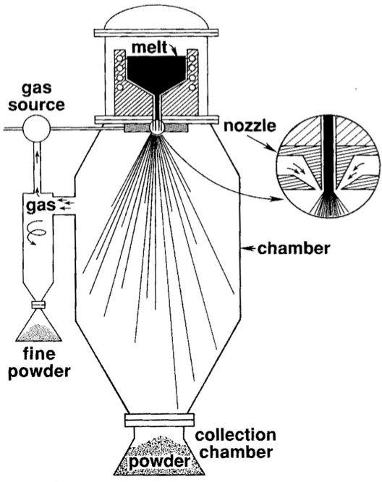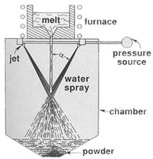

(a) (b)
Figure 6.2 Production of metal powder by atomization. (a) Gas atomization, (b) water atomization

d) Electrolytic deposition commonly processes iron, copper, silver, tantalum, and several other metals (figure below).
i) Steel plates are used as anodes in electrolysis tanks to produce iron powders. Stainless steel is used as a cathode. Direct current passes through the circuit, and iron powder is deposited on the cathode. In this condition, they are brittle and must be annealed.
ii) For the production of copper powder, blister copper is used as an anode and steel or cast iron plates are used as a cathode. Sulphuric acid is used as an electrolyte

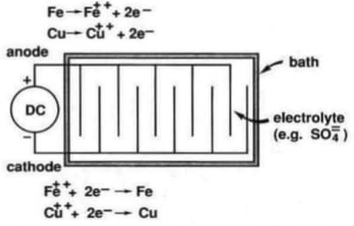

Production of iron and copper powders by electrolytic deposition

e) The reduction method reduces metal oxides to powder form by contact with gas at temperatures below the melting point. Mill scale (iron oxide or iron ore, magnetite (Fe₃O₄,72.4%Fe), hematite (Fe₂O₃, 69.9% Fe), goethite (FeO(OH) 62.9% Fe), limonite (FeO(OH)·n(H₂O) 55%Fe), or siderite (FeCO₃ 48.2% Fe) is fed into a rotating kiln (döner fırın) and crushed coke for making iron powder. The mixture is heated to around 1050°C, causing the carbon to unite with the oxygen in the iron oxide. With the oxygen removed, the product remaining is a relatively pure iron with a sponge-like structure (referred to as "sponge iron").

COMPACTION (Pressing)

Various sizes of powder particles are mixed to change the flowability, density and compressibility characteristics. Mixing or blending is necessary when powders are alloyed or nonmetallic particles are added. Practically all powders have lubricants added during blending to reduce die wall friction and aid part ejection. Lubricants may include stearic acid, lithium stearate, and powdered graphite.

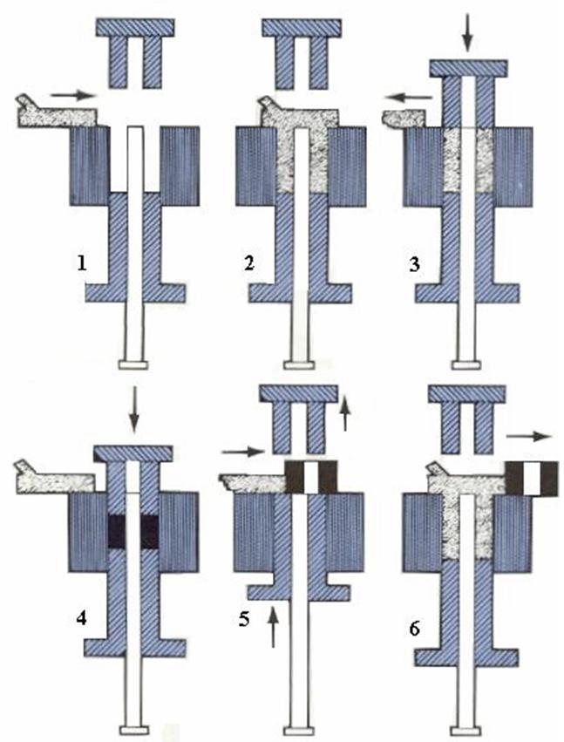
Figure 6.3 Punch and die arrangement for compacting metal powder.

Powders are pressed to shape in steel dies under pressures up to 1400 MPa. A simple punch-and-die arrangement for compacting metal powder is shown in Figure 6.3. Two punches are involved: an upper punch that conforms to the top shape of the part and a lower punch that conforms to the lower end of the die cavity. The lower punch also serves as an ejector, removing the briquette portion of the green compact (ham parça) from the die. The die cavity must be smooth to reduce friction and have a slight draft to facilitate part removal. Wall friction prevents much of the pressure from being transmitted to the powder. If pressure is exerted only from one side, density will vary considerably from top to bottom. This accounts for the use of both top and bottom punches in most dies. The compression ratio of the powder for iron and copper is roughly 2.5:1. The ejected part, known as a green compact, resembles the finished part but has only the structural strength derived from the interlocking of the powder particles obtained by compression. The final strength is obtained by sintering.

SINTERING

The application of heat during the process or subsequently is known as sintering. It results in bonding the fine particles together, thus improving the strength and other properties of the finished product. A green compact is unsintered and has low strength and limited abrasion resistance. Types of sintering;

- Solid State/Phase Sintering: Solid-state sintering transforms compacted metal powders into a solid, high-density component at temperatures below the melting point. It operates via atomic diffusion, resulting in particle necking, reduced surface area, and significant densification (shrinkage) by eliminating voids. Sintering is driven by the reduction in surface energy of powder particles, which promotes atomic transport (surface diffusion, grain boundary diffusion and volume diffusion). The sintering results in a coherent solid with mechanical strength, often with reduced volume (shrinkage).

The sintering temperature is about 1100 °C for steels, with a time of about 20-40 minutes.

ii) Liquid Phase Sintering: Temperature is generally below the melting point of the principal powder. But one of the powders might melt (Figure 6.4b). They are commonly used in the production of cemented carbide (WC+Co) cutting tool inserts (insört, sert maden uç, plaket), where the cobalt powder (T_{m} = 1495 °C) melts. T_{m} of the WC powder is 2750 °C. The fragile green inserts are heated to over 1300 °C–1500 °C, causing the Co binder to melt and create a highly dense structure.

SOLID
STATE
DIFFUSION
compacted
no diffusion (“cold welding” may occur)
sintered
(necking due to diffusion)
(a)

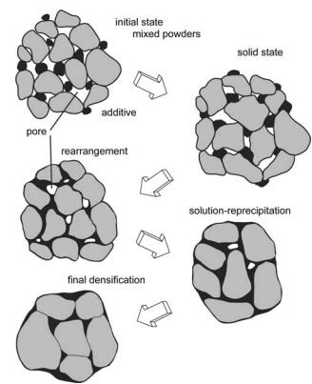
(b)
Figure 6.4 a) Solid phase sintering, b) Liquid phase sintering

Types of Furnaces: To prevent reduction or oxidation of the powders, sintering furnaces are atmosphere-controlled. Sintering of the steel is done under dissociated ammonia (nitrogen-rich). Sintering furnaces can be a) continuous type, in which a wire-mesh belt carries the compacts through the furnace (Figure 6.5), or b) batch type (no belt, only a simple furnace).

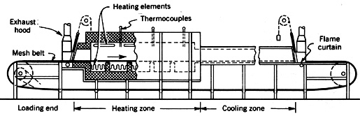

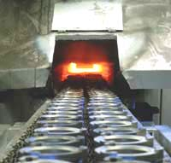
Figure 6.5 Continuous-type furnace for sintering
---------------------------------------------------------------------------

FINISHING OPERATIONS

-Impregnation is accomplished either by immersing the sintered bearing in heated oil or vacuum treatment. The oil is released as the bearing is used. Most bearings are made of porous bronze or iron.

-Infiltration is filling the pores of a sintered product with molten metal to decrease porosity or improve physical properties, such as increasing density.

-Sizing and coining operations repress the part in a die similar to the one used for compacting it. Sizing is a cold-working operation that improves surface hardness, smoothness, and dimensional accuracy. The part's density is also increased.

-Plating can be applied to high-density parts by standard procedures.

-Products requiring geometric features such as threads, grooves, undercuts, or side holes cannot be produced by powder metallurgy methods and must be finished machined.

METAL POWDER PRODUCTS (APPLICATIONS)

PM parts are increasingly being used in industry. Commonly, they weigh less than 1 kg, and most are completed without machining. Some applications of PM parts are summarized below:

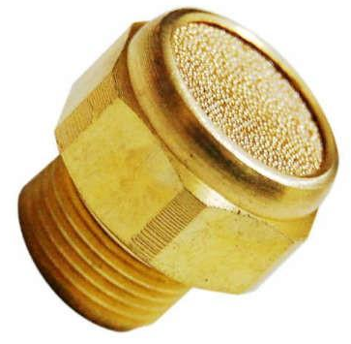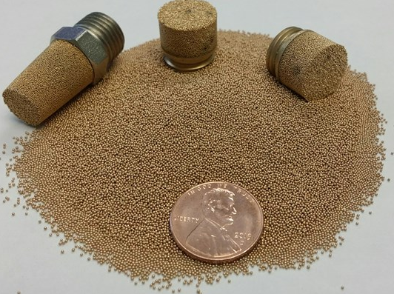
Bronze filters

- Permanent metal powder filters have greater strength and shock resistance than ceramic filters, being made with porosities up to 80%. They are used for filtering hot or cold fluids and air.

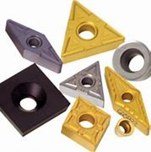
Inserts

2) Tungsten carbide (WC) particles are mixed with a cobalt (Co) binder, pressed to shape, and then liquid-phase sintered at a temperature above the melting point of the matrix metal (Co) to produce cemented carbides that are used for cutting tools and dies.

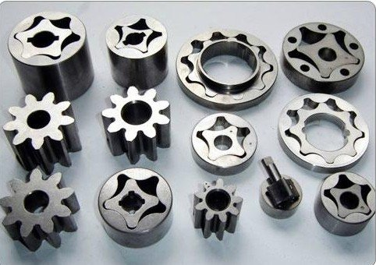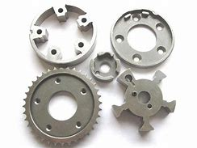
Gear and pump parts

3) Gears and pump rotors are made from powdered iron mixed with sufficient graphite to give the product the desired carbon content. A porosity of 20 % is obtained in the process. After sintering, the pores are impregnated with oil to provide quiet operation.

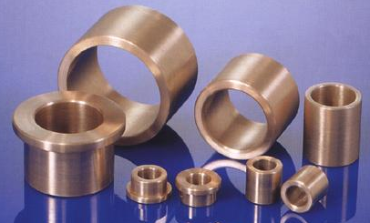
Bronze bearings

4) Most porous bearings (kaymalı yataklar) are made from copper, tin, and graphite powders. After sintering, the bearings are sized and then impregnated with oil by vacuum. These are called "self-lubricated bearings" and do not need lubrication during work.

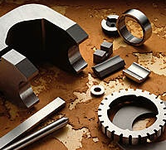

Various Alnico magnets

5) Excellent small Alnico magnets are produced from iron, aluminum, nickel, and cobalt powder compositions. They are superior to those of the cast.

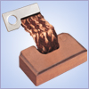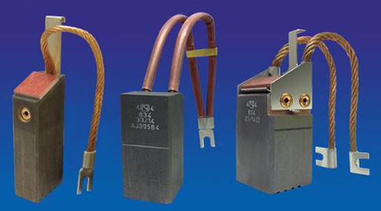
Copper-graphite electrical contacts

6) Electric contact parts must be wear-resistant, refractory and have good electrical conductivity. Many combinations, such as tungsten-copper, tungsten-cobalt, tungsten-silver, silver-molybdenum and copper-nickel-tungsten, have been developed for electrical applications.

7) Numerous other parts, including clutch faces, brake drums, ball retainers, and welding rod coatings, are produced by powder metallurgy. Other uses for powder metals include paint pigments, missile fuels, and thermit welding.

****** FORMING/powder metallurgy (S.M.E./Wiley’s video) *******
Chapter 6
METAL CUTTING

METAL CUTTING THEORY

The discussion in this section deals mostly with orthogonal tools in which the cutting edge is perpendicular to the direction of the cut and there is no lateral flow of metal. This simple form of cutting tool is a single-point tool such as that found in a lathe cut-off operation, planer and shaper work.

Orthogonal cutting (dik kesme) tool model.

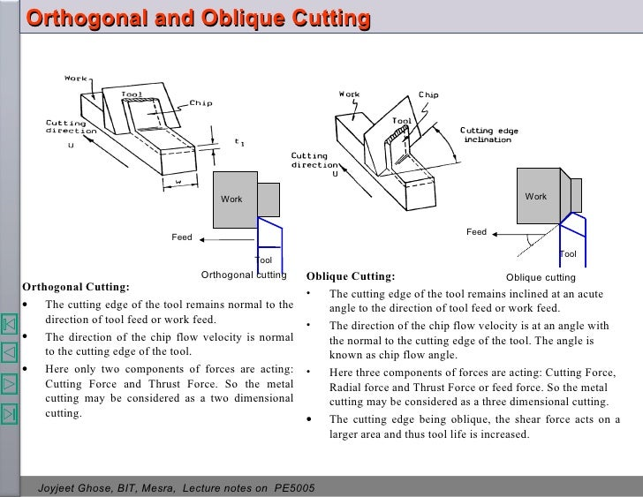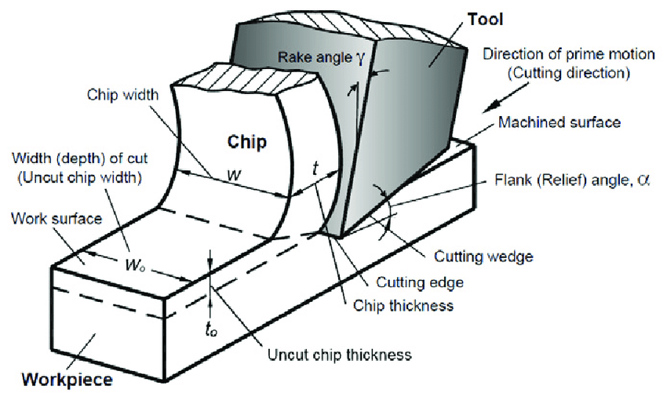

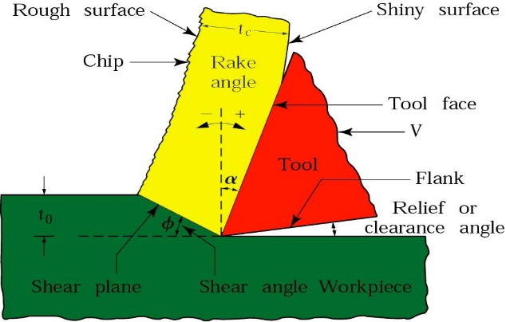

(a)

(b)
Figure 6.1 (a) Orthogonal and (b) Oblique cutting models

t_{c} = chip thickness (talaş kalınlığı)
t_{o}= depth of cut (uncut chip thickness) (kesilmemiş talaş kalınlığı)
φ= shear angle (kayma/kesme/makaslama açısı)
α = rake angle (talaş açısı)

In analyzing the cutting process, it is assumed that the chip is removed from the workpiece by a shearing action across the plane (Figure 7.1). Because the deformed chip is in compression against the face of the tool (takım/talaş yüzü), a frictional force is developed. The work of making the chip must overcome both the shearing force and the frictional force. The shear plane (kayma düzlemi) is determined by the rake angle α (talaş açısı) of the tool and by the friction between the chip and the tool face.

METAL CUTTING TOOLS

A) Geometry

Single-Point Cutting Tools

- Angles (Figure 6.2)
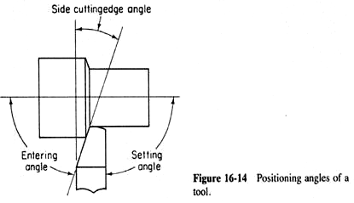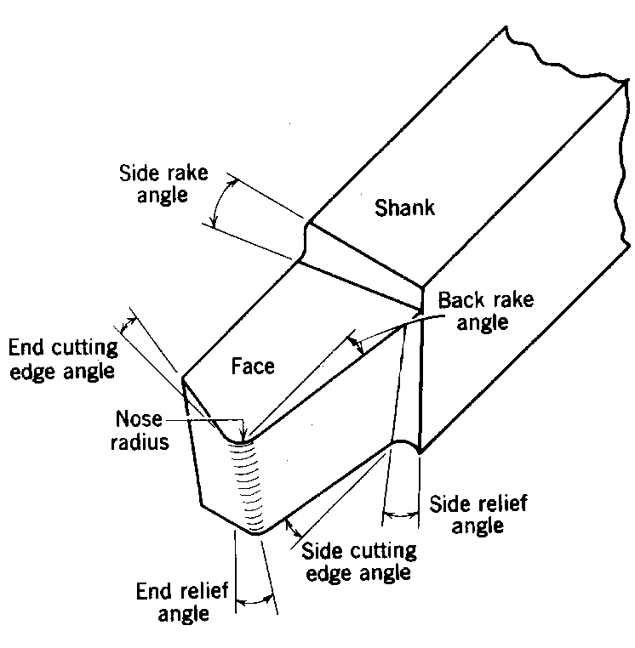
Flank
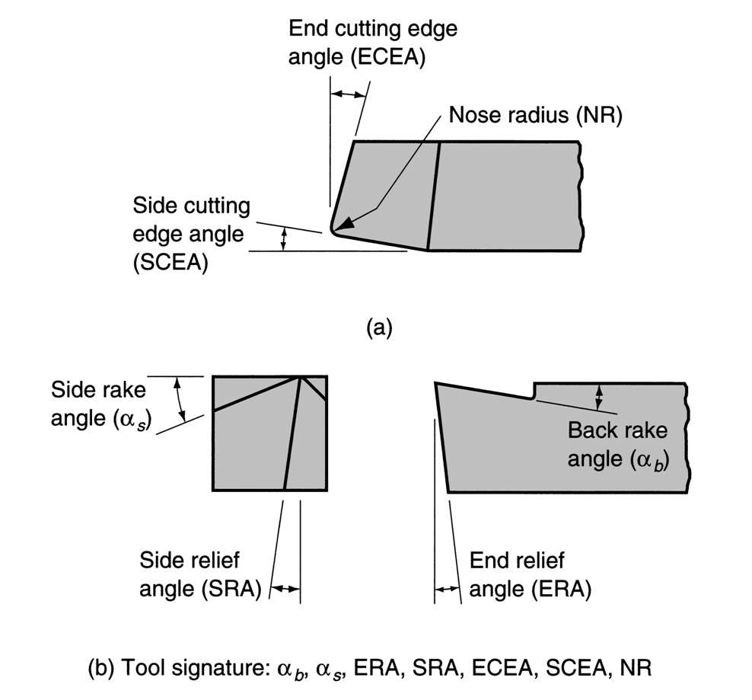

Figure 6.2 Setting angles and terminology for a right-hand cutting tool (solid single-point cutting tool)

-Side rake angle (yan talaş açısı)-(0-20º for HSS, -5, 15º for inserts (takma uç, sert maden uç)

-Back rake angle (arka talaş açısı)-(0-30º for HSS, -5, 15º for inserts); ground in HSS and tool holder positions in “carbides” and “ceramics”.

-End cutting edge angle (yardımcı kenar açısı)

-Side cutting edge angle (kesici kenar açısı)-(6-8º)

-End relief angle (ön boşluk açısı)

-Side relief angle (yan boşluk açısı)- (10-15º for HSS, 6-8º for inserts)

-Lip angle (cutting angle) (kama açısı)

1) small angles are given to reduce cutting power;

2) large angles are given; i) to withstand tool forces, ii) to carry the heat generated.

-Heel (dip veya oturma yüzeyi)

b) Functions of the tool angles

RELIEF ANGLES- prevent rubbing.

SIDE CUTTING EDGE ANGLE- a) reduces shocks, b) distributes the chip on a larger surface.

BACK RAKE ANGLE- a) reduces cutting force, b) directs the flow direction of the chip

NOSE RADIUS affects the surface finish and thrust force (a larger radius yields better surface finish and lower thrust force).

Inserts (disposable cutting tools) (sert maden uç, plaket, takma uç)

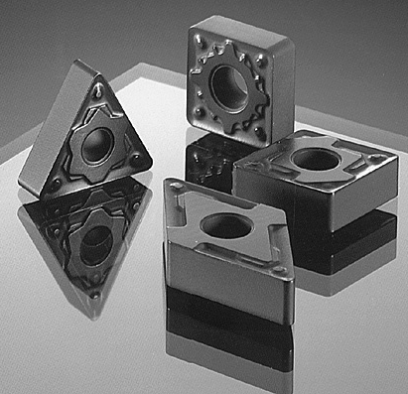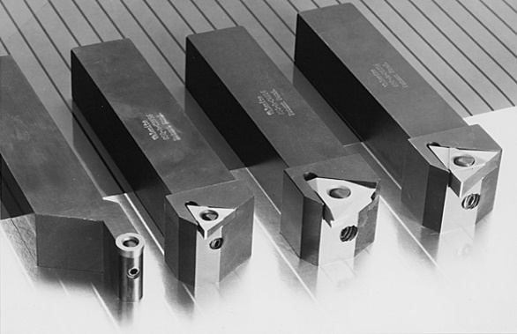

In addition to the solid single-point tool, a carbide tip may be inserted or brazed in a toolholder. Many styles of toolholders (kater) and inserts are available. The inserts are disposable and vary in geometry from triangular, square, circular (yuvarlak uç) and diamond (baklava uç) to other special shapes. Figure 6.3 is a view of the components of a single-point tool using a disposable carbide tool insert.
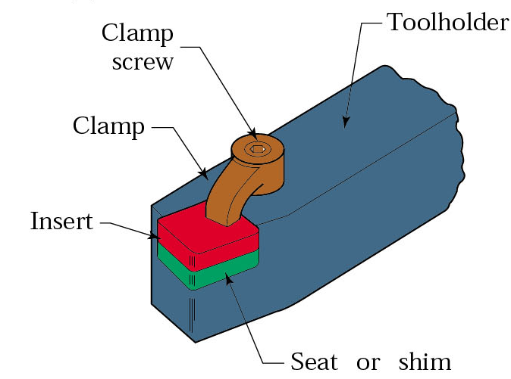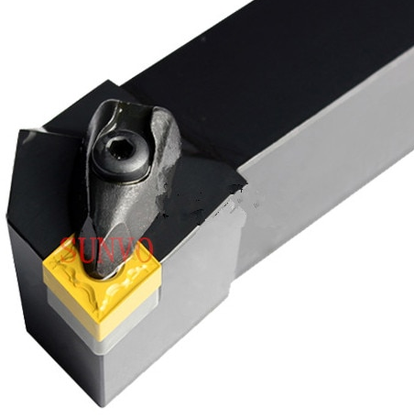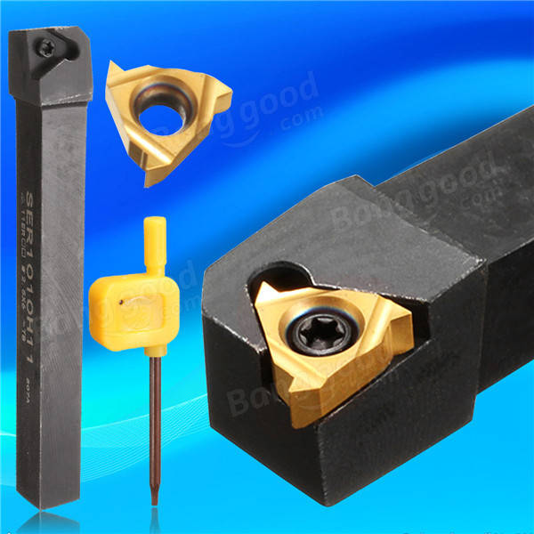
Figure 6.3 The tools with disposable carbide insert

B) Tool Materials (Figure 6.4)

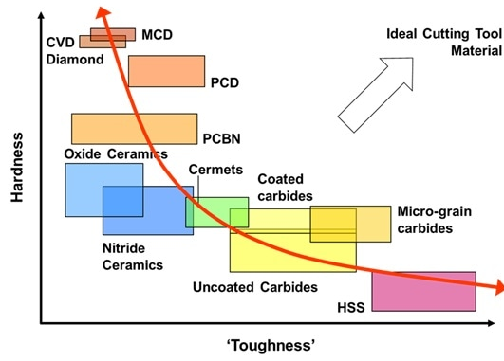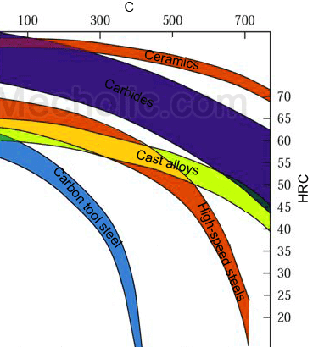

Figure 6.4 Hardness, toughness and temperature resistance of cutting tool materials

High-Carbon Steel. Their carbon content ranges from 0.80% to 1.20%. Because these tools lose hardness around 300°C, they are unsuitable for high cutting speeds and heavy-duty work, and their usefulness is confined to soft materials such as wood.

High-Speed Steel (HSS). High-speed steels are high in alloy content, have excellent hardenability, and retain a good cutting edge at around 650°C. Although there are numerous HSS compositions, they may all be grouped into the following three classes:

1. 18-4-1 HSS: This steel, containing 18% tungsten, 4% chromium, and 1% vanadium, is considered one of the best all-purpose tool steels.

2. Molybdenum (6-6-4-2) HSS: Many high-speed steels use molybdenum as the principal alloying element. Molybdenum steels such as 6-6-4-2 containing 6% tungsten, 6% molybdenum, 4% chromium, and 2% vanadium have excellent toughness and cutting ability.
3. Super HSS: Some high-speed steels have added cobalt amounts ranging from 2% to 15%. Because of the material's higher cost, it is used principally for heavy cutting operations that impose high pressures and temperatures on the tool.

Carbides. Carbide-cutting tool inserts are made only by the powder metallurgy technique. The red hardness of carbide tool materials is superior to that of all others because it maintains a cutting edge at temperatures above 1200°C. In addition, it is the hardest manufactured material and has extremely high compressive strength. However, it is very brittle and has low resistance to shock. Types;

1. Tungsten carbide inserts (WC-Co) containing only tungsten carbide and cobalt (about 94% tungsten carbide (WC) and 6% cobalt (Co)) are suitable for machining cast iron and most other materials except steel.
2. Titanium carbide (TiC) and Tantalum carbide (TaC) inserts (Cemented Carbides): Straight WC-Co cutting tools cannot be used effectively to machine steel. It was subsequently discovered that additions of TiC and TaC to the WC-Co tool significantly retards the rate of crater wear when cutting steel. The result is cemented carbides. Titanium carbides are suitable for steel machining and comprise 82% WC, 10% TiC, and 8% Co. This composition has a low coefficient of friction and, as a result, has little tendency toward top wear or cratering.
3. Coated carbide inserts. Cemented carbide tools may be coated with a 0.05 to 0.08 mm bonded layer of titanium carbide (TiC), aluminum oxide (Al₂O₃), or titanium nitride (TiN). These coatings reduce the heat caused by the chip flowing over the tool. Al₂O₃-coated tools will operate at almost twice the cutting speed of any other coating.

Ceramic. Al₂O₃ powder, along with titanium, magnesium, or chromium oxide additives (nowadays typically silicon nitride (Si₃N₄), silicon carbide (SiC), and zirconium oxide (ZrO₂)), is mixed with a binder and processed into a cutting tool insert by powder metallurgy techniques. Because of this, the inserts must be given a 5° to 7° negative rake to strengthen their cutting edge and be well supported by the toolholder.

CHIP SHAPE AND FORMATION

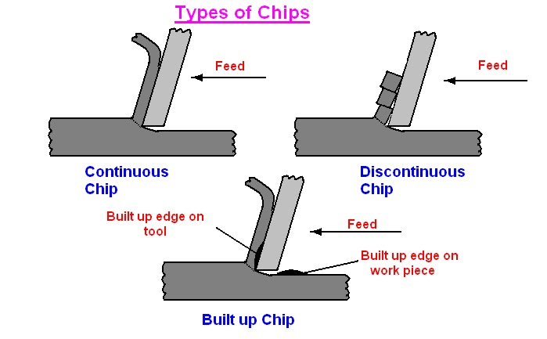
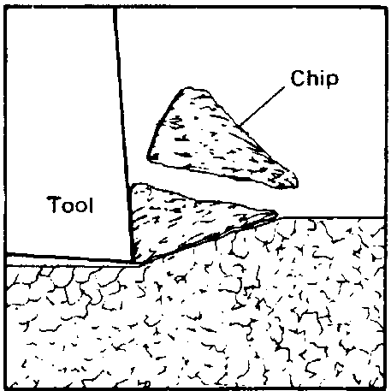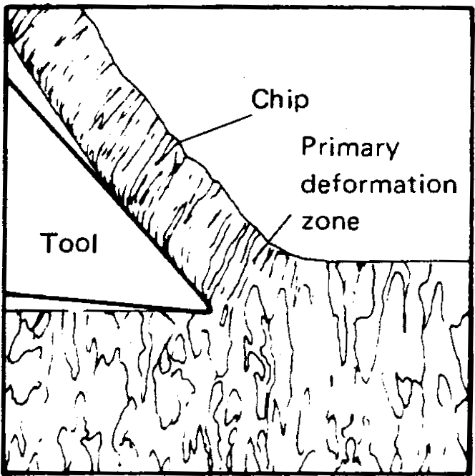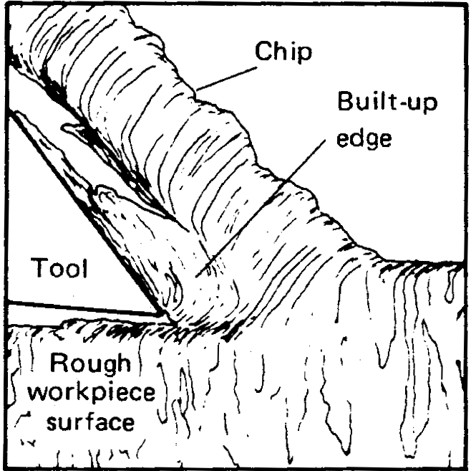
A
B
C

Figure 6.5 Type of chips

a) Type 1 (discontinuous or segmental) chip (kesikli talaş) (Figure 6.5A), represents a condition in which the metal ahead of the cutting tool is fractured into fairly small pieces. This type of chip is obtained in machining most brittle materials, such as cast iron and bronze. As these chips are produced, a fairly good finish is obtained. Tool life is reasonably good, and failure usually occurs due to abrading action on the contact surface of the tool. Discontinuous chips can also be formed on some ductile materials if the coefficient of friction is high.

b) An ideal type of chip from the standpoint of tool life and finish is the Type 2 (simple continuous) chip (sürekli talaş) (Figure 6.5B), which is obtained in cutting ductile materials having a low coefficient of friction. In this case, the metal is continuously deformed and slides up the face of the tool without being fractured. Chips of this type are obtained at high cutting speeds and are common when cutting is done with carbide tools.

c) Type 3 (continuous chip with Built-up Edge (BUE)) chip (yığma uç talaş) is characteristic of those machined from ductile materials that have a fairly high coefficient of friction. As the tool starts the cut, some of the material, because of the high friction coefficient, builds up ahead of the cutting edge (Figure 6.5C). Some workpiece material may even weld to the tool point, forming a BUE. As the cutting proceeds, the chips flow over this edge and up along the face of the tool. This phenomenon can also be reduced by reducing the chip thickness or increasing the rake angle, but it cannot be eliminated in many ductile materials.

CUTTING FLUIDS (COOLANTS)

Cutting action is improved by using solids, liquids, emulsions, or gases in the cutting process. A proper cutting fluid can perform the following functions:
1. Reduce friction between the chip, tool, and workpiece.
2. Reduce the temperature of the tool and work.
3. Wash away chips.
4. Improve the surface finish.
5. Reduce the power required.
6. Increase the tool life.
7. Reduce possible corrosion on both the work and the machine.
8. Prevent or reduce the welding of the chip to the tool.

Solids that improve cutting ability include certain elements in the workpiece, such as graphite in grey cast iron or lead in steel. Liquids are primarily in water- or oil-based solutions, with certain additives to enhance their effectiveness. Gases include water vapor, carbon dioxide and compressed air. Most coolants are liquids because they can be directed to the proper place on the tool and are easily recirculated.

The following are some coolants used for several of the common materials.

1. Cast iron. Compressed air, soluble oil, or work dry.
2. Aluminum. Kerosene (gazyağı), soluble oil, or soda water.
3. Brass. Worked with dry, paraffin oil, or oil compounds.
4. Steel. Water-soluble oil, sulfurized oil, or mineral oil.

MACHINABILITY

Machinability, or the ease with which a given material can be cut. Machinability is a relative term expressed in factors such as 1) length of tool life, 2) power required to cut, 3) cost of removing a certain amount of material, and 4) surface condition obtained. The most important of these factors so far as machining costs are concerned, is tool life. The values of machinability given in handbooks are based only on this factor.

Plain-carbon steels have better machinability than alloy steels of the same hardness and carbon content. Adding lead to steel improves machinability, although it makes the steel more costly, softer, and ductile. Adding a small amount of tellurium to steel increases machinability. The addition of moderate amounts of phosphorus and sulfur improves machinability. The addition of phosphorus makes chips brittle.

The important test for the machinability values is as follows: A fixed-shape tool is set to cut at a predetermined depth and feed. The cutting speed at which a tool can be run and still have a 60-min life (V₆₀) is a measure of machinability.

TOOL LIFE

Tool life is the length of time a tool will cut satisfactorily. In general, four basic types of wear affect tool life:

1) Abrasion wear. This type of wear is caused by small workpiece particles "rubbing" against the tool surface.

2) Adhesion wear. Cause a welding action on the surfaces of the tool and workpiece. The stresses induced by the cutting process lead to weld fracture, resulting in degradation of the cutting tool.

3) Diffusion wear. It is caused by a displacement of atoms in the metallic crystal of the cutting element from one lattice point to another. This results in a gradual deformation of the tool surface.

4) Oxidation wear. At high temperatures, oxidation of the carbide in the cutting tool leads to edge wear.

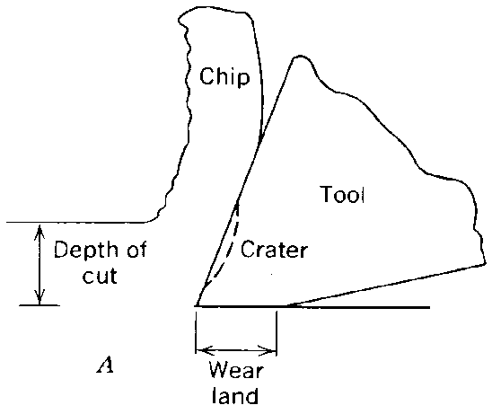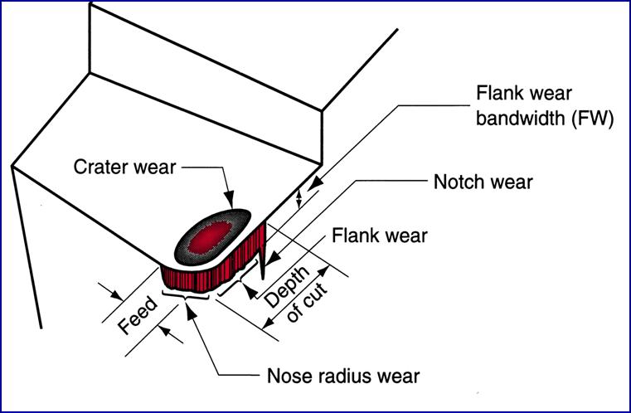
- Orthogonal cutting tool b) Oblique cutting tool

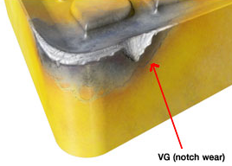

Figure 6.6 Wear of a) orthogonal and b) oblique cutting tools

Wear is evident in two places on a tool (Figure 6.6). One of the important is on the flank of the tool (flank wear) where a small land extending from the tip to some distance below is abraded away. On high-speed (HSS) tools, a failure is considered to have occurred if this land has worn 1.58 mm, and carbide tools when the wear land has reached 0.76 mm. The other wear happens on the tool face in the form of a crater (crater wear). For brittle cutting tools (especially ceramic tools), the depth of this crater should not exceed a specified value.


In 1906, Frederick W. Taylor reported the relationship between tool life and cutting speed as follows:

VT^{n} = C

V: Cutting speed, m/min (or m/s)
T: Tool life, min (or s)
n, C: The value of n is influenced by tool material, while C depends more on work material and cutting conditions (speed, feed, depth of cut, and cutting fluid parameters).

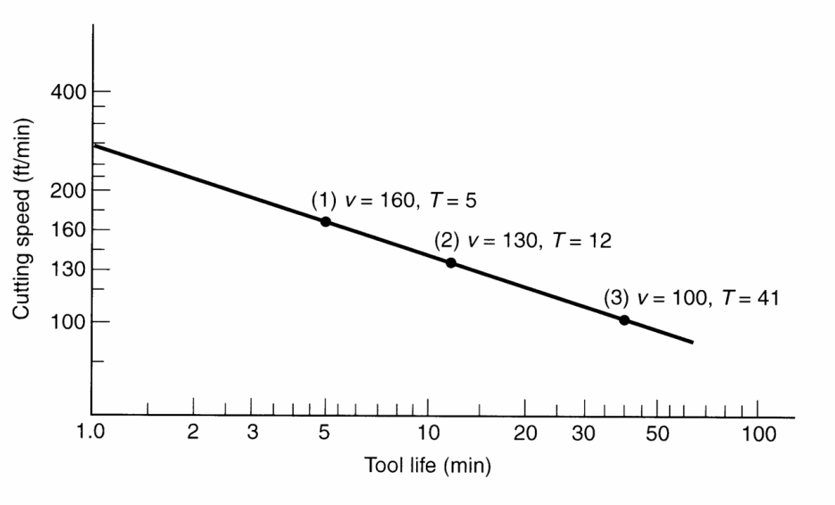
Effect of cutting speed on tool life (log-log scale)

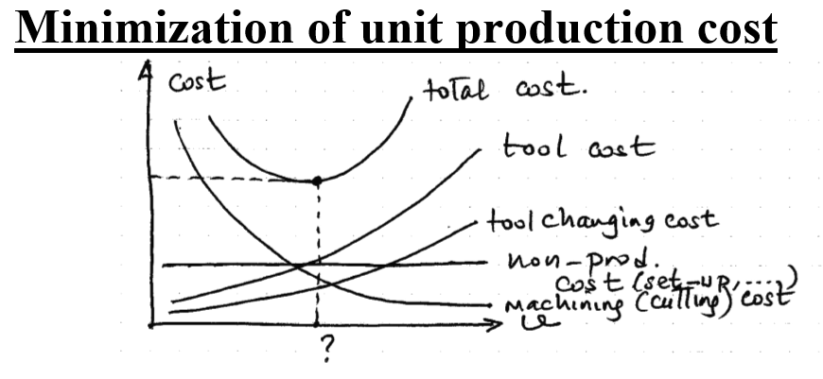

*************** MACHINING/cutting tool materials (SME/Wiley's video)********

REFERENCES

- Çoğun C, Manufacturing Processes, Lecture Notes, Ankara, 2021.
- Koç M, and Usta Y, EGRM426 Manufacturing Processes, Lecture Notes, Virginia Commonwealth Univ., School of Engineering, Richmond, 2017.
- Ostwald PF and Munoz J, Manufacturing Processes, John Wiley and Sons, New York, 9th ed., 1997, ISBN: 0-471-04741-4.
- Kalpakjian S and Schmid SR, Manufacturing Processes for Engineering Materials, 4th ed., Prentice Hall, 2003, ISBN: 0-13-040871-9.
- Çiğdem M, İmal Usulleri, Çağlayan Kitabevi, İstanbul, 1996, ISBN: 975-436-027-8.
- Akkurt M, “Talaş Kaldırma Yöntemleri ve Takım Tezgahları”, Birsen Yayınevi, İstanbul, 2000, ISBN: 975-511-214-8.

