Chapter 7

NON-TRADITIONAL PROCESSES

- WATER JET MACHINING (WJM)

(SU JETİ İLE İŞLEME)

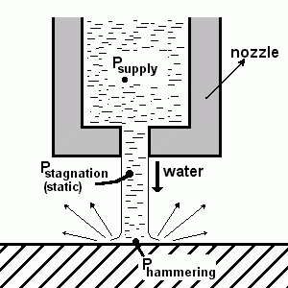
Figure 1.1 Principle of WJM

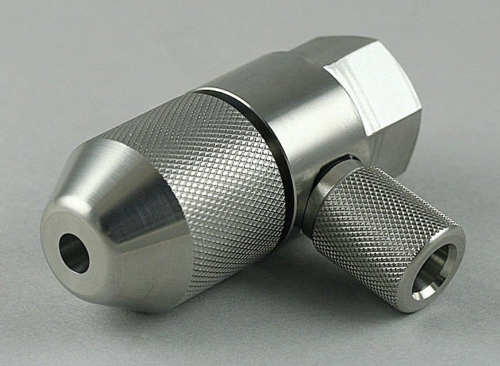
Figure 1.2 Nozzle

Common Use

-Used to cut and slit porous non-metals (started in 1971 in the USA)
-Nozzle diameter of d=0.1 - 0.25 mm (Figure 1.2).
-No abrasive particles are used.

Mechanism of Material Removal
In the first few milliseconds after the initial impact of the jet on the workpiece (before the lateral flow is initiated), a transcend pressure of three times the normal stagnation pressure is generated (Figure 1.1). Erosion occurs when the local fluid pressure exceeds the material's strength.

Typical Pressures and Velocities

P_{supply} = 350 MPa (range: 70 - 700 MPa, typically 400 MPa)
P_{static} = 350 MPa
P_{hammering} = 1000 MPa
(σ_{yield})_{steel} = 400 - 700 MPa
V_{flow}= 300 - 900 m/s

Nozzle (Figures 1.2 and 1.5)
Nozzle material should be extremely hard. Typical materials;
- Sintered diamond,
- Sapphire (synthetic),
- Tungsten carbide,
- Special steels.

The diameter typically ranges from 0.07 to 0.5 mm. Nozzle lifetime is 250-500 hrs.

To increase the length of the coherent jet (Figure 1.5b) (i.e., without dispersion), ~1% long-chain polymer is added to water to increase the viscosity of water. In this way, length/diam=600 can be obtained.

Due to the table movement, the jet angles cause angled traces on the workpart (Figure 1.6).

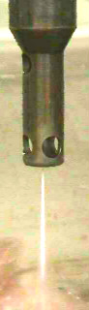 | 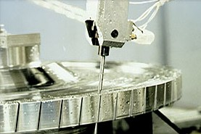
a)
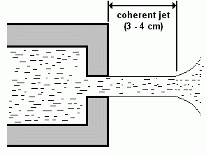
b)
Figure 4.5 Nozzle and the Coherent Jet

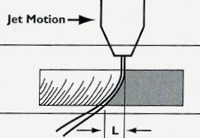
Figure 1.6 Deflection of Jet Due to Table Movement

Applications
-Wood industry (for cutting purposes),
-Cutting brick and marble (Figure 1.7e, 1.7g, 1.7h),
-Paper industry (corrugated box board cutting) (Figure 1.7i),
-Textile (confection) industry,
-Leather,
-Coal mining,
-Fiberglass and polyethylene automotive parts (by using robots),
-Cable stripping,
-Thin Metal cutting (Figure 1.7a-1.7d, 1.7f, 1.8, 1.11).
-Glass cutting (Figure 1.9)

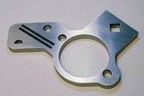 |  | 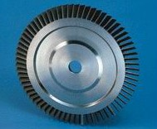
a) |  | b)
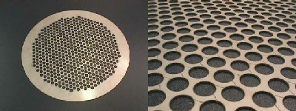
c)

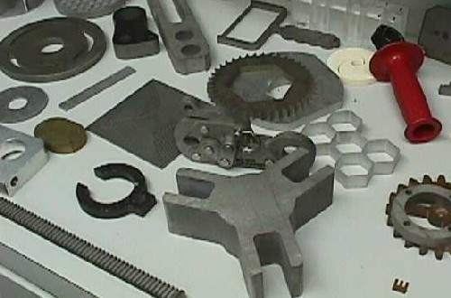 |  | 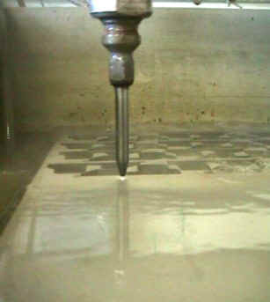
d) |  | e)
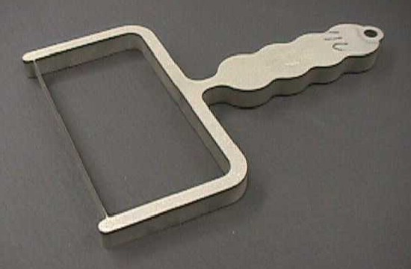 |  | 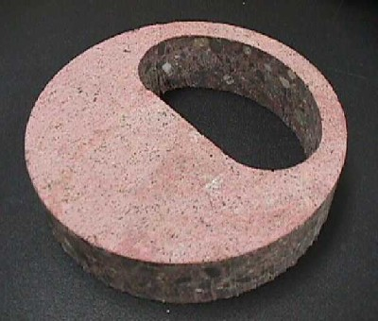
f) |  | g)
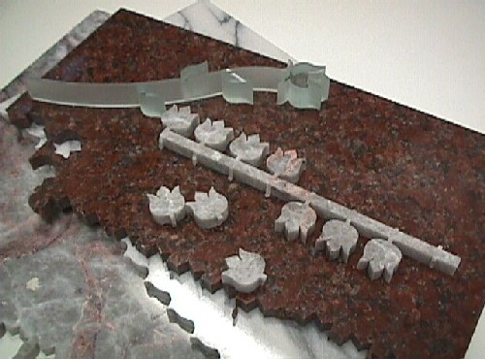 | 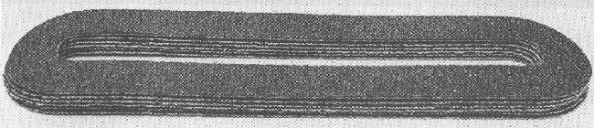
h) | i)
Figure 1.7 WJM Application Examples

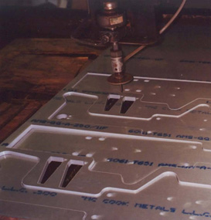
Figure 1.8a Aluminum Cutting
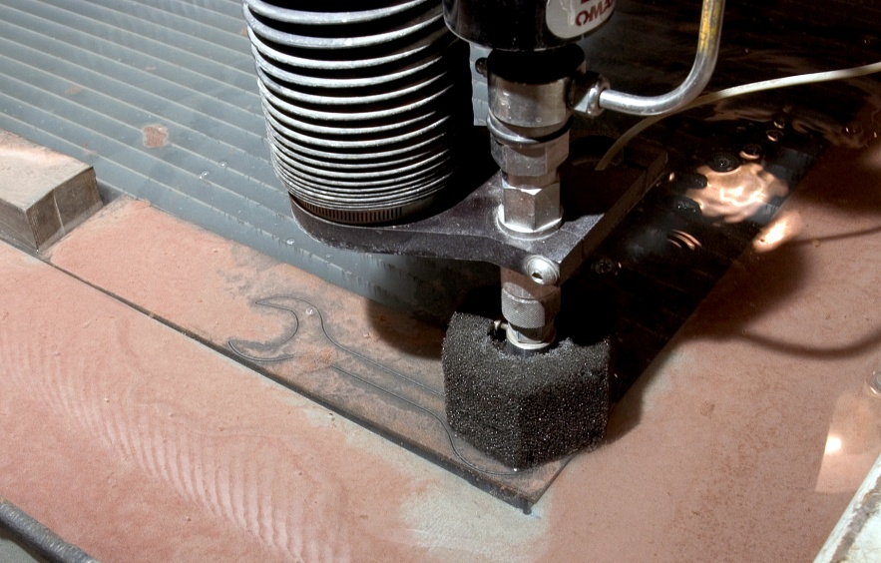
Figure 1.8b Steel Cutting

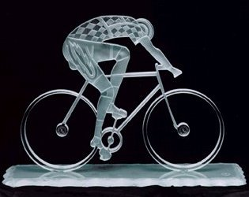
Figure 1.9 Glass Cutting

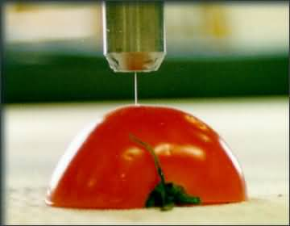
Figure 1.10 Tomato Cutting

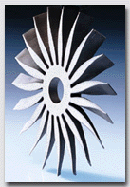
Figure 1.11 Turbine Blade Cutting

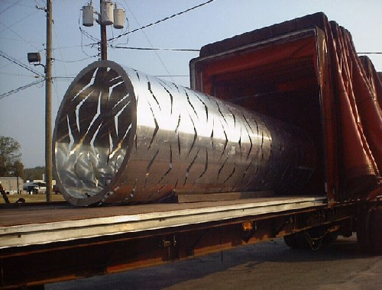
Figure 1.12 A Large-Scale Work

Technical Capabilities
Cutting up to 250 mm thickness (then, the jet diverges)

Advantages
-No problem about nozzle wear compared to AJM,
-No heat damage,
-Cutting can start at any location,
-Gives clean (dust-free) and sharp cut (minimum kerf),
-Water is cheap, available and non-toxic,
-High cutting rates.

Machine Tool (Figure 1.13)

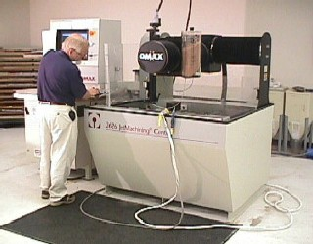

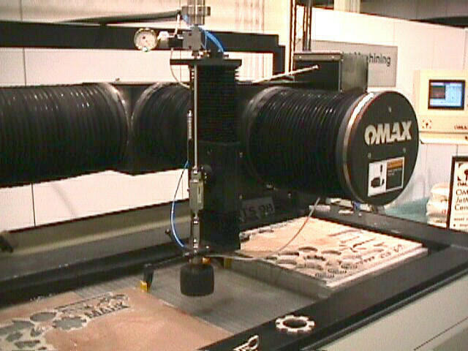
Figure 1.13 WJM Machine Tool

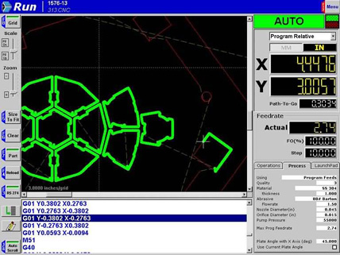
Figure 1.14 PC Control Screen

2. ABRASIVE WATER JET MACHINING (CUTTING) (AWJM) (AŞINDIRICILI SU JETİ İLE KESME)

Commonly used abrasives:

Garnet
- It is the most common type of waterjet abrasive.
- Hard and sharp. Ideal for cutting through hard materials.
- Produces a smooth finish.
- Relatively inexpensive.

➣ Silica Sand (SiO₂)
- Less expensive than garnet.
- It can be used to cut through soft materials.
- Produces a rough finish.
- Softer than garnet. It may not be suitable for cutting through hard materials.

➣ Aluminum Oxide (Al₂O₃)
- Harder than garnet. Ideal for cutting through very hard materials.
- Produces a smooth finish.
- More expensive than garnet.

Figure 2.1 Nozzle Principle

Figure 2.2 Schematic Presentation of Abrasive Mixing in the Nozzle
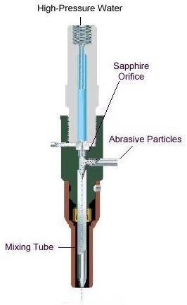  Figure 2.3 AWJM Nozzle Cross-section | 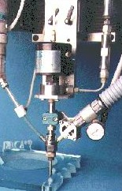  Figure 2.4 Nozzle
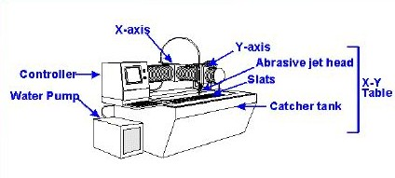
Figure 2.5 AWJM Machine Tool

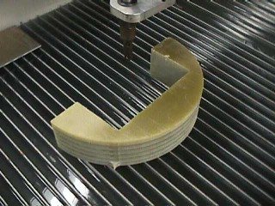  Figure 2.6 Grate Table | 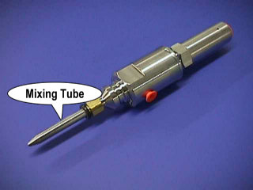  Figure 2.7 Nozzle
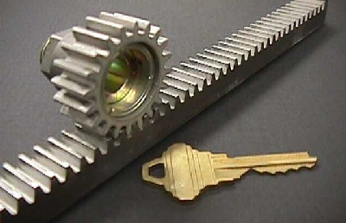

Figure 2.8 Pinion And Rack Cut By AWJM
--------------------------------------------------------------------------------------

3. ELECTRIC DISCHARGE MACHINING (EDM)

(ELEKTRO EROZYON İLE İŞLEME)

Applications
Lazarenko (1943) discovered the erosive effects of electric discharges. Usage is favorable for
- Hard metals or alloys which conventional techniques cannot machine
- Very complex shapes.
Figure 3.1 Electric Discharge Machining

Mechanism of Metal Removal
When a voltage is applied between the electrodes, an electric field builds up. Electrons are removed from the cathode surface and impelled towards the anode due to the electric field (Figure 3.1). During their travel, they collide with neutral molecules of the dielectric, detaching electrons and causing ionization. Since the channel is narrow, a continuous current flows (electrons moving along the channel to the anode). Due to increased channel temperature, the fluid evaporates, increasing the flow density. The discharge temperature in the channel is 8.000 - 12.000º K. This causes fusion (melting) or partial evaporation of metal and dielectric at the discharge point. The metal in liquid drops is dispersed in the dielectric due to the explosive pressure of gaseous products in the discharge (Figure 3.2a and 3.2b).

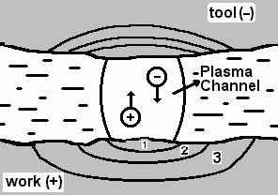
(a)

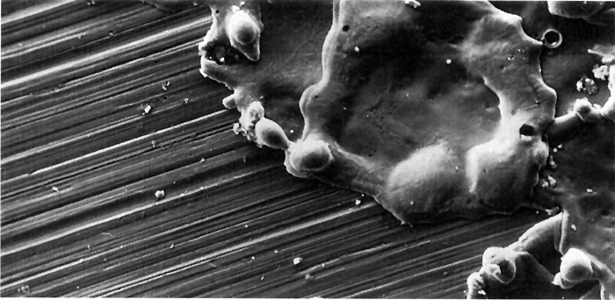
(b)
Figure 3.2 a) Crater Removed by a Plasma Channel ("1" evaporated (100% removal, "2" boiled (70-80% removal), "3" melted (18 - 20% removed)),
b) Crater formed by a single spark on a ground surface

The popularity of the EDM process is due to the following advantages;
- For electrically conductive materials (physical and metallurgical properties are not effective)
- No physical contact (no mechanical deformation)
- There is a slight thermal effect on the surface; the bulk of the material is not even heated.
- Complex shapes can be produced with high accuracy.
- The surface is formed by craters (craters provide better lubrication in some applications).
- It needs very little operator attention.

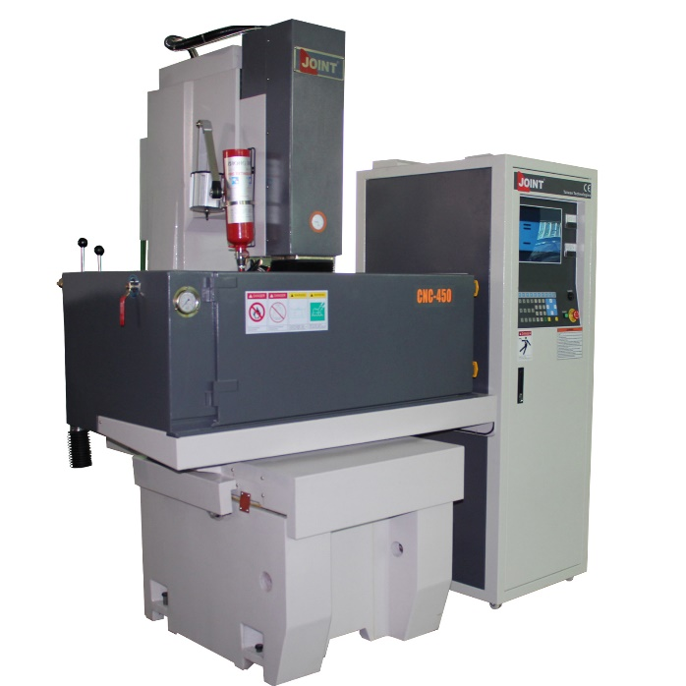

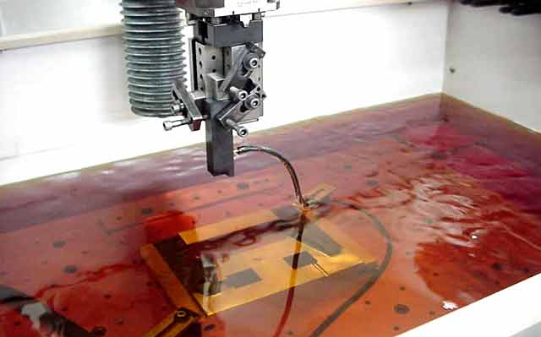

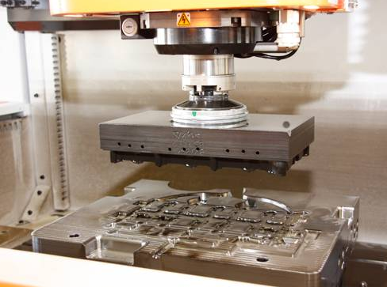

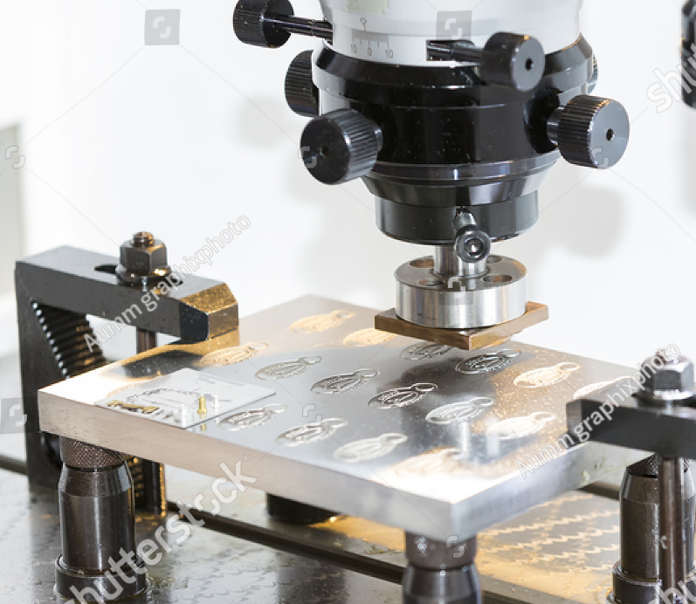
(a)

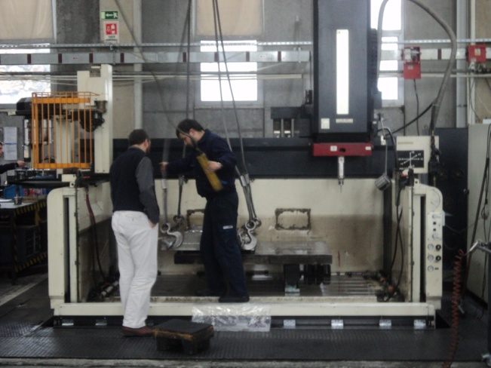

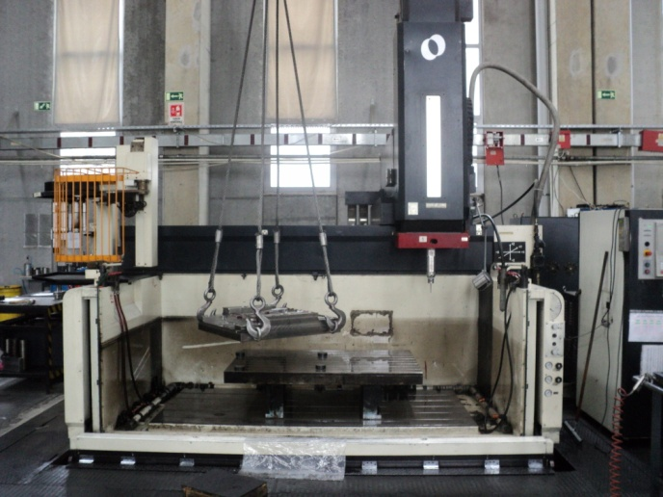
(b)

Figure 3.6 a) An industrial type EDM Machine Tool and Tank-Electrode Arrangements, b) A Big EDM Machine Tank (KAREL KALIP INC. Tuzla/İSTANBUL)
-------------------------------------------------------------------

Functions and Properties of Dielectric Fluids
-Remain electrically nonconductive until the required breakdown voltage is reached (i.e., it should have high dielectric strength).
-Breakdown electrically in the shortest time once the breakdown voltage is reached
-Provide an effective cooling medium
-Carrying away the swarf particles (work and electrode materials, decomposition products, hydrogen, carbon, bubbles)
-Good degree of fluidity
-Be cheap and readily (easily) available

Typical Fluids (the size of particles in the dielectric is ~ 3 - 5 μm)
-Light hydrocarbon oils (transformer oil, kerosene, paraffin oil, and lubricating oils)
-Silicon-based oils

Typical Electrode Materials and Their Characteristics
80% of the money spent on EDM is due to the tool electrodes (their design, shaping and material) (Figure 3.9a). So, it must be chosen very carefully.
Material | Wear | MRR | Fabrication
Copper | Low | High  (for roughing) | Easy
Brass | High | High  (for finishing) | Easy
Tungsten | Lowest | Low | Difficult
Tungsten Copper | Low | Low | Difficult
Cast Iron | Low | Low | Easy
Steel | High | Low | Easy
Zinc-based alloys | High | High  (for roughing) | Easy
Copper Graphite | Low | High | Difficult

 | Tool Electrode Design (Figure 3.9). If there are three electrodes;
Electrode |  | Electrode #1  (smaller than the final cavity size) | Electrode #2  (near the final cavity size) | Electrode #3  (almost equal to the final cavity size
Metal Removal (%) |  | 80 | 18 | 2
Machining Rates |  | High | Medium | Very low

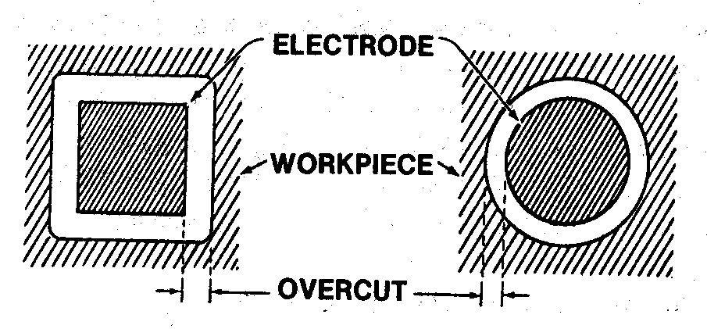
Figure 3.9 Overcuts Between Tool Electrode and Workpiece

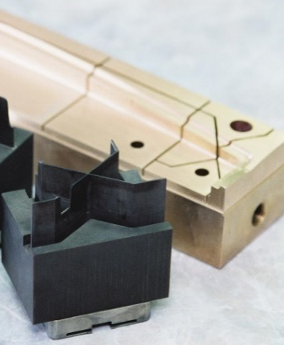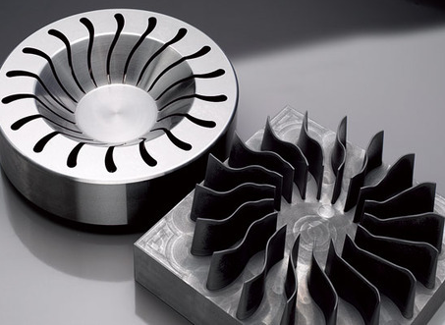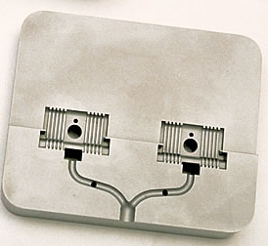

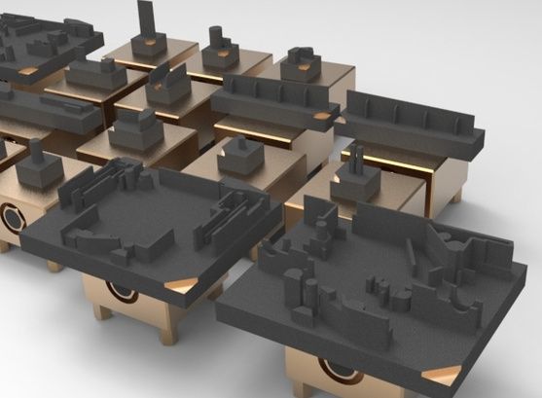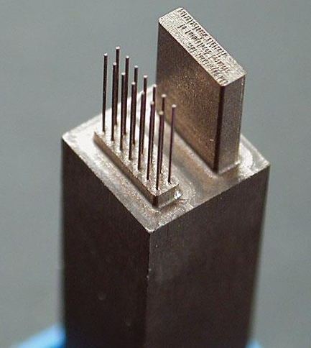

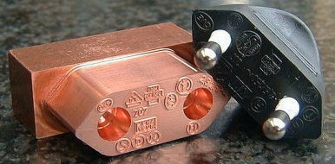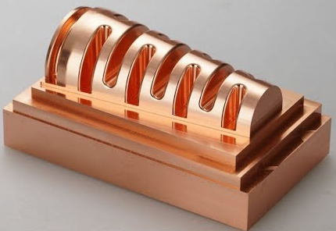

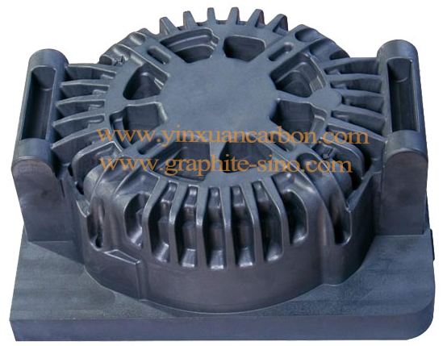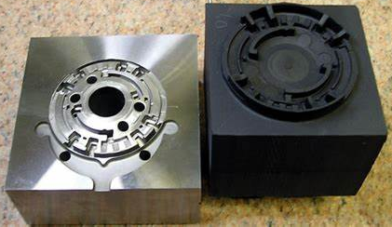

Figure 3.9a Some electrodes and their machined surfaces

Surface Finish
-R_{a} is 0.8 - 4 μm (with special setup 0.2 μm).
-The quality of the surface mainly depends on the spark's energy. If the energy content is high, deeper craters will produce a poor surface.
-Surface roughness is inversely proportional to discharge frequency (R_{a} ~ 1 / f).

Technical Capabilities
-Accuracy =± 0.025 - ± 0.1257 mm.
-Taper= 0.0005 - 0.005 mm/mm
-H/D = Aspect ratio (when drilling small holes) = 30/1
-MRR = 0.01 - 0.1 cm³/hr (finishing). MRR can be 15-20 times higher than finishing values in roughing operations.

Applications of EDM in Industry
It is reported that the use of EDM as;
-50% die shops
-30% captive (demand-based) industrial tool rooms
-10 % aerospace
-5% automotive parts
-5% others

The application fields (Figure 3.12a-12c)
-Difficult (hard) to machine materials (electrically conductive),
-Deep cavities,
-Conical machining, die cavity sinking,
-Small holes, narrow slots,
-Micromachining (small scale),
-Repair work of dies, through holes,
-Complex shapes,
-Non-circular holes.

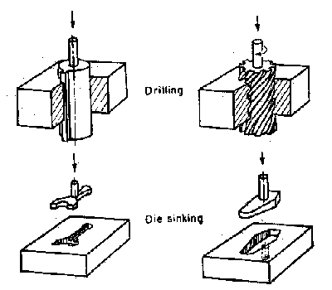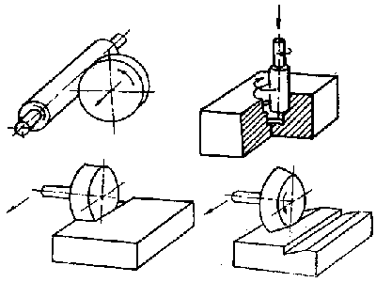

Figure 3.12a Some Applications of EDM

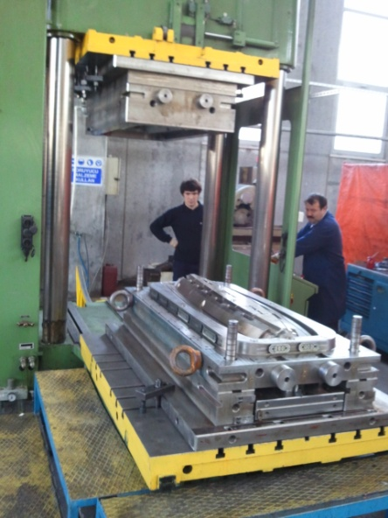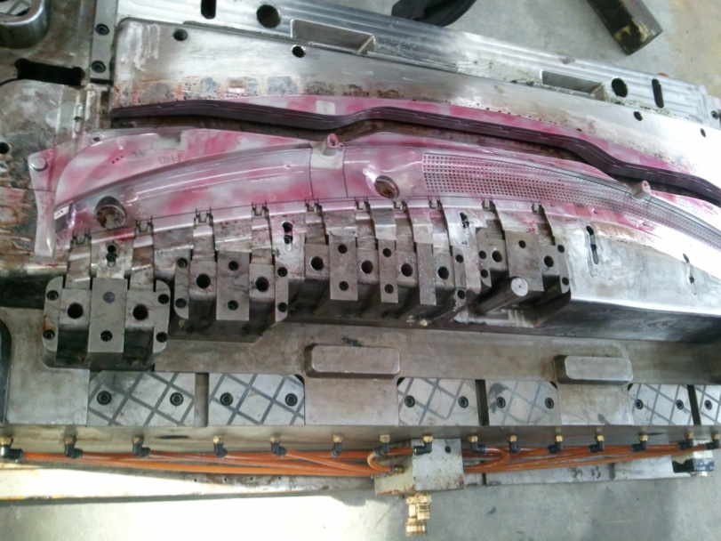
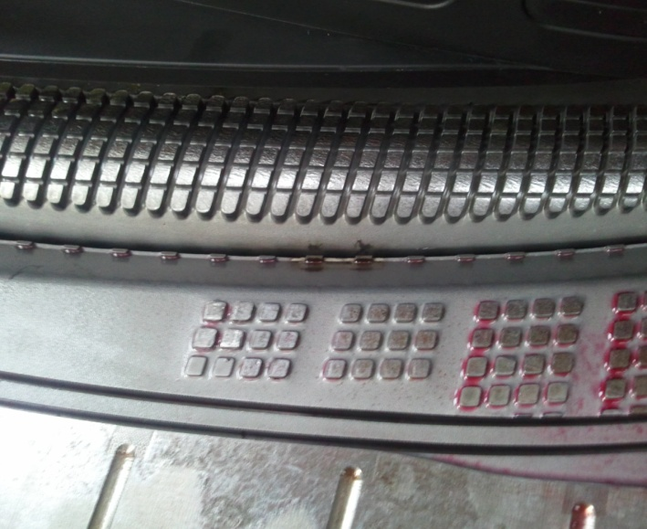

Figure 3.12b The EDMed Die Surfaces (KAREL KALIP INC.-Tuzla/İSTANBUL)

SME Video/Machining Processes
---------------------------------------------------------------------------------------------

4. WIRE EDM (WEDM)

(TEL EROZYON İLE KESME)

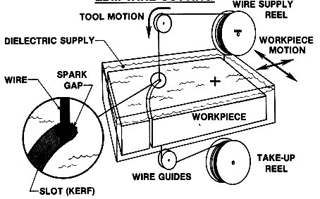
a)

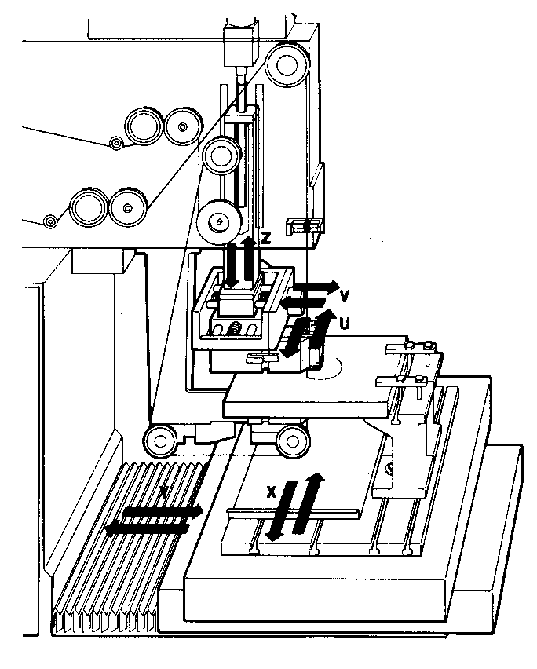
b)
Figure 4.1 Principle of WEDM, Movements of Wire and Workpiece

General Application
Applicable for 2D cutting processes. A wire is used instead of a shaped electrode in die-sinking EDM.
Machining Principles

- Wire (Figure 4.2)
d₁>d₂
d=0.15 - 0.3 mm for copper and brass wire
d=0.05 - 0.15 mm for molybdenum steel wire

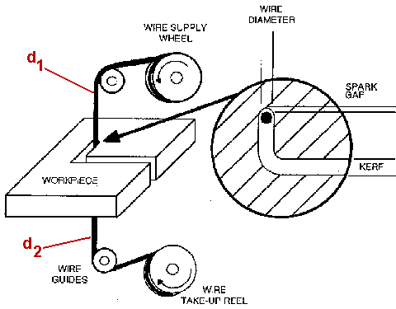
Figure 4.2 Cutting Width (KERF) in WEDM
b) Dielectric
Dielectric is "deionized water".
- KERF (Figure 4.2)

a: KERF
x: spark gap (0.025-0.05 mm)
a = 2x+d
a_{min}= 0.1 mm.

- Motions
-u and v are the motions of the upper guide to the lower guide to cut in angle (u, v displacements are max. 35 mm distance) (Figure 4.1b).
-x, y, u and v movement axes are controlled by CNC.
-During machining (cutting), the table controls the movement route for replacing the wire-pushing.

Technical Capabilities
-Linear cutting speed, V_{x}, V_{y} = 38 - 115 mm/hr
-Wire-speed = 8 - 42 mm/s
-Only for through cutting.
-Accuracy = ±0.007 mm (common)

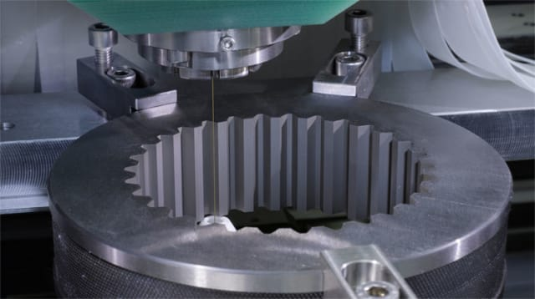

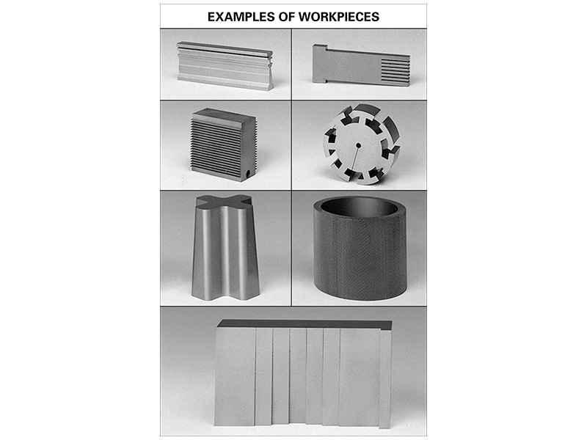

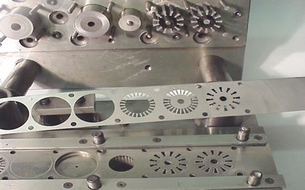

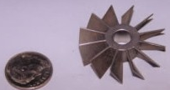

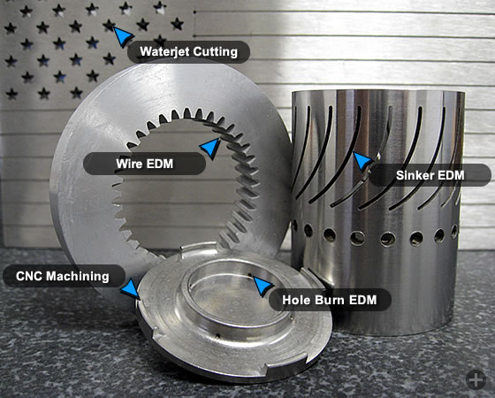
Figure 4.3 WEDMed Workpieces

SME Video/Machining Processes

5. LASER BEAM MACHINING (LBM) (CUTTING/DRILLING/WELDING)

(LASER İLE İŞLEME (KESME/DELME/KAYNAK))

LASER (Light Amplification Using Stimulated Emission of Radiation)
Sun's radiation: 7 kW/cm² (on the sun's surface)
In laser for short pulses: 10 kW/cm² (on beam cross-section)

Principles
-If a laser beam is focused on (1/100) of mm², E=105 kW/cm², this heat vaporizes any known materials.
-The laser rod is excited by a xenon-filled flash lamp that surrounds it.
E_{(usable)} = 10⁶ - 10⁷ kW/cm²
Efficiency = E_{usable} / E_{supply} = 0.5 - 50 %

Material Removal Mechanism
Melting and evaporation of the workpiece material under extensive heat

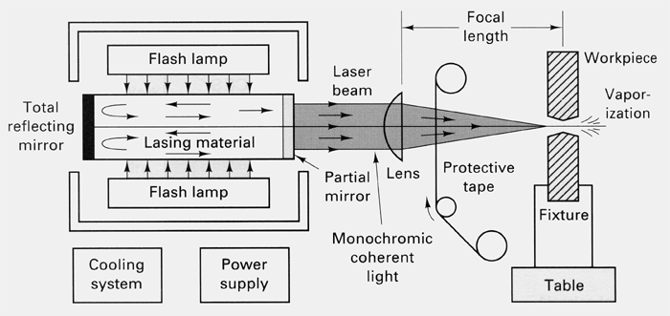
Solid-State LBM Mechanism (nowadays, instead of flash lamps, laser diodes are used due to their light efficiency).

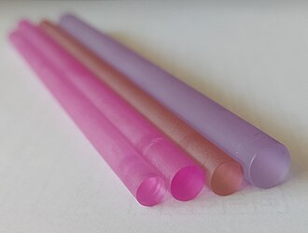
Lasing materials for Solid-state lasers: Ruby, Er-YAG, and Nd-YAG laser rods.

(a)
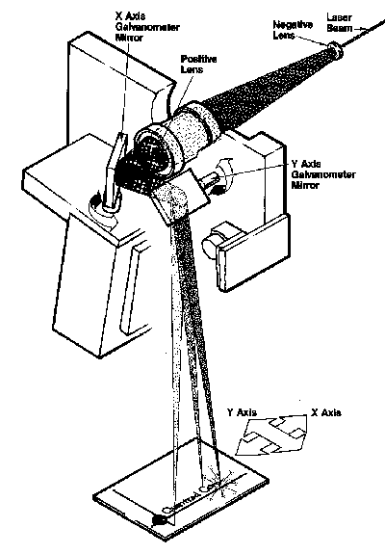
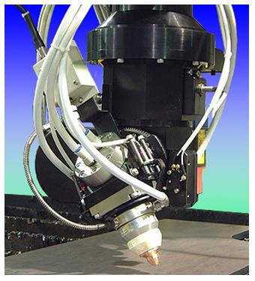

5-DOF Laser Drilling Machine
(b)

Figure 5.1 LBM Mechanism

Laser Types and Materials
Continuous waves  (CW) |  | Heavy and continuous machining
Pulsed waves |  | drilling of small areas
Pulsed waves |  | for thin material (sheets)

Laser materials and performances
Laser Material | Wavelength  (μm) | Mean Power  (W) | η  (%) | Relative  Cost
CO₂ (gas) | 10.2 | 100 - 25.000  (400 - 1.500 common) | < 10 | 400
NdYAG (Continuous) * | 1.06 | Av. 400  (peak 20.000) | < 1 | 10 - 44
Nd YAG (Pulsed) *
Argon (gas) | 351 - 529 | - | < 0.1 | 3 - 9
CO (gas) | - | 2000 | 60
* Solid state of neodymium, yttrium-aluminum-garnet

Possibilities for Cutting (Figure 5.1a)
- Move the workpiece
- Move the laser equipment
- Move the lenses or mirror (the simplest way)

Applications
- LBM Drilling

-Round holes ranging from 0.127-1.27 mm can be drilled.
-L/D ratios = 100/1
-Heat affected zone thickness = 0.002 - 0.1 mm
-Diametric repeatability = ± 0.025 mm (or 10% of the diameter)

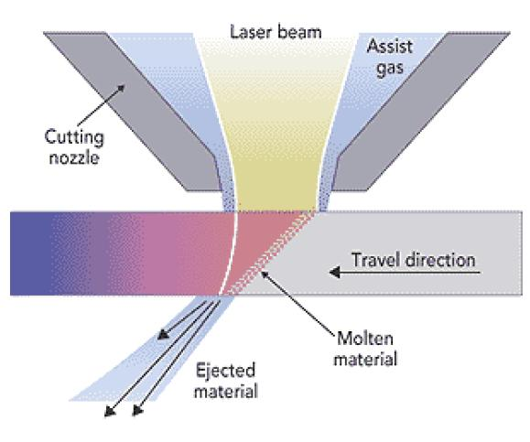
Figure 5.2 Gas-assisted Laser Cutting

- LBM Cutting (Figure 5.2)

-LBM Cutting = (Laser beam) + high-velocity gas to melt, vaporize and oxidize (oxygen (highest cutting speeds), air, argon (to prevent oxidation),)
- Cutting stainless steel is extensive.
-Holes with a diameter larger than 10 mm or holes that are not round are produced by CNC contour cutting.
-Trepanning can produce holes with a 0.5-10 mm diameter range. L/D = 20/1 (Figure 13.3).

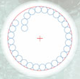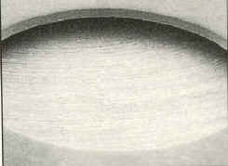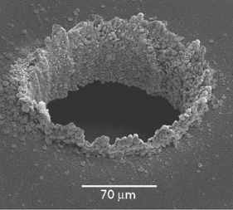
Laser trepanning Hole trepanning Micro hole trepanning.

Figure 5.3 Laser trepanning

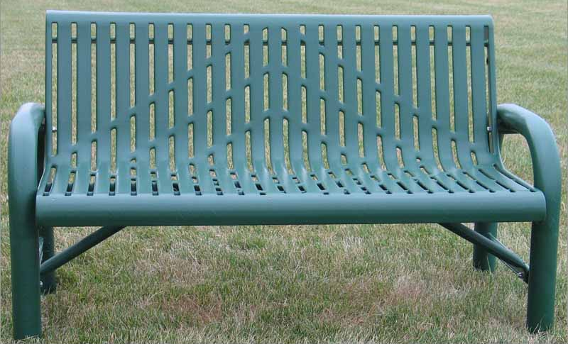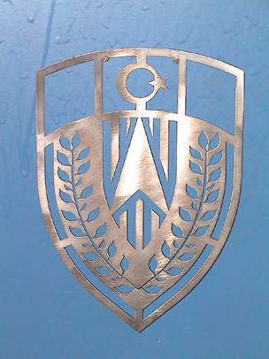

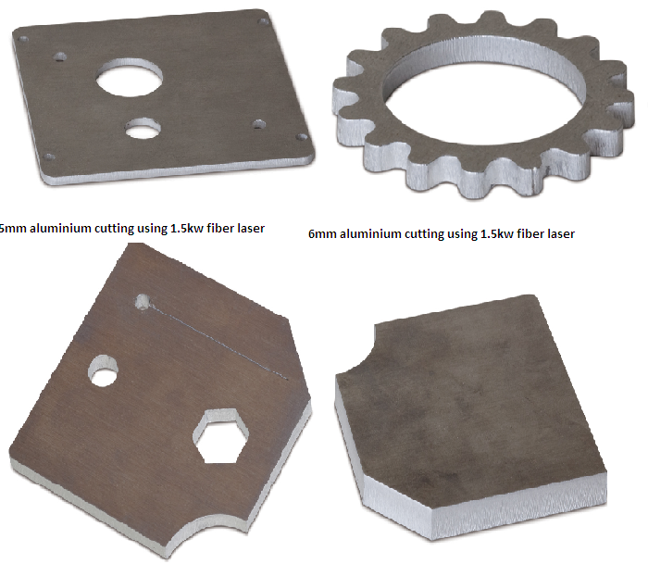

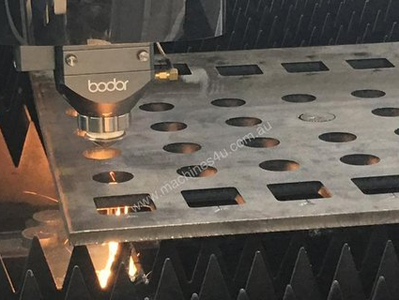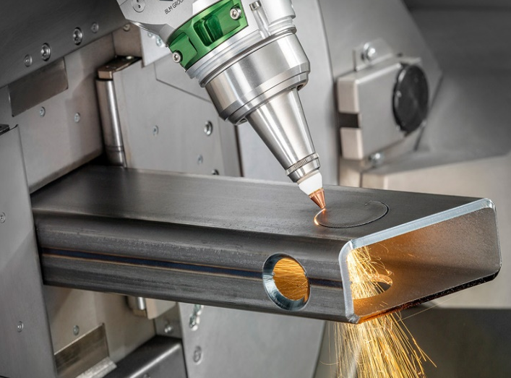

Figure 5.4 LBM Cut Parts

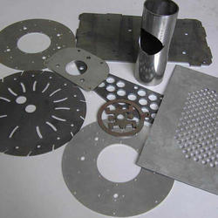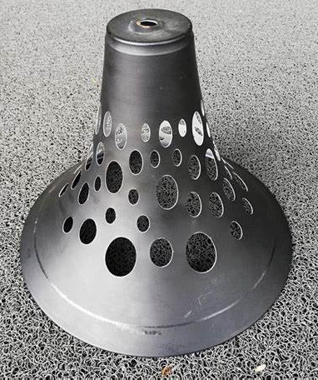

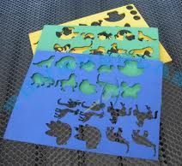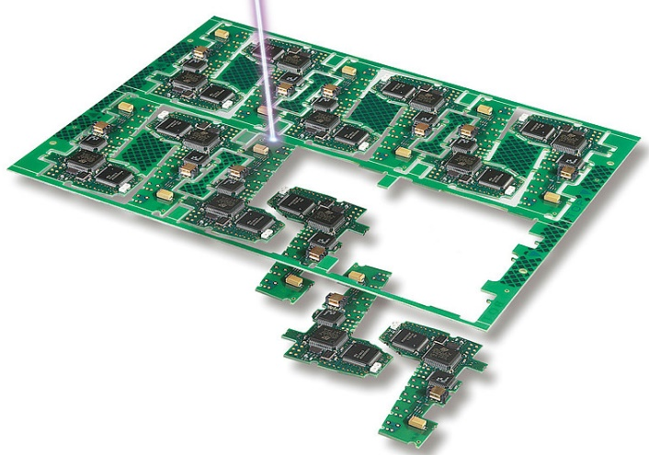

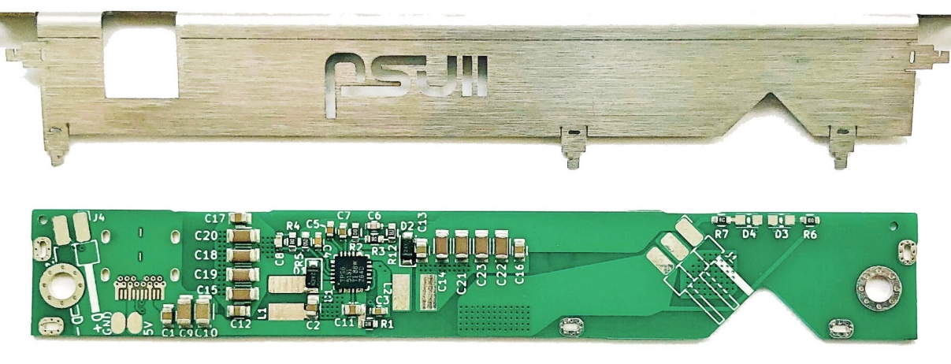
Figure 5.4 (cont'd)

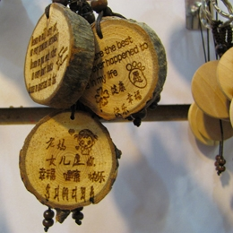 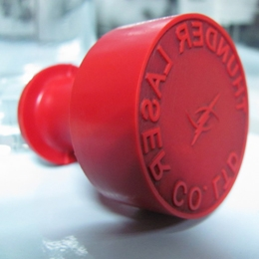 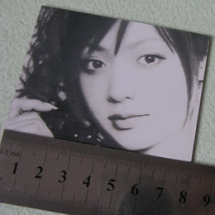 Wood engraving Stamp engraving Photo engraving

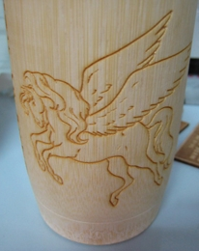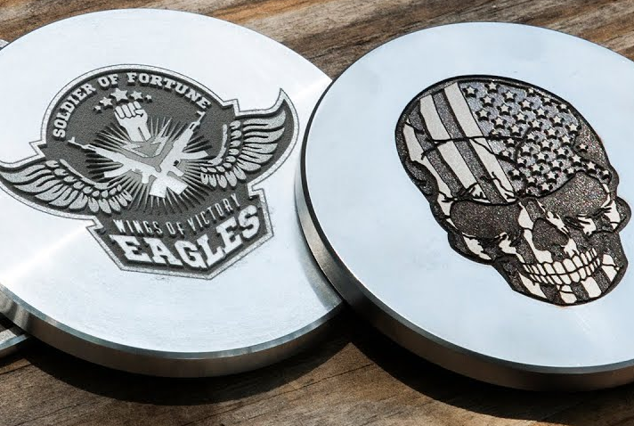
Cylinder item Metal engraving

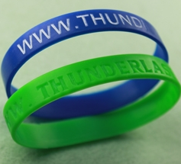
Plastic engraving

Figure 5.5 Laser Engraving

- Laser Engraving (Figure 5.5)

Laser engraving (or laser marking) is the practice of using lasers to engrave or mark an object. The system is capable of engraving precisely on any metal and non-metal materials. YAG lasers (50-100W) and CO₂ (80W/100W) are common. The engraving speed is 0-1000mm/s. Worktables are the electrical type with up and down movements.

- LBM Welding

Used for spot and seam welding (Figure 5.6-a.). Weld penetration is limited to a maximum of 2.5 mm. Some seam welding and filling applications are shown in Figure 5.6-b

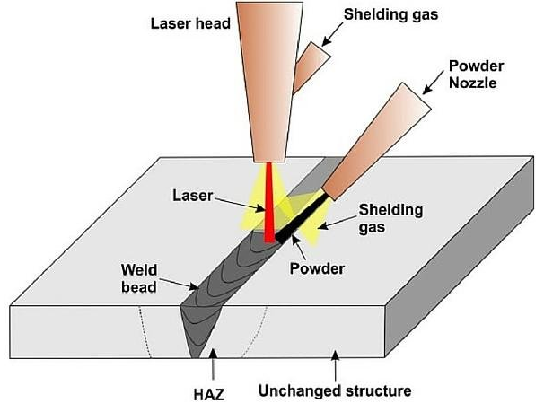
(a)

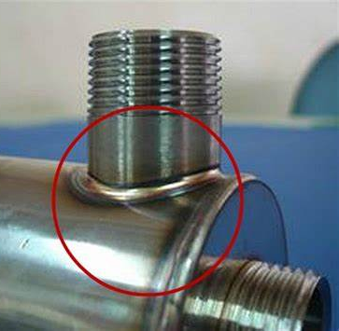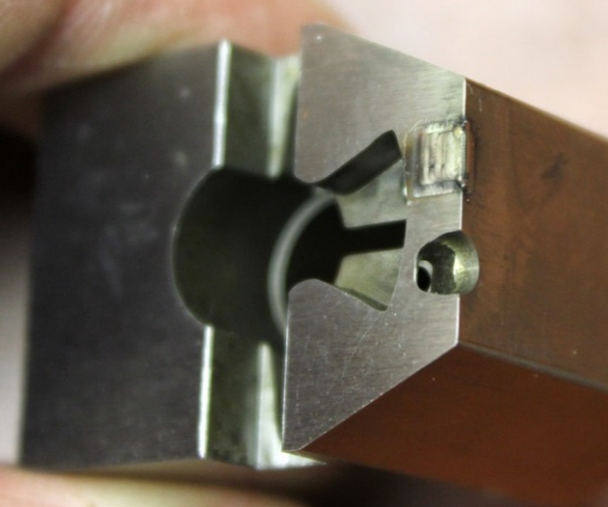

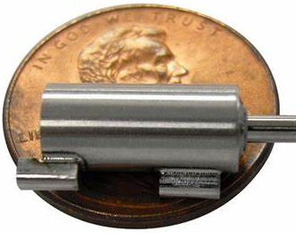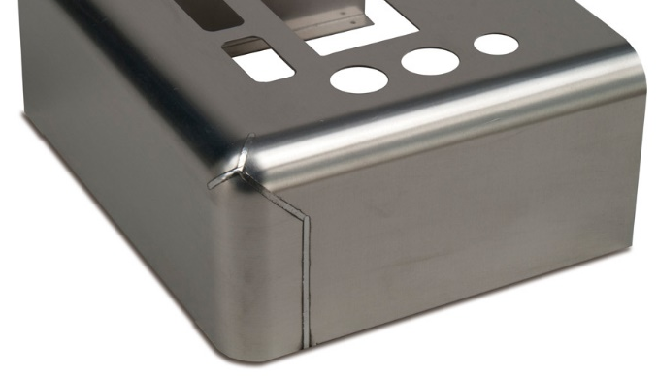

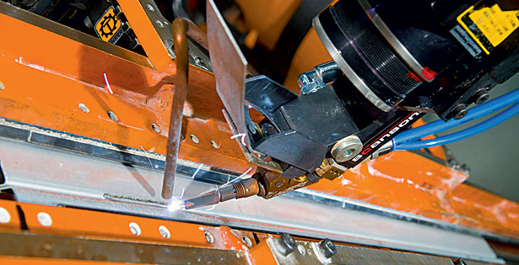

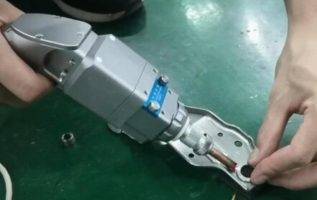

(b)

Figure 5.6 (a) Laser Welding Principle, (b) Laser Seam Welding and Filling Applications

