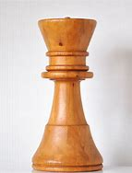
- Wood (60 mm height)

- Plastic (coated with Ni) (max dimension of each piece is 30 mm)

- Stainless steel (200 mm height)

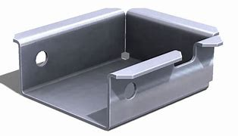
- St37 steel (100x90x38 mm, 1.5 mm thick)

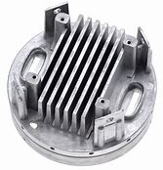
- Al alloy (180 mm diameter)

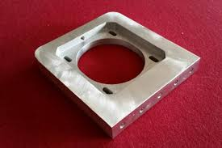
- Al, 10 mm thickness, 100x100 mm

- Alloy Steel, 6 kg, 500 mm length

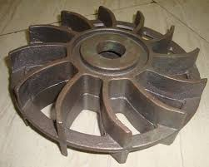
- Steel, 13 kg, 40 mm thick, 400 mm diameter

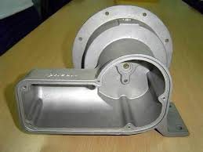
- Al alloy, 3 kg, 200x150x200 mm

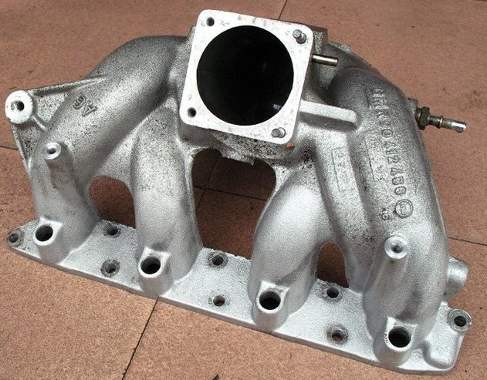
- Al Alloy (400 mm length)

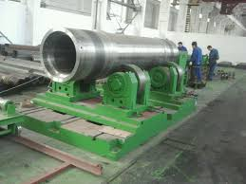
- Steel, 25 tons, 130 cm dia., 5 m length

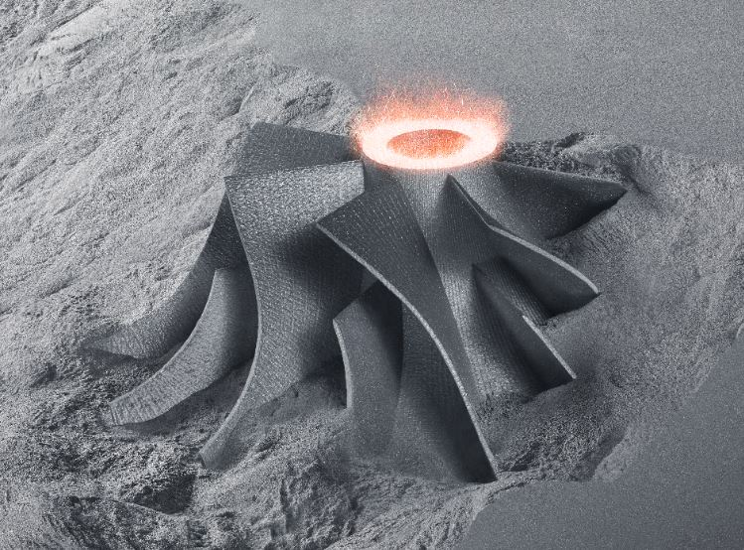
- Iron (80 mm height, 80 mm upper dia., 120 mm lower dia.)

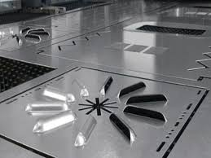
- 1.5 mm thick, stainless steel, 500x500 mm

- Al alloy (approx. 120 mm dia., 12 mm thick)

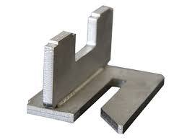
- SAE1020 Steel, 10 mm thick, 100x100x100 mm

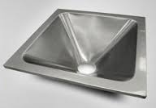
- Stainless steel, 1 mm thick, 550x550 mm

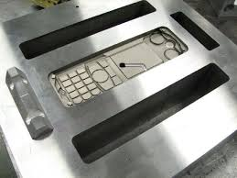
- SAE4140 Steel die (cell phone) (max dimension 180 mm)

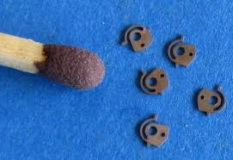
- Brass

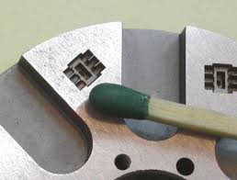
- SAE4140 Steel die

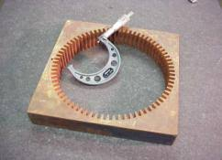
- Bronze (300x300x20 mm)

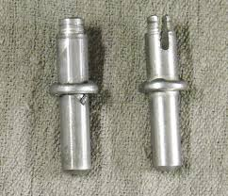
- Steel (only the slotting operation), 10 mm dia., 60 mm length

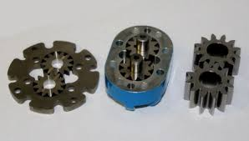
- Gear, st52 steel, (the right ones, 20 mm dia., 15 mm thick)

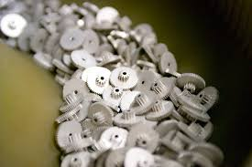
- Al gears (for toys, 10 mm dia.)

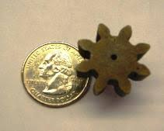
- Polymer (PMMA) gear (dimension reference to coin)

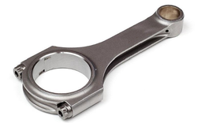
- Piston rod (steel) (180 mm length)

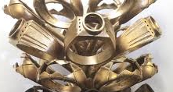
- Gold Ring (choose the front one)

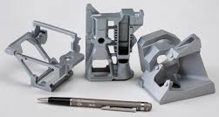
- Al parts (consider the left one)

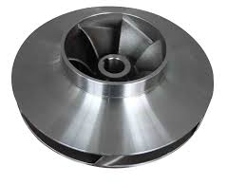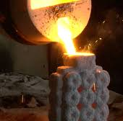
- Steel pump vane (single piece)(150 mm dia.)

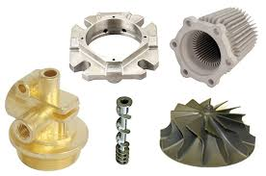
- Consider the top right one (spheroid iron steel, 200 mm dia.)

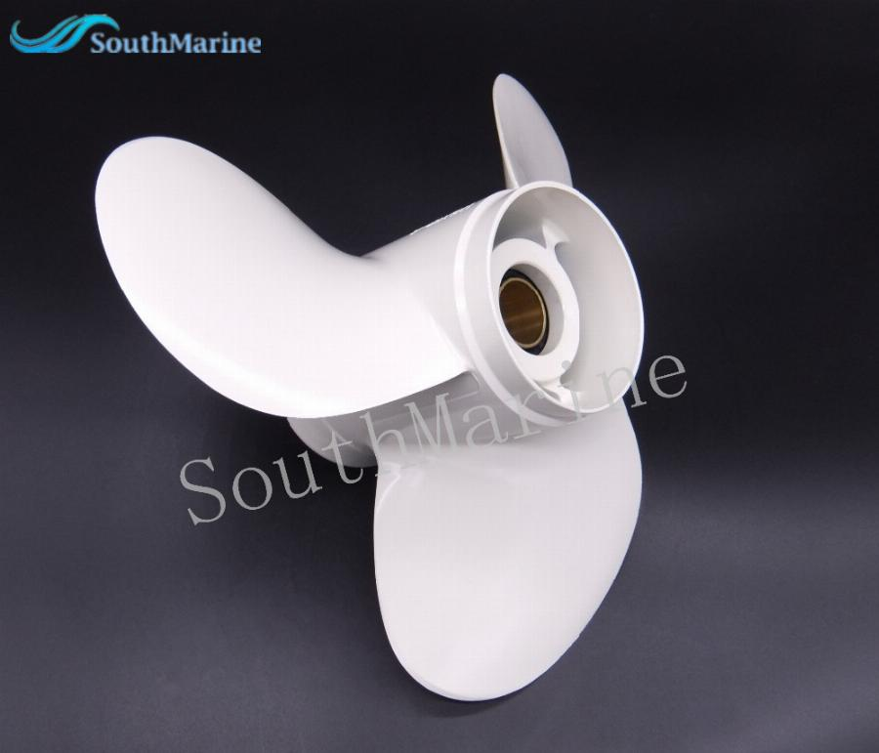
- Polymer marine propeller (100 mm diameter, 80 mm depth)

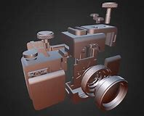
- Camera body parts (Al, consider the front cylindrical one, 60 mm dia.)

- Copper electrode and SAE2370 steel die (60 mm average dia.)

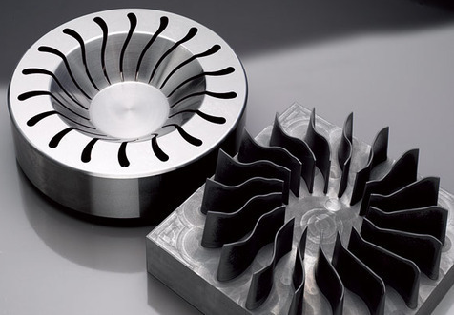
- steel die (with graphite electrode) (die, 120 mm outer dia.)

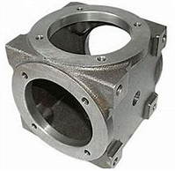
- St42 pipe junction, 18 kg, 50x50x50 cm

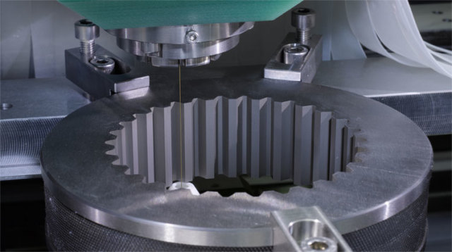
- Gear, St52 steel (inner profile cutting) (120 mm inner dia.)

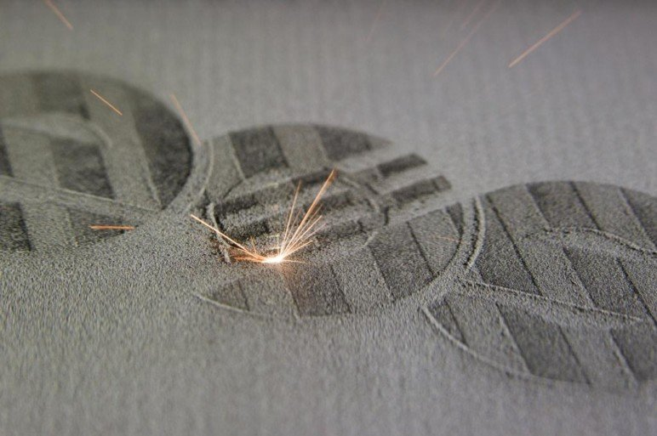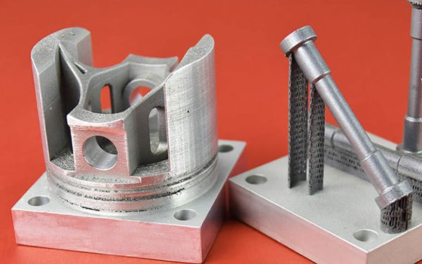
- Al part (consider the left part (i.e. piston), 70 mm dia.)

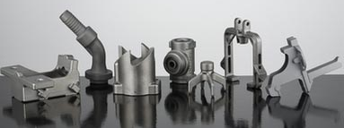
- Stainless steel, parts less than 0.2 kg. (consider the 3rd on the left)

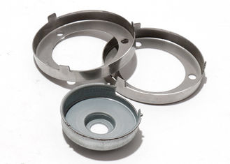
- Stainless steel (consider the left at the back, 0.8 mm thick, 50 mm outer dia.)

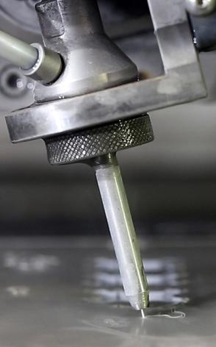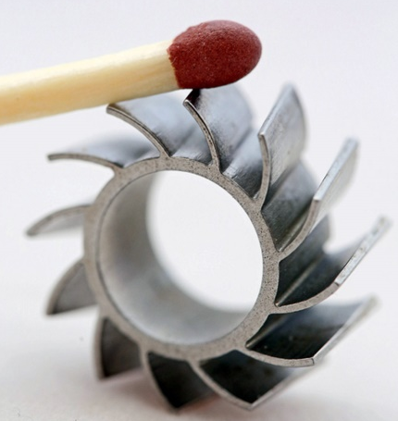
- Steel part (the middle figure)

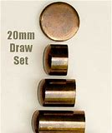
- Brass cartridge (the middle figure, 10 mm cartridge outer dia.)

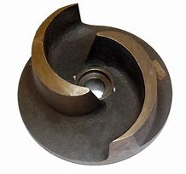
- Brass, pump rotor (2.5 kg, 20 cm dia.)

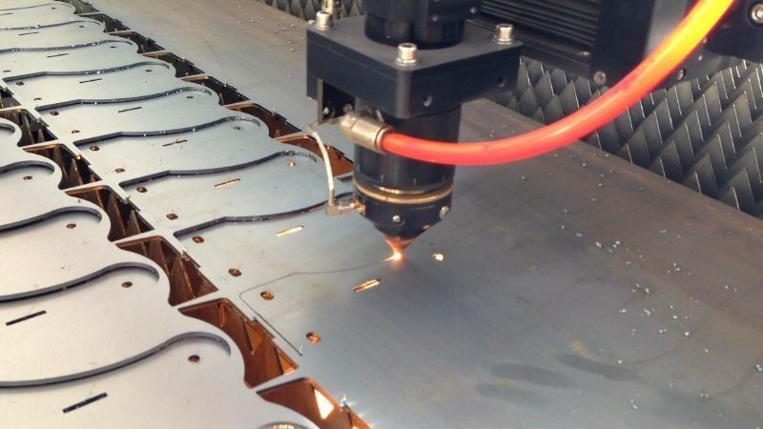
- St42 steel (80x40 mm, 0.8 mm thick)

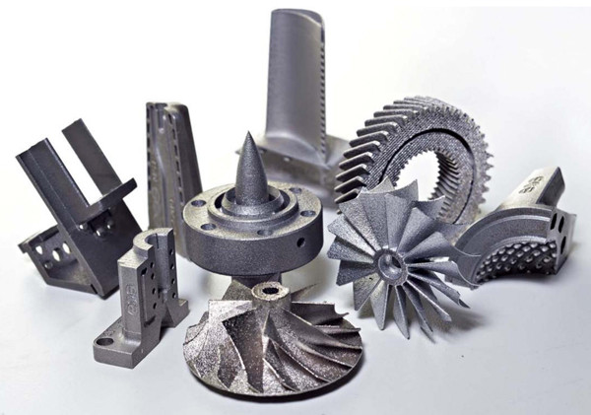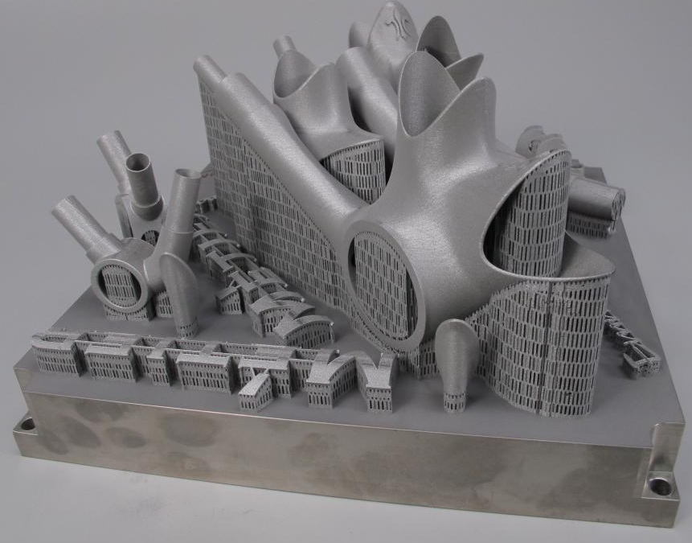
- Steel parts (consider the parts on the left figure, the behind one, 100 mm height)

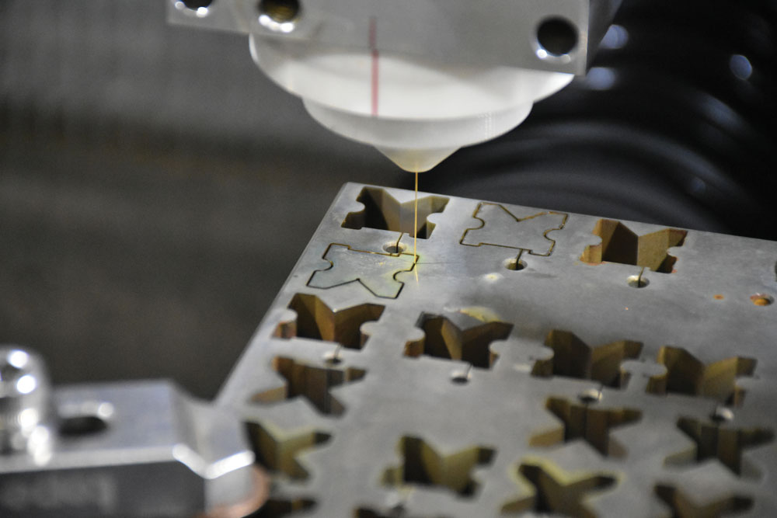
- Steel plate, 30 mm thick (each part 40x40x30 mm dimension)

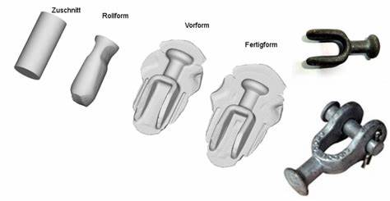
- St42 steel, connection part (120 mm length)

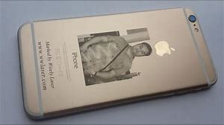
- Photo engraving on Al surface

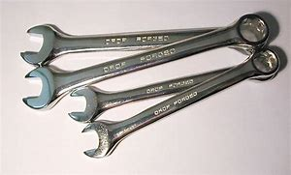
- Steel wrench (approx. length 180 mm)

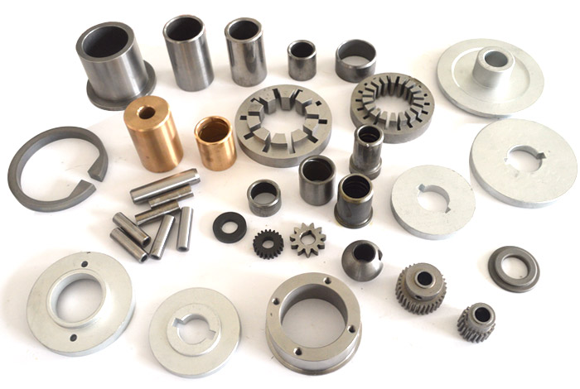
- Parts (made of Al, brass, steel) sizes less than 100 mm (choose the gear on the right, made of steel, 25 mm dia., 20 mm height)

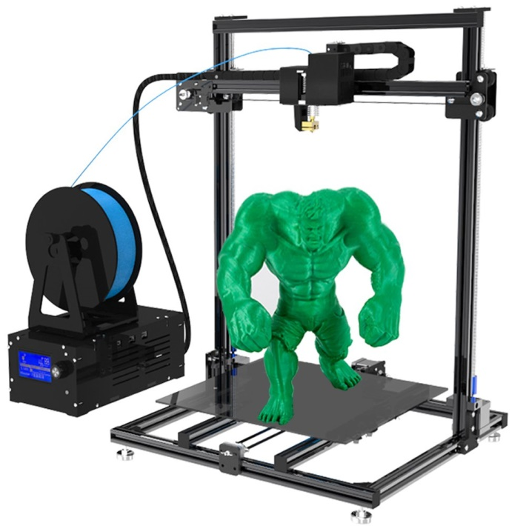
- Polymer HULK(120 mm tall)

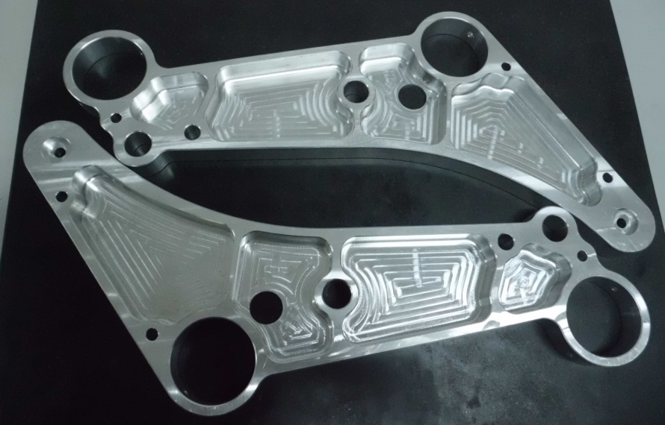
- 7XXX series high strength Al (220 mm overall length)

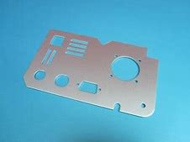
- Al, 1 mm thick, 100x180 mm

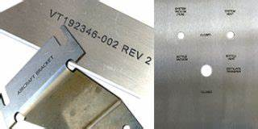
- Engraving (writings) on steel sheet

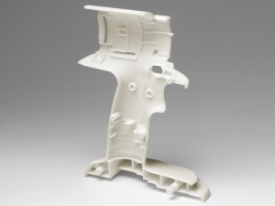
- Chargeable drill body (half) (Polymer ABS, 200 mm tall)

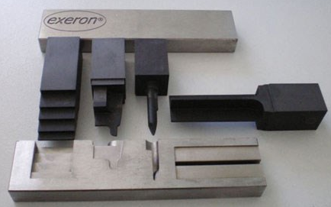
- Steel die sinking (choose the form on the left of the part, 40x40 mm)

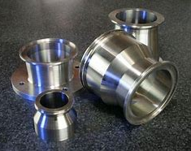
- SS304 stainless steel, diameters between 10 and 20 mm (choose the one at the right)

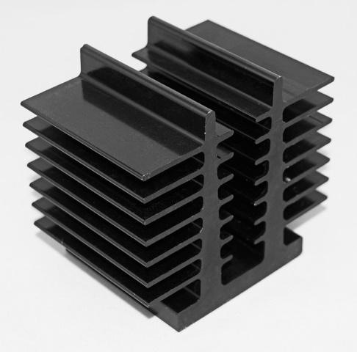
- Al cooler (surface coated by a black metallic substrate, 60x60x60 mm)

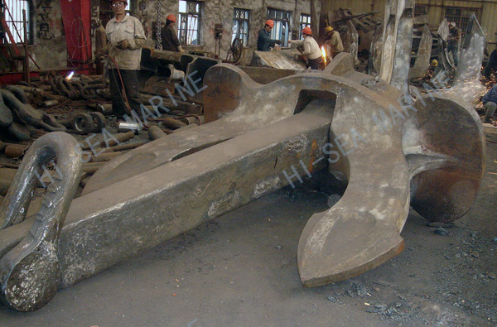
- Cruise ship anchor (iron, 5 m length, 20 tons)

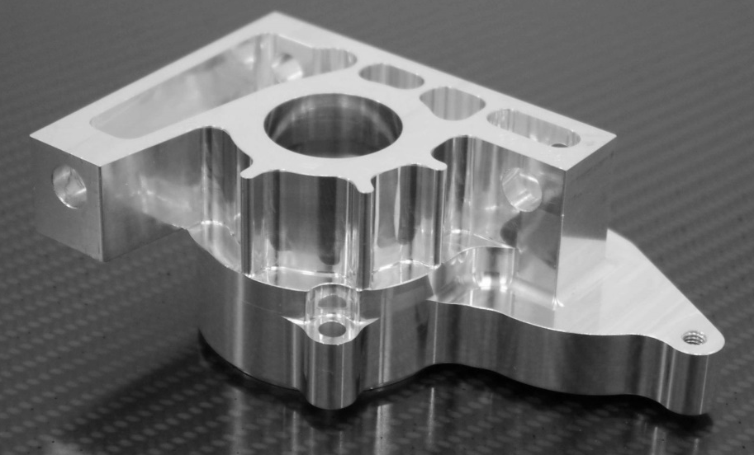
- Al, 200x100x80 mm

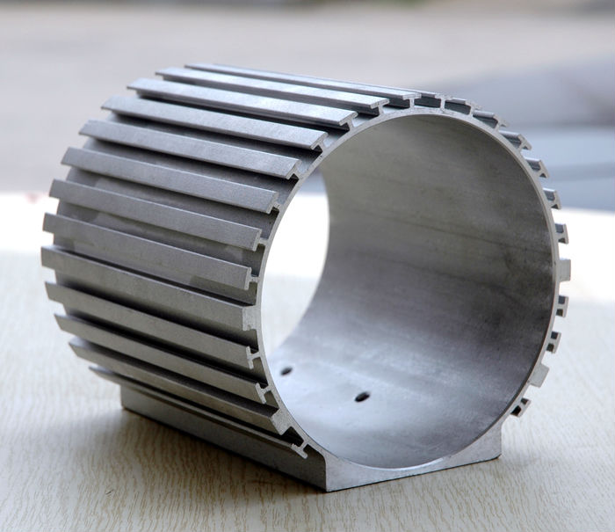
- Al, electric motor shell (180 mm inner hole dia., 240 mm long)

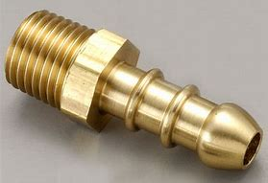
- Brass (raw is 20 mm hex material)

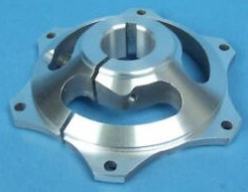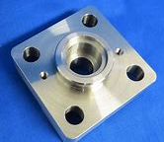
- Al (choose the left one, 150x150x70 mm)

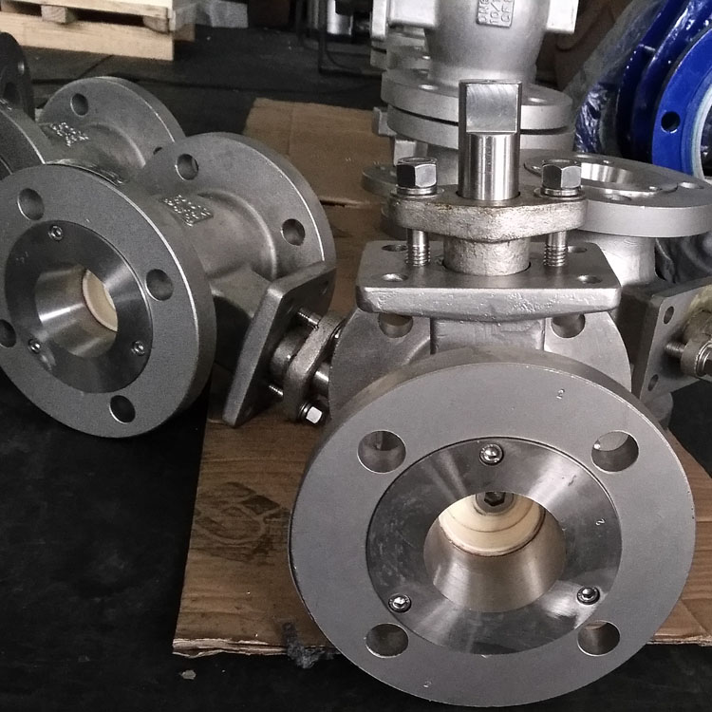
- Steel vane body (8.5 kg, outer flange dia. 220 mm, length 300 mm)

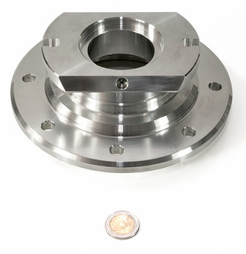
- GG70 Steel (take dimension reference to the coin)

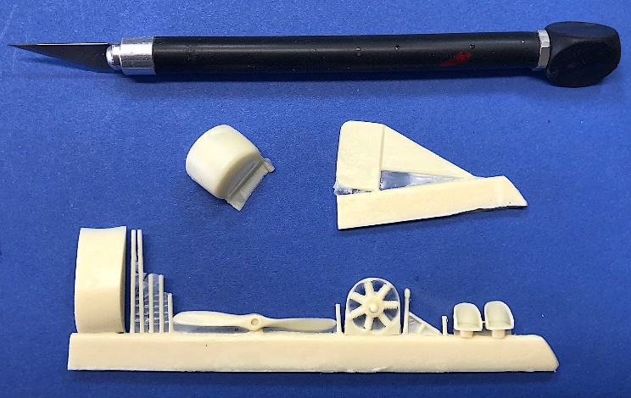
- Polymer parts (ABS, all together, 15 mm depth)

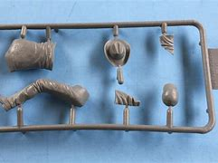
- Polymer (100x50 mm frame)

- OP1 (GG-30 grey cast iron, raw 100x70x15 mm)

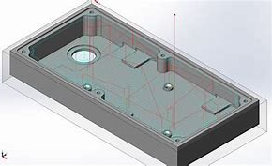
- OP2 (St42 steel, raw 100x70x15 mm)

- OP3 (Al7075, raw 100x50x50 mm)

- OP4 (12L13 steel, raw form 140x60x35 mm)

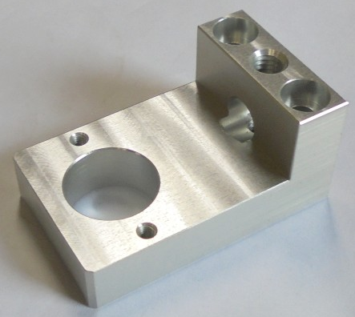
- OP5 (St37-3 steel, raw 180x60x60 mm)

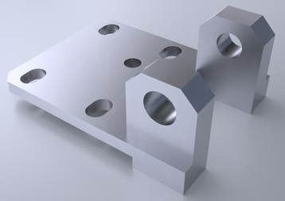
- OP6 (SAE4140 alloy steel, raw 180x60x60 mm)

………………………………………………………………………..
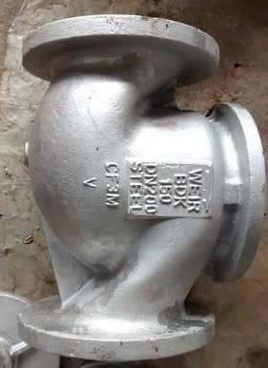
SAE1030 steel, length 300 mm, dia. 200 mm.
(Sand Casting, die casting, investment casting, continuous casting, rolling, forging, extrusion, wire drawing, piercing-blanking, bending, deep drawing, powder metallurgy, metal cutting (chip removal processes), AWJC, EDM, wire EDM, Laser cutting, FDM, SLA, SLS, DMLS)

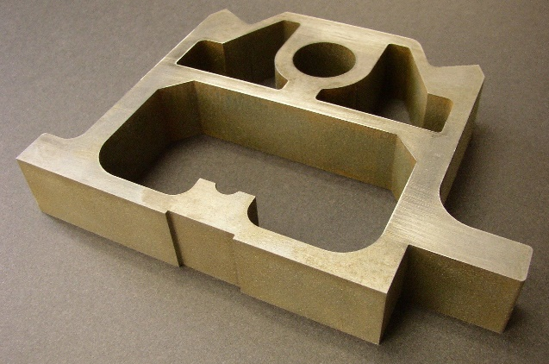
Brass, 150x100x15 mm
(Sand Casting, die casting, investment casting, continuous casting, rolling, forging, extrusion, wire drawing, piercing-blanking, bending, deep drawing, powder metallurgy, metal cutting (chip removal processes), AWJC, EDM, wire EDM, Laser cutting, FDM, SLA, SLS, DMLS)

Steel, dia. 35 mm, thickness 6 mm
(Sand Casting, die casting, investment casting, continuous casting, rolling, forging, extrusion, wire drawing, piercing-blanking, bending, deep drawing, powder metallurgy, metal cutting (chip removal processes), AWJC, EDM, wire EDM, Laser cutting, FDM, SLA, SLS, DMLS)

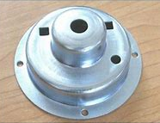
St37 steel, 50 mm outer dia., 0.5 mm thick
(Sand Casting, die casting, investment casting, continuous casting, rolling, forging, extrusion, wire drawing, piercing-blanking, bending, deep drawing, powder metallurgy, metal cutting (chip removal processes), AWJC, EDM, wire EDM, Laser cutting, FDM, SLA, SLS, DMLS)

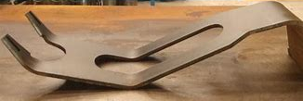
Al, 3 mm thick, 120 mm length
(Sand Casting, die casting, investment casting, continuous casting, rolling, forging, extrusion, wire drawing, piercing-blanking, bending, deep drawing, powder metallurgy, metal cutting (chip removal processes), AWJC, EDM, wire EDM, Laser cutting, FDM, SLA, SLS, DMLS)

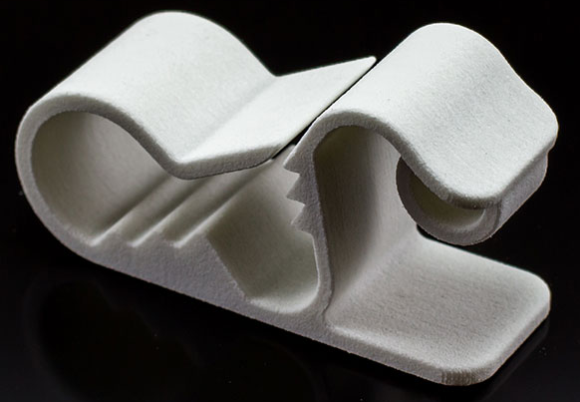
ABS, 150 mm length
(Sand Casting, die casting, investment casting, continuous casting, rolling, forging, extrusion, wire drawing, piercing-blanking, bending, deep drawing, powder metallurgy, metal cutting (chip removal processes), AWJC, EDM, wire EDM, Laser cutting, FDM, SLA, SLS, DMLS)

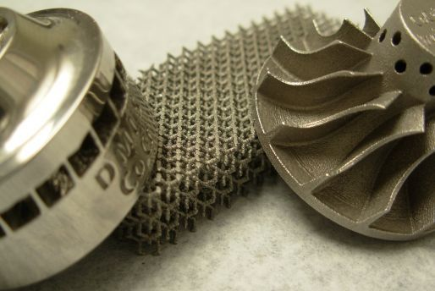
Brass, propeller dia. 80 mm.
(Sand Casting, die casting, investment casting, continuous casting, rolling, forging, extrusion, wire drawing, piercing-blanking, bending, deep drawing, powder metallurgy, metal cutting (chip removal processes), AWJC, EDM, wire EDM, Laser cutting, FDM, SLA, SLS, DMLS)

