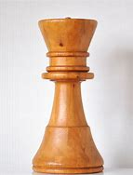
- Wood (60 mm height)

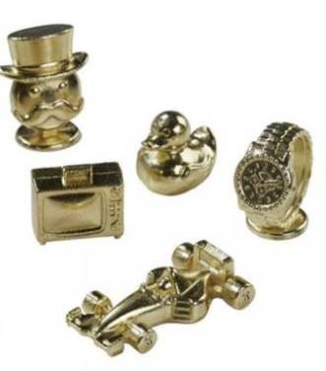
- Plastic (coated with Ni) (max dimension of each piece is 30 mm)

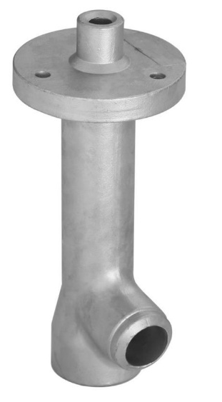
- Stainless steel (200 mm height)

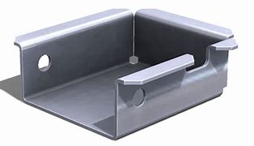
- St37 steel (100x90x38 mm, 1.5 mm thick)

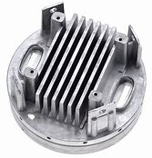
- Al alloy (180 mm diameter)

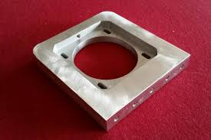
- Al, 10 mm thickness, 100x100 mm

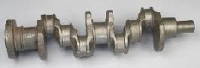
- Alloy Steel, 6 kg, 500 mm length

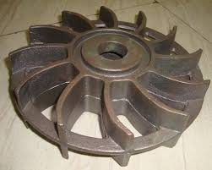
- Steel, 13 kg, 40 mm thick, 400 mm diameter

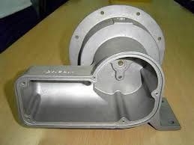
- Al alloy, 3 kg, 200x150x200 mm

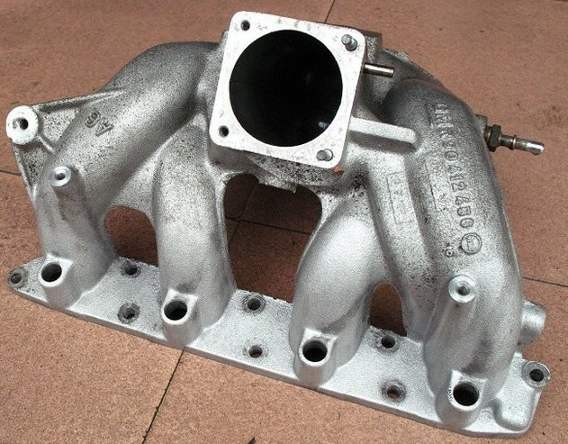
- Al Alloy (400 mm length)

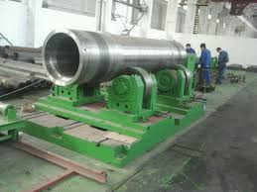
- Steel, 25 tons, 130 cm dia., 5 m length

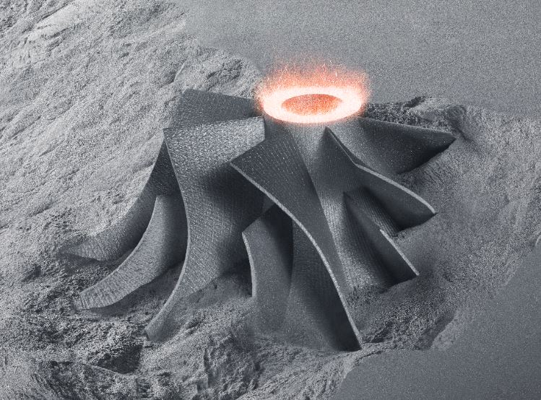
- Iron (80 mm height, 80 mm upper dia., 120 mm lower dia.)

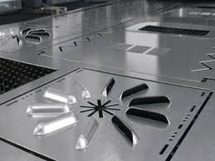
- 1.5 mm thick, stainless steel, 500x500 mm

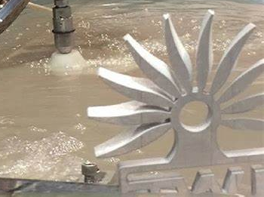
- Al alloy (approx. 120 mm dia., 12 mm thick)

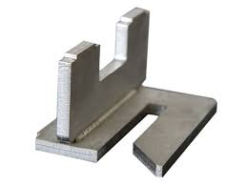
- SAE1020 Steel, 10 mm thick, 100x100x100 mm

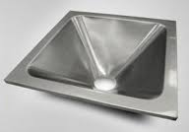
- Stainless steel, 1 mm thick, 550x550 mm

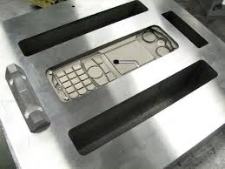
- SAE4140 Steel die (cell phone) (max dimension 180 mm)

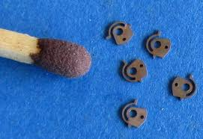
- Brass

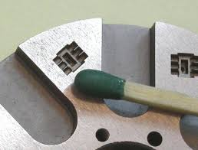
- SAE4140 Steel die

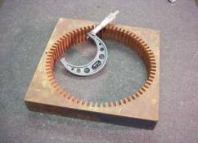
- Bronze (300x300x20 mm)

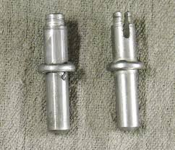
- Steel (only the slotting operation), 10 mm dia., 60 mm length

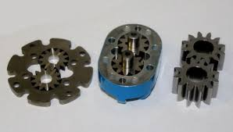
- Gear, St52 steel (the right ones, 20 mm dia., 15 mm thick)

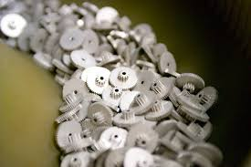
- Al gears (for toys, 10 mm dia.)

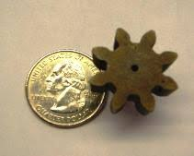
- Polymer (PMMA) gear (dimension reference to coin)

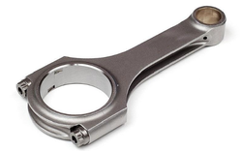
- Piston rod (steel) (180 mm length)

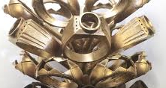
- Gold Ring (choose the front one)

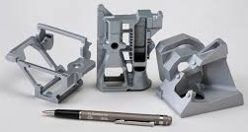
- Al parts (consider the left one)

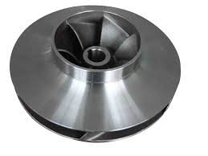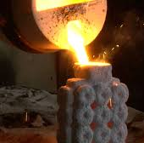
- Steel pump vane (single piece)(150 mm dia.)

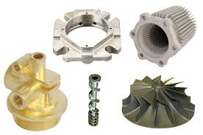
- Consider the top-right one (spheroid iron steel, 200 mm dia.)

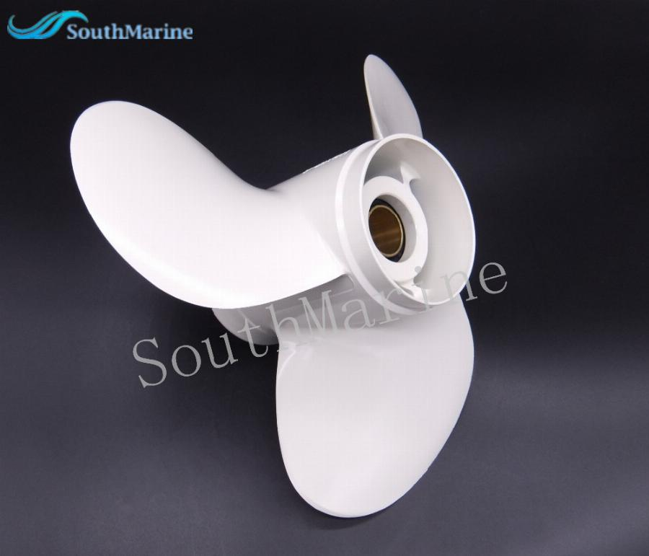
- Polymer marine propeller (100 mm diameter, 80 mm depth)

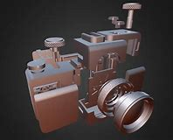
- Camera body parts (Al, consider the front cylindrical one, 60 mm dia.)

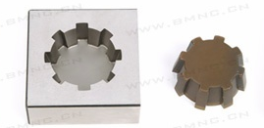
- Copper electrode and SAE2370 steel die (60 mm average dia.)

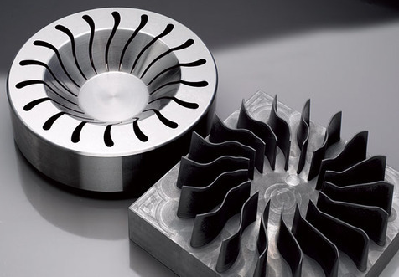
- steel die (with graphite electrode) (die, 120 mm outer dia.)

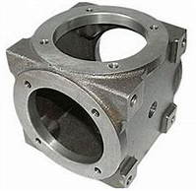
- St42 pipe junction, 18 kg, 50x50x50 cm

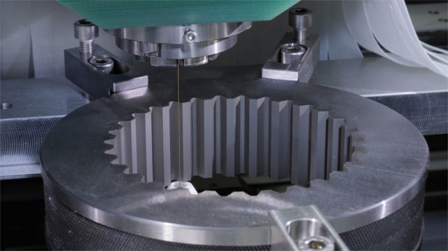
- Gear, St52 steel (inner profile cutting) (120 mm inner dia.)

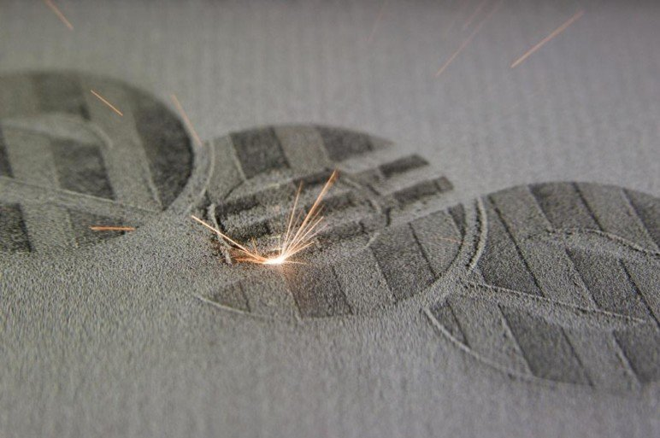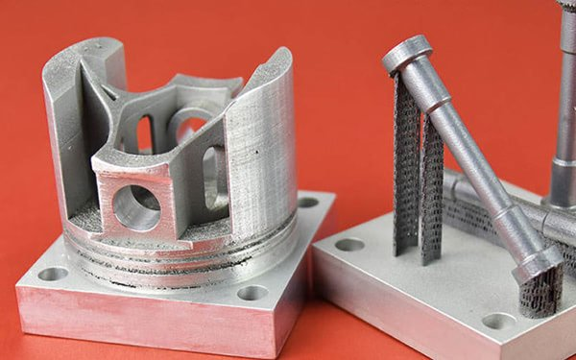
- Al part (consider the left part (i.e., piston), 70 mm dia.)

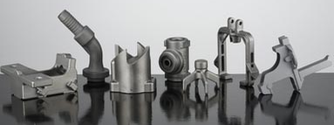
- Stainless steel, parts less than 0.2 kg. (consider the 3rd on the left)

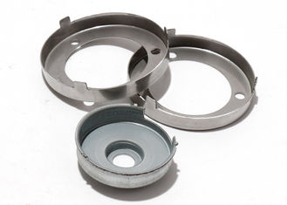
- Stainless steel (consider the left at the back, 0.8 mm thick, 50 mm outer
dia.)

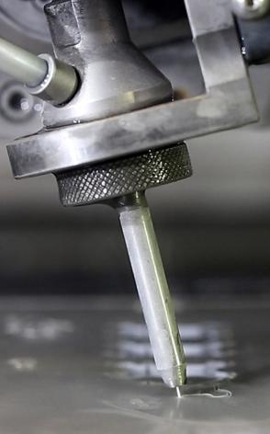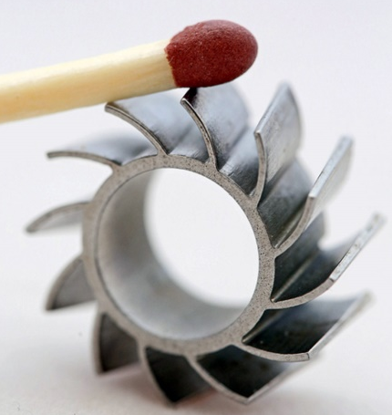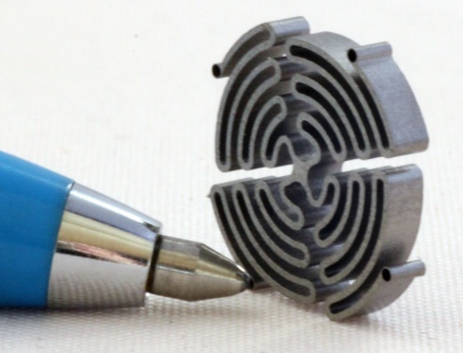
- Steel part (the middle figure)

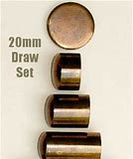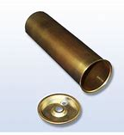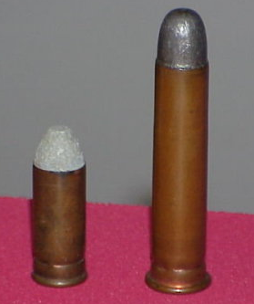
- Brass cartridge (the middle figure, 10 mm cartridge outer dia.)

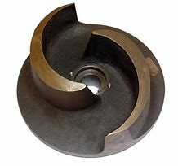
- Brass, pump rotor (2.5 kg, 20 cm dia.)

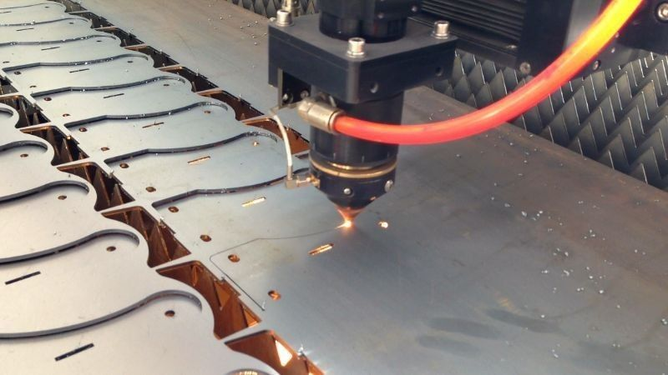
- St42 steel (80x40 mm, 0.8 mm thick)

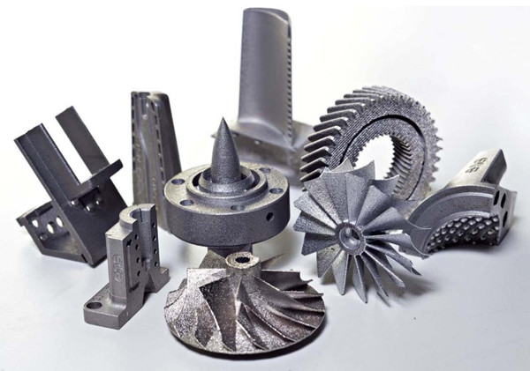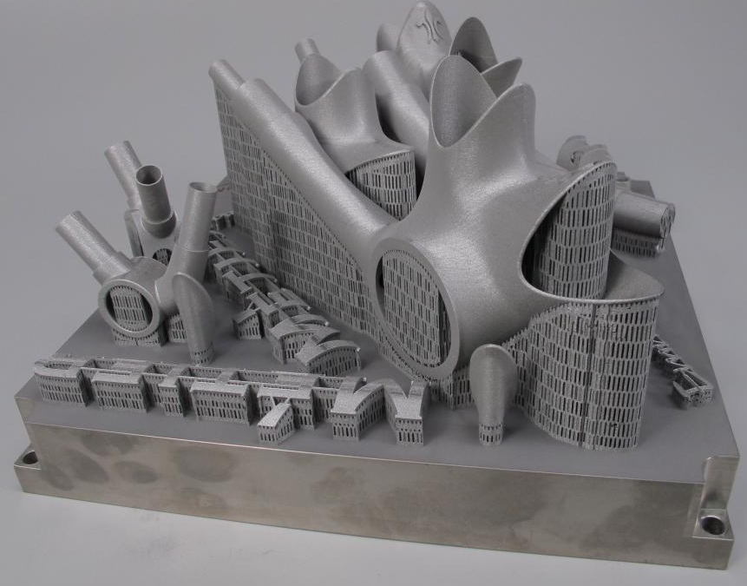
- Steel parts (consider the parts in the left figure, the one behind, 100 mm height)

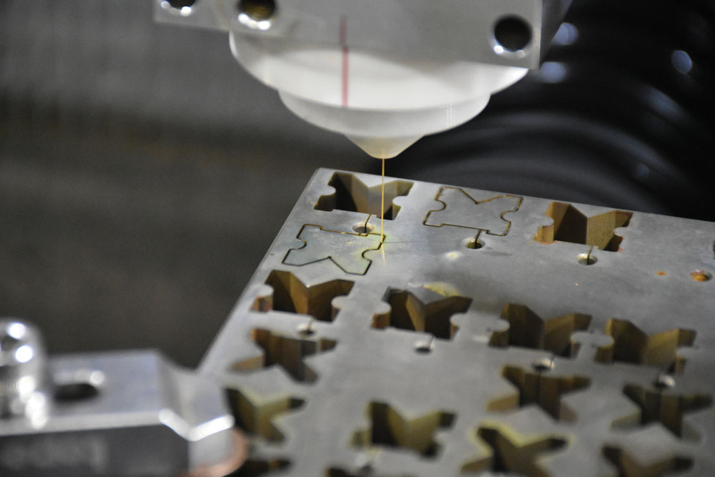
- Steel plate, 30 mm thick (each part 40x40x30 mm dimension)

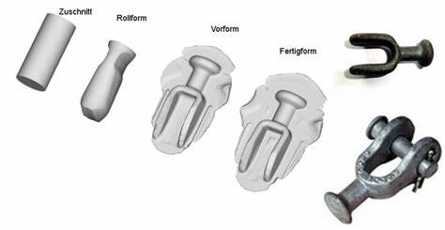
- St42 steel, connection part (120 mm length)


- Photo engraving on Al surface

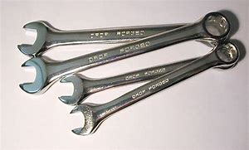
- Steel wrench (approx. length 180 mm)

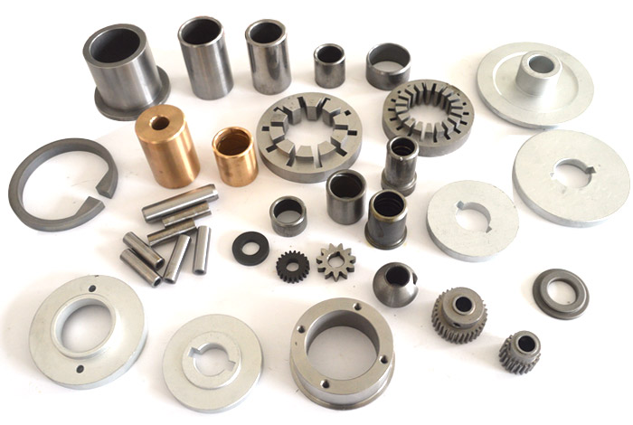
- Parts (made of Al, brass, steel), sizes less than 100 mm (choose the gear on the right, made of steel, 25 mm dia., 20 mm height)

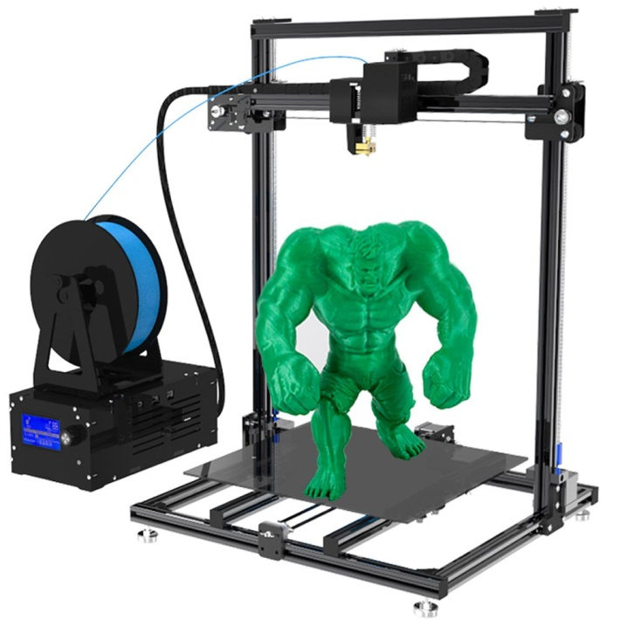
- Polymer HULK(120 mm tall)

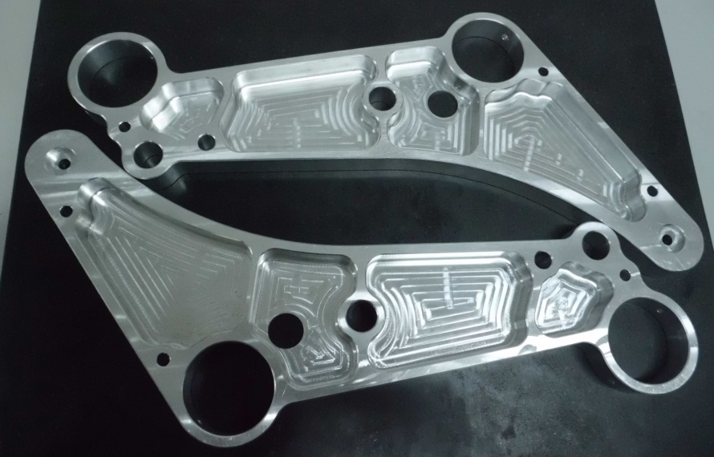
- 7XXX series high-strength Al (220 mm overall length)

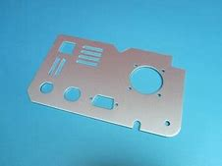
- Al, 1 mm thick, 100x180 mm

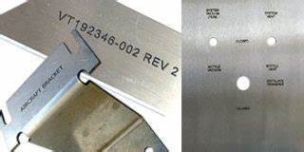
- Engraving (writings) on a steel sheet

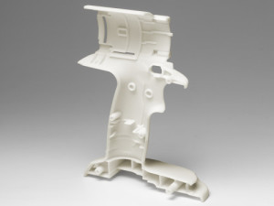
- Chargeable drill body (half) (Polymer ABS, 200 mm tall)

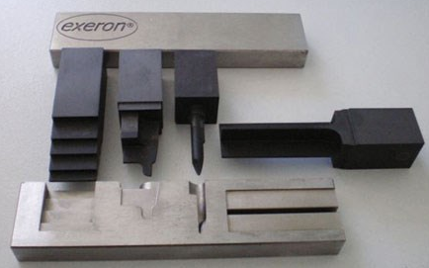
- Steel die sinking (choose the form on the left of the part, 40x40 mm)

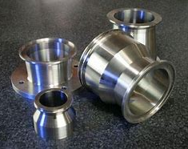
- SS304 stainless steel, diameters between 10 and 20 mm (choose the one at the right)

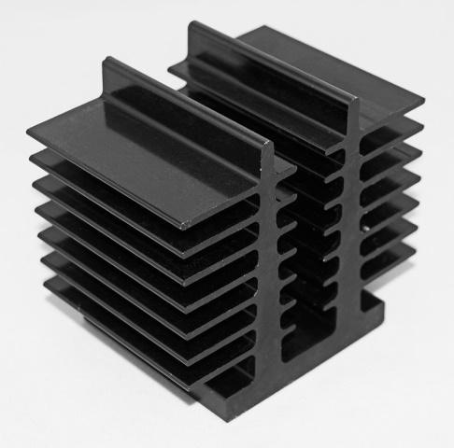
- Aluminum cooler (surface coated by a black metallic substrate, 60x60x60 mm)

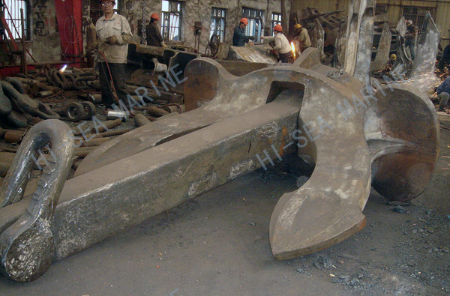
- Cruise ship anchor (iron, 5 m length, 20 tons)

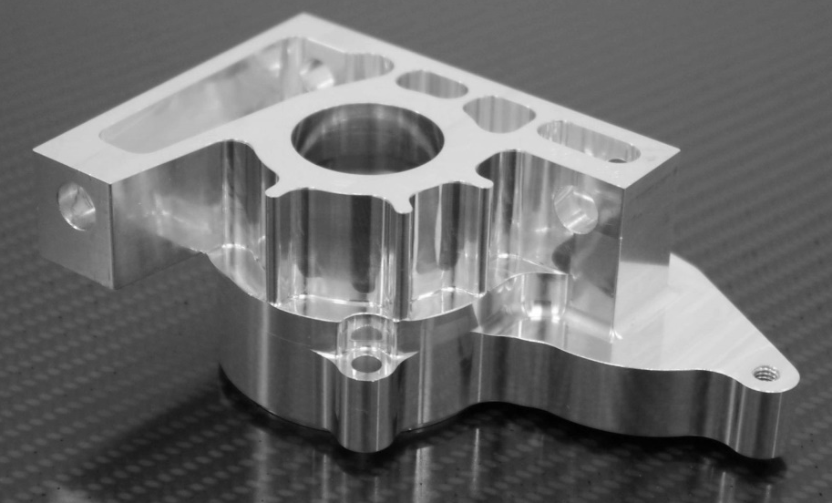
- Al, 200x100x80 mm

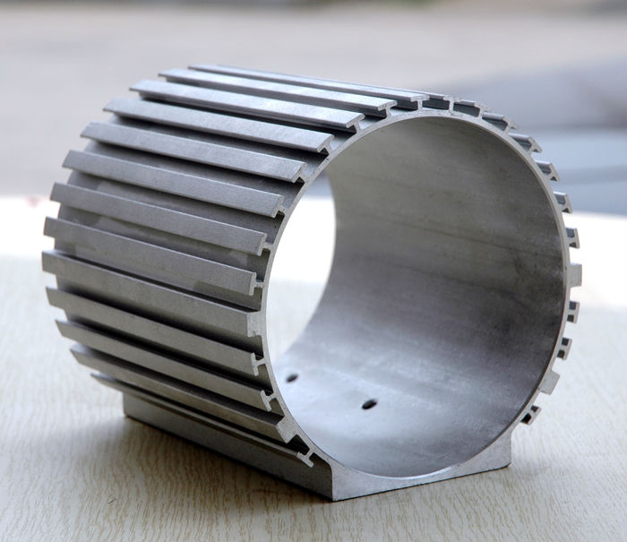
- Al, electric motor shell (180 mm inner hole dia., 240 mm long)

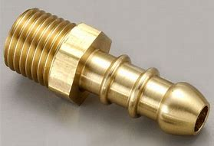
- Brass (raw is 20 mm hex material)

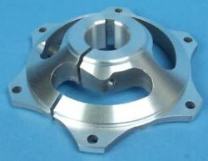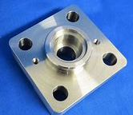
- Al (choose the left one, 150x150x70 mm)

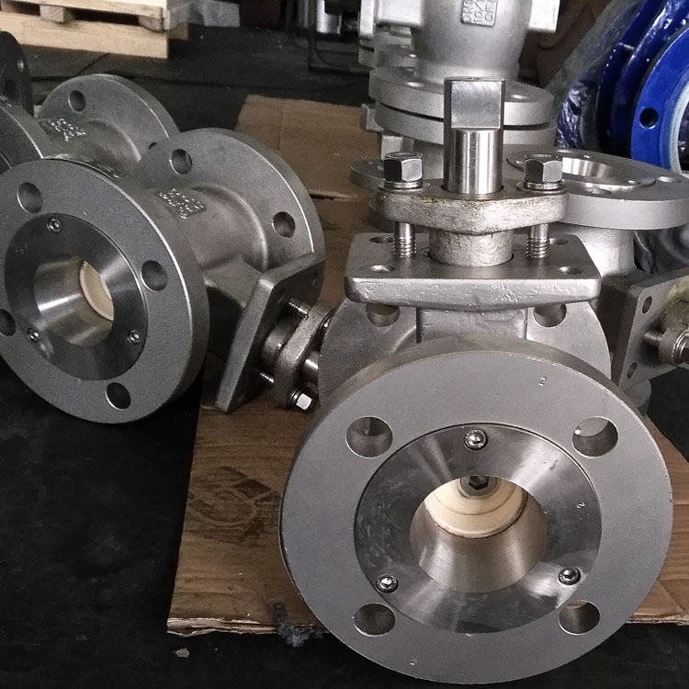
- Steel vane body (8.5 kg, outer flange dia. 220 mm, length 300 mm)

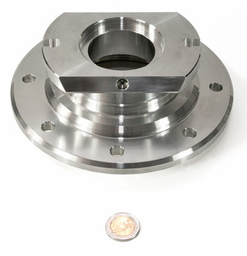
- GG70 Steel (take dimension reference to the coin)

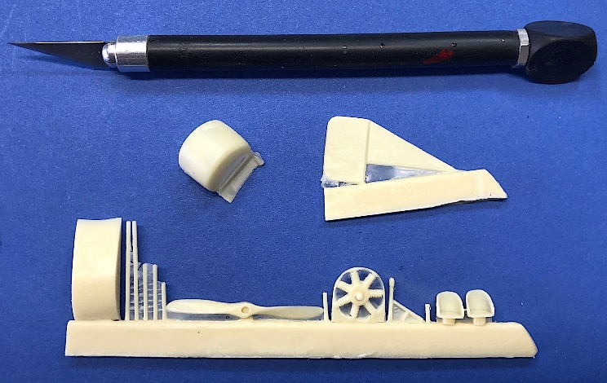
- ABS Polymer parts (each 15 mm depth)

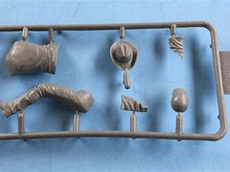
- Polymer (100x50 mm frame)

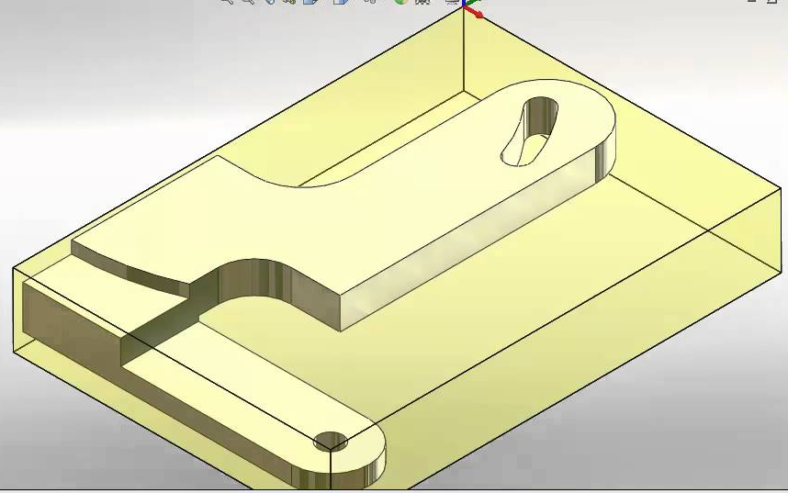
- GG-30 grey cast iron, raw 100x70x15 mm

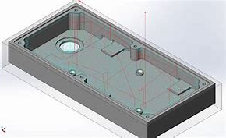
- St42 steel, raw 100x70x15 mm

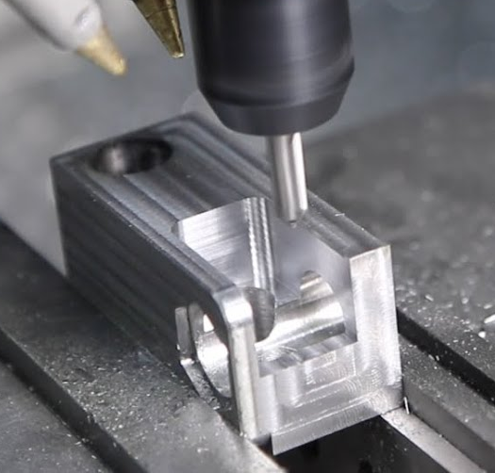
- Al7075, raw 100x50x50 mm

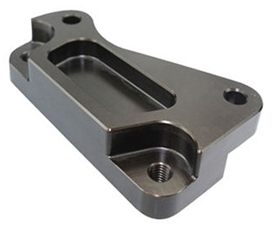
- 12L13 steel, raw form 140x60x35 mm

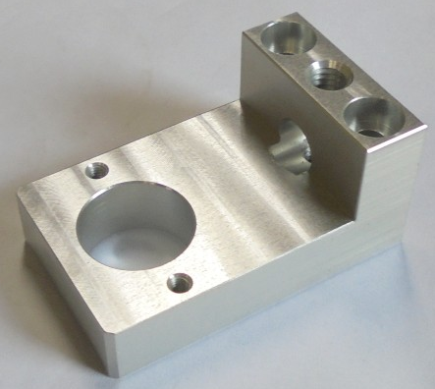
- St37-3 steel, raw 180x60x60 mm

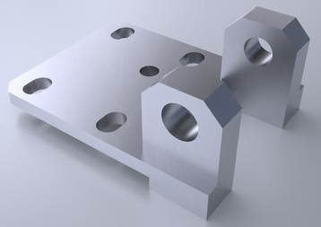
- SAE4140 alloy steel, raw 180x60x60 mm

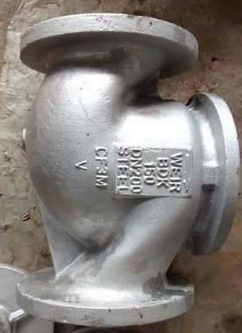
- SAE1030 steel, length 300 mm, dia. 200 mm.
(Sand Casting, die casting, investment casting, continuous casting, rolling, forging, extrusion, wire drawing, piercing-blanking, bending, deep drawing, powder metallurgy, metal cutting (chip removal processes), AWJC, EDM, wire EDM, Laser cutting, FDM, SLA, SLS, DMLS)

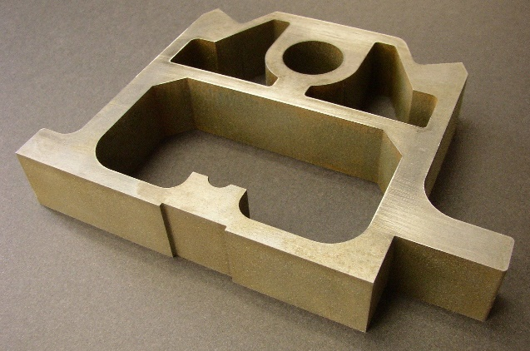
- Brass, 150x100x15 mm
(Sand Casting, die casting, investment casting, continuous casting, rolling, forging, extrusion, wire drawing, piercing-blanking, bending, deep drawing, powder metallurgy, metal cutting (chip removal processes), AWJC, EDM, wire EDM, Laser cutting, FDM, SLA, SLS, DMLS)

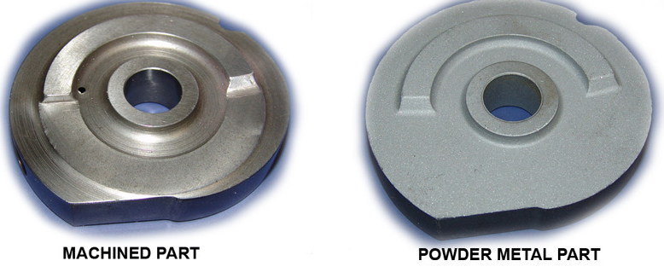
- Steel, dia. 35 mm, thickness 6 mm
(Sand Casting, die casting, investment casting, continuous casting, rolling, forging, extrusion, wire drawing, piercing-blanking, bending, deep drawing, powder metallurgy, metal cutting (chip removal processes), AWJC, EDM, wire EDM, Laser cutting, FDM, SLA, SLS, DMLS)

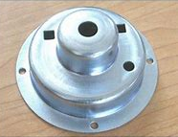
- St37 steel, 50 mm outer dia., 0.5 mm thick
(Sand Casting, die casting, investment casting, continuous casting, rolling, forging, extrusion, wire drawing, piercing-blanking, bending, deep drawing, powder metallurgy, metal cutting (chip removal processes), AWJC, EDM, wire EDM, Laser cutting, FDM, SLA, SLS, DMLS)

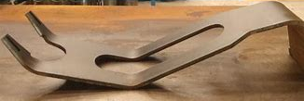
- Al, 3 mm thick, 120 mm length
(Sand Casting, die casting, investment casting, continuous casting, rolling, forging, extrusion, wire drawing, piercing-blanking, bending, deep drawing, powder metallurgy, metal cutting (chip removal processes), AWJC, EDM, wire EDM, Laser cutting, FDM, SLA, SLS, DMLS)

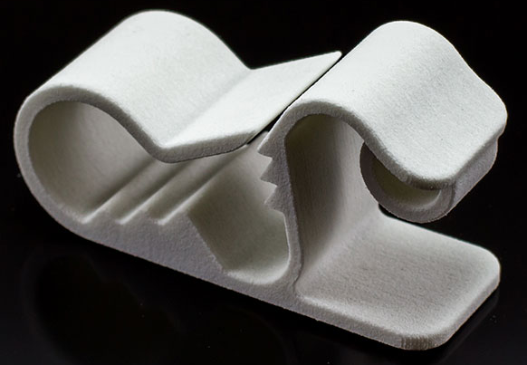
- ABS, 150 mm length
(Sand Casting, die casting, investment casting, continuous casting, rolling, forging, extrusion, wire drawing, piercing-blanking, bending, deep drawing, powder metallurgy, metal cutting (chip removal processes), AWJC, EDM, wire EDM, Laser cutting, FDM, SLA, SLS, DMLS)

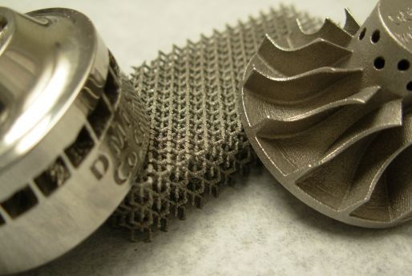
- Brass, propeller dia. 80 mm.
(Sand Casting, die casting, investment casting, continuous casting, rolling, forging, extrusion, wire drawing, piercing-blanking, bending, deep drawing, powder metallurgy, metal cutting (chip removal processes), AWJC, EDM, wire EDM, Laser cutting, FDM, SLA, SLS, DMLS)

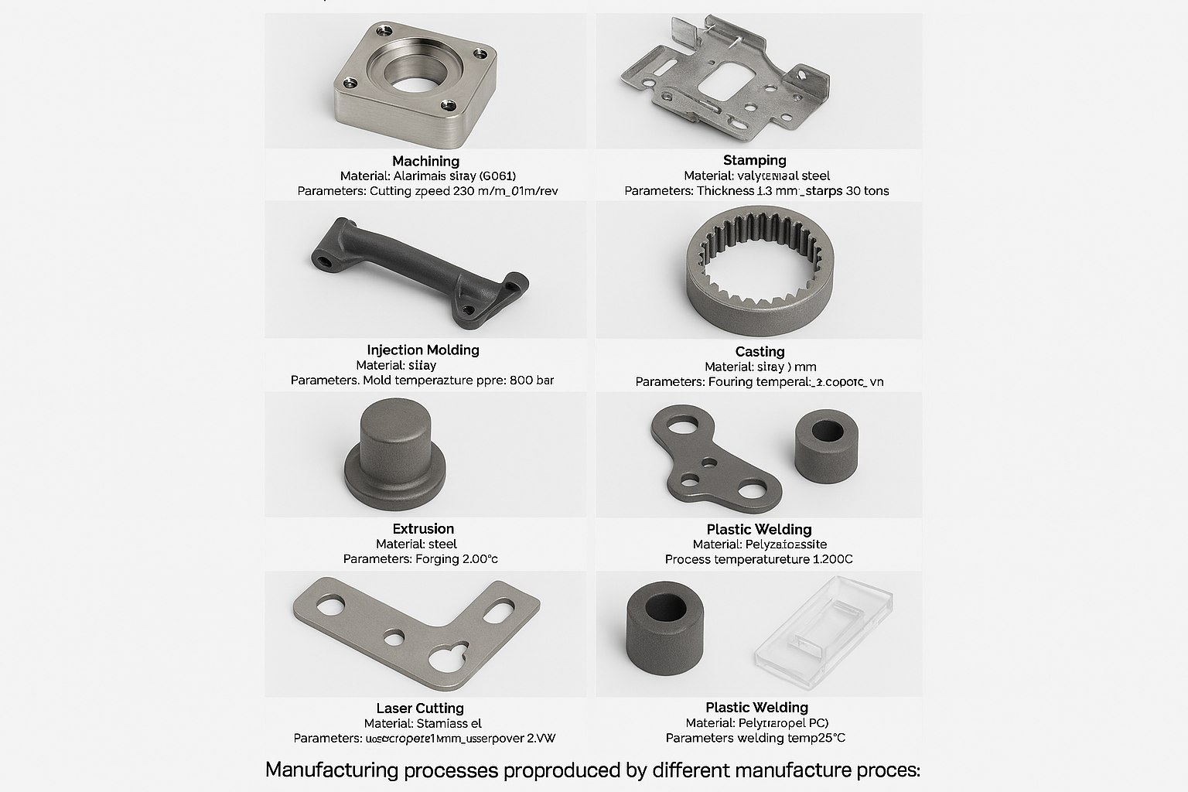

CNC Machining – Aluminum 6061-T6 Housing
• Tool: 3-flute carbide end mill, Ø10 mm
• Cutting speed: ~250 m/min
• Feed per tooth: 0.06 mm/tooth
• Coolant: Flood (water-soluble)
• Ra surface finish (flat): 0.8–1.6 μm (typical)

Sheet Metal Stamping – Galvanized Steel Bracket
• Sheet thickness: 1.0–1.5 mm
• Press force: 300–500 kN
• Operations: Blanking + Piercing + Flanging + Coating (Hot-dip zinc)

Injection Molding – Polypropylene (PP) Handle
• Melt temperature: 200–230 °C
• Mold temperature: 40–70 °C
• Injection pressure: 600–1000 bar (part- and gate-dependent)

Sand Casting – Gray Iron (ASTM A48 Class 30)
• Melt/pour temperature: ~1350 °C
• Mold: Green sand;

Extrusion – Aluminum 6063-T5 Spacer
• Billet temperature: ~480–520 °C
• Ram speed: 1–5 mm/s (profile-dependent)
• Quench: Air or water spray; artificial age to T5
• Finish: Anodize-ready surface

Laser Cutting – Gray Iron (ASTM A48 Class 30)
• Fiber laser, N₂ assist gas for oxide-free edges
• Sheet thickness: 2–4 mm
• Kerf: ~0.1–0.2 mm

Plastic Welding (Ultrasonic) – ABS/PC
• Frequency: 20–40 kHz (typical)
• Amplitude: ~60–80% of machine scale
• Weld time: ~1.5–2.5 s; Hold: ~3–5 s
• Downforce: ~1.5–2.5 bar
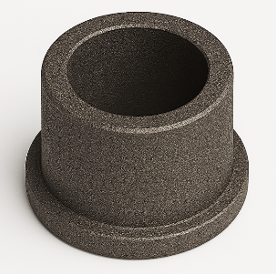

Powder Metallurgy – Fe-Cu Bushing
• Compaction pressure: ~400–800 MPa
• Sintering: ~1120 °C protective atmosphere
• Optional: Sinter-forge to raise density and strength
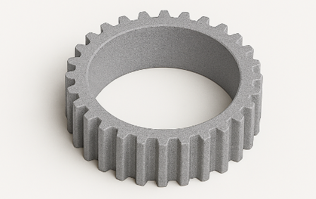

Additive Manufacturing (SLS) – PA12 Gear
• Layer thickness: 0.1–0.12 mm (typical)
• Build temperature: ~170–180 °C (PA12 window)
• Post-process: Bead blast; optional dye or vapor smooth

Closed-Die Forging – AISI 1045 Steel Link
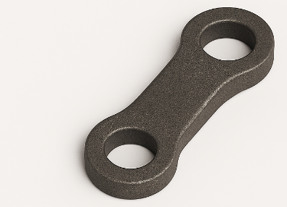
• Heating: 850–1250 °C
• Press/hammer forging; normalize or quench & temper as required
• Scale removal & machining of flash

